Radio Frequency Identification (RFID) Based Electronic Toll Collection System

SONARGAON UNIVERSITY (SU)
Supervised By
Md. Majharul Islam
Lecturer
Department of EEE
Sonargaon University (SU)
Submitted By
Md. Rejwanul Islam | ID: EEE1602008030
S.M Hait-Ud-Zaman | ID: EEE1602008002
Md. Abdul Alim | ID: EEE1502005126
Md. Rubel Mia | ID: EEE1602008216
Md. Oleur Rahman Chowdhury | ID: EEE1602008045

Department of Electrical & Electronic Engineering (EEE)
Sonargaon University (SU)
147/I, Green Road,
Tejgaon, Dhaka-1215

Date of Submission: 31st January 2020

Declaration
It is declared hereby that this thesis paper or any part of it has not been submitted to anywhere else for the award of any degree.

........................................ ….…..........................................
Md. Rejwanul Islam S.M Hait-Ud-Zaman

........................................ …...................................................
Md. Abdul Alim Md. Rubel Mia

.........................................................................
Md. Oleur Rahman Chowdhury

Under Supervision of

...................................
Md. Majharul Islam
Lecturer
Department of EEE
Sonargaon University (SU)

Certification
This is to certify that this project and thesis entitled “RFID Based Electronic Toll Collection System” is done by the following students under my direct supervision and this work has been carried out by them in the laboratories of the Department of Electrical and Electronic Engineering under the Faculty of Engineering of Sonargaon University in partial fulfillment of the requirements for the degree of Bachelor of Science in Electrical and Electronic Engineering.

Supervisor

……………………………………………
Md. Majharul Islam
Lecturer
Department of Electrical and Electronic Engineer (EEE)
Sonargaon University (SU)
ACKNOWLEDGEMENT

The report titled as on RFID Based Electronic Toll Collection System” has been prepared to fulfill the requirement of our practicum program. In the process of doing and preparing our practicum report, we would like to pay our gratitude to some persons for their enormous help and vast co-operation.
At first, we would like to show our gratitude to the University authority to permit us to do our practicum. Specially, we would like to thank to our honorable teacher Md. Majharul Islam, Lecturer, Department of Electrical & Electronics Engineering, SU− Sonargaon University, Dhaka, for his valuable and patient advice, sympathetic assistance, co-operation, contribution of new idea. Deep theoretical and hardware knowledge & keen interest of our supervisor in this field influenced us to carry out this project. His endless patience, scholarly guidance, continual encouragement, constant and energetic supervision, constructive criticism, valuable advice, reading many inferior draft and correcting them at all stage have made it possible to complete this project.
Finally, we would like to thanks again to the respected Vice- Chancellor of SU, Professor Dr. Md. Abul Bashar also thanks to Head of Department of SU, Electrical & Electronics Engineering, Professor Dr. M. Bashir Uddin because they are designated such an environment for learning through which we got the opportunity to acquire knowledge under Bsc in EEE program, and that will be very helpful for our prospective career.
We are, indeed, grateful to all those from whom we got sincere cooperation and help for the preparation of this report.

ABSTRACT

In this thesis we will discuss RFID based Smart Toll Collection System as a solution to solve the traffic problems and also to maintain transparency of the toll collection system. Our aim is to make a digital toll collection system which will be less time consuming and automated. This project focuses on an electronic toll collection (ETC) system using radio frequency identification (RFID) technology. The proposed RFID system uses tags that are mounted on the windshields of vehicles, through which information embedded on the tags are read by RFID readers; the proposed system eliminates the need for vehicle owners and toll authorities to manually perform ticket payments and toll fee collections, respectively. Data information are also easily exchanged between the vehicle owners and toll authorities, thereby enabling a more efficient toll collection by reducing traffic and eliminating possible human errors.
In addition, in this project we will measure weight of the vehicles using a weight sensor. Over weight transport will be blocked, they will not get access. In calculation, Economical analysis of the automatic toll collection system is also presented and is compared with the manual ticketing base system.

Table Contents
Declaration II
Certification III
ABSTRACT V
Table Contents VI
List of Figure IX
LIST OF TABLES X
List of Abbreviations XI
Chapter 1 1
INTRODUCTION 1
1.1 Introduction 1
1.2 History of ETC: 2
1.3 Problem Statement 2
1.4 Aims of project 3
1.5 Scope 3
1.6 Research Methodology 3
1.7 Project/Thesis Outline 4
Chapter 2 5
LITERATURE REVIEWS 5
2.1 Introduction 5
2.2 Block diagram 5
2.3 Circuit diagram 6
2.4 Working principle of the system 6
2.5 Flow chart of our system 8
2.6 List of components 8
2.7 Summary 9
Chapter 3 10
ANALYSIS AND SIMULATION 10
3.1 Introduction 10
3.2 Software analysis 10
3.3 Description of software 10
3.4 Important initialization &Setup 11
3.5 Summary 11
Chapter 4 12
HARDWARE DEVELOPMENT 12
4.1 Introduction 12
4.2 Basic Description of Arduino 12
4.3.1 Architecture of Arduino 13
4.3.2 Block diagram of microcontroller 13
4.3.3 Specification of Arduino 14
4.3.4 Pin diagram of microcontroller 14
4.3.5 Pin description of Arduino 15
4.3.6 Inputs Outputs 16
4.3 Description of Display 17
4.3.1 Pin diagram of LCD 18
4.3.2 Pin description 18
4.4 RFID module 20
4.5 RFID Card/ Tag 22
4.6 Keypad 24
4.7 IR sensor 27
4.8 Servo motor 29
4.3.3 Working of a Servo Motor 30
4.3.4 Controlling a Servo Motor 31
4.3.5 Advantages: 31
4.3.6 Disadvantages: 31
4.3.7 Applications of Servo Motors 31
4.3.8 Specification: 32
4.9 Power supply 33
4.3.9 Specifications: 34
4.3.10 Characteristics curve 34
4.10 PCB 35
4.11.1 Application of PCB board: 36
4.11 WIRES 36
4.12 Cost Analysis 36
4.13.1 Cost Sheet: 37
4.13 GSM Module 37
4.14.1 Specification 38
4.14 Conclusion 38
Chapter 5 39
RESULTS AND DISCUSSIONS 39
5.1 Introduction 39
5.2 Experimental setup 39
5.3 Advantage 40
5.4 Disadvantage 41
5.5 Result 41
5.6 Summary 42
Chapter 6 43
CONCLUSIONS 43
6.1 Conclusions 43
6.2 Limitations of the Work 43
6.3 Future Scopes of the Work 43
REFERENCES 45
Appendix A 47
Appendix B 47
Appendix C 52

List of Figure
Figure 1.1: Electronic Toll Collection 2
Figure 2.1: Block Diagram 5
Figure 3.1: Circuit Diagram 6
Figure 5.1: Flow chart 8
Figure 2.1: Software Logo 10
Figure 3.1: Arduino software 11
Figure 2.1: Arduino NANO R3 board 13
Figure 2.2: Block diagram of microcontroller 13
Figure 2.3: Pin diagram of microcontroller 15
Figure 3.1: LCD (Liquid Crystal Display) 18
Figure 3.2: Pin diagram of LCD 18
Figure 4.1: RFID Module 20
Figure 5.1: RFID tag and card 24
Figure 6.1: Keypad 24
Figure 6.2: Internal Structure of a keypad 25
Figure 6.3: Keypad pinout 26
Figure 6.4: Keypad diagram 26
Figure 7.1: IR Sensor 27
Figure 7.2: IR sensor module details 28
Figure 8.1: Servo motor cross-section 30
Figure 8.2: SG9 Servo motor 33
Figure 10.1: Power supply 34
Figure 10.2: Characteristics curve 35
Figure 11.1: PCB board 36
Figure 12.1: Wires 36
Figure 3.5.1: GA6 GSM module 37
Figure 2.1: Display output of our system 39

LIST OF TABLES
Table # | Table Caption | Page #
1 | Component list | 9
2 | Specification of Arduino | 14
3 | Pin description of LCD | 19
4 | Cost list | 36

List of Abbreviations
CD | Chromatic Dispersion
EMI | Immune to Electromagnetic Interference
FBG | Fiber Bragg Gratings
FWHM | Full Width at Half Maximum
GVD | Group Velocity Dispersion
LED | Light Emitting Diodes
MD | Material Dispersion
NLSE | Nonlinear Schrödinger Equation
PMD | Polarization Mode Dispersion
PUA | Piecewise Uniform Approach
RMS | Root Mean Square
SSMF | Standard Single Mode Fiber
TFBG | Tilted Fiber Bragg Gratings
UV | Ultraviolet
WD | Wave-guide Dispersion
WDM | Wavelength Division Multiplexed

INTRODUCTION

Introduction
Electronic toll collection (ETC) intends to dispense with the postponement on toll streets, carpool lanes, toll scaffolds, and toll burrows by gathering tolls without money and without expecting vehicles to stop. Electronic toll stalls may work close by money paths with the goal that drivers who don't have transponders can pay a clerk or toss coins into a container. With cashless tolling, vehicles without transponders are either barred or pay by plate – a bill might be sent to the location where the vehicle's tag number is enrolled, or drivers may have a specific measure of time to pay with a charge card by telephone. Open Street tolling is a prevalent type of cashless tolling without toll corners; vehicles pass electronic perusers even at interstate velocities without the security risk and traffic bottlenecks made by backing off to experience a robotized toll stall path.
Transponders are utilized to encourage micropayments from drivers who have regularly joined ahead of time and stacked cash into a declining-balance account which is charged each time they pass a toll point. Tag perusers and sensors can be utilized to identify vehicles that are avoiding tolls or which are needed by law authorization for different reasons. Electronic tolling is less expensive than a staffed corner, diminishing exchange costs for government offices or private street proprietors recovering development or upkeep expenses or getting income from a toll street. The simplicity of fluctuating the measure of the toll and the capacity to charge drivers without building a toll corner additionally makes it simple to actualize street clog estimating, including for high-inhabitance paths, toll paths that sidestep blockage, and city-wide clog charges.

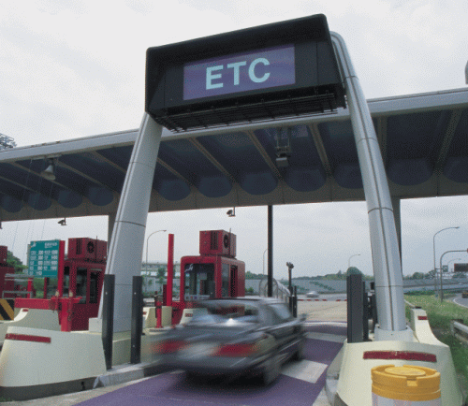
Figure 1.1: Electronic Toll Collection

History of ETC:
In 1959, Nobel Economics Prize champ William Vickrey was the first to propose an arrangement of electronic tolling for the Washington Metropolitan Area. He suggested that every vehicle would be outfitted with a transponder: "The transponder's customized sign would be gotten when the vehicle went through a convergence, and afterward handed-off to a focal PC which would ascertain the charge as per the crossing point and the hour of day and put it on the vehicle's bill." In the 1960s and the 1970s, free stream tolling was tried with fixed transponders at the undersides of the vehicles and perusers, which were situated under the outside of the parkway. Current toll transponders are ordinarily mounted under the windshield, with perusers situated in overhead gantries.
Norway has been the world's pioneer in across the board execution of this innovation. And so forth was first presented in Bergen, in 1986, working together with customary tollbooths. In 1991, Trondheim presented the world's first utilization of totally independent max throttle electronic tolling. Norway currently has 25 toll streets working with electronic expense assortment (EFC), as the Norwegian innovation is called (see AutoPASS). In 1995, Portugal turned into the principal nation to apply a solitary, all-inclusive framework to all tolls in the nation, the Via Verde, which can likewise be utilized in parking garages and service stations.

Problem Statement
Numerous choice focuses exist while moving toward the court, at the square, and on takeoff from the square. The choice focuses can prompt vehicle consolidating, weaving, lining, veering and differential rates. Veering and weaving happen on the way to deal with the square as electronic toll collection(ETC) users separate from money paying users , who at that point further wander dependent on chose money installment path type, most brief traffic line, and path status (i.e., open or shut). Various assortment strategies can build the potential for sideswipe and backside impacts if the path groupings are uncertain to users who are settling on decisions of which path to use for installment. Potential wellbeing dangers especially exist when drawing closer and leaving ETC devoted paths. At the point when a driver new to the toll court understands their vehicle is in an inappropriate installment path and all of a sudden stops, and after rapid, ETC–prepared vehicle can without much of a stretch slam into the halted vehicle. Therefore, the speed change is another significant factor to be considered at blended-use toll offices. So also, blending and weaving happen on the takeoff side of the square as the number of toll paths decreases down to the width of the proceeding mainline.

Aims of project
The main goal of this project is:
- To understand the main aim of our project is develop such a device can collect toll without cash.
- Learn how Electronic Toll Collection System works.
- To reduce traffic due to regular toll collection.
- To reduce time while paying toll.

Scope
- In this circuit we use the RFID Module, Arduino, Servo Motor, LCD display, IR sensors and Keypad.
- Those sensors will be directly connected and qualified by amicrocontroller.
- We can see the output reading to the display onLCD
- The Arduino will collect all data from the RFID card via the RFID reader module.
- By using our system we can save time and reduce traffic.

Research Methodology
This project focuses more on the study case and the project development based on the RFID technology. The microcontroller will continually be working to receive the data from the RFID module via SPI communication protocol. It will process the data and cross check with the previously stored data. The data will be converted into displayed by the LCD. If the data matches and has balance on the card, it will allow the vehicle to pass otherwise not. The cardnumbers as being set on the source code. The methodology of the project divided in many steps taken so that entire the project. The methodology includes some step like planning, development of the design and the management of the project.

Project/Thesis Outline
The project report totally has six chapters. We are explained in the first chapter an idea about our project Gas leakage detector with gsm communication system and smoke protection system. Brief description of the project scopes and recharge methodology.
This Project/thesis is organized as follows:
Chapter 1: Introduction, history of Electronic Toll Collection, , problem statement, aim of project, scope, research methodology.
Chapter 2 reviews the literature: Introduction, Block diagram, Circuit diagram, Working principle of the system, Flow chart of our system, List of components, Summary.
Chapter 3 analyzes and simulates the theoretical works: introduction, solenoid valve, software analysis, description of software, Important initialization & Setup, summary.
Chapter 4 describes the hardware development part: introduction, basic description of Arduino, architecture of Arduino, block of microcontroller, specification of Arduino, pin diagram of microcontroller, pin description of Arduino, input and output, digital input and output, analog input, description of display, pin diagram of LCD, pin description LCD, RFID module, characteristics curve, IR sensor module, Keypad, buzzer, power supply, specification of power supply, PCB board, application of PCB board, wires, cost analysis, conclusion.
Chapter 5 presents the result and its discussions: introduction, experimental setup, advantage, disadvantage, results, summary.
Chapter 6 concludes with some recommendations: introduction, limitation of work, future scope of work, chemical and petrochemical plant, nuclear power plant, food and drinks industries, reference, appendix A, appendix B, appendixC.

LITERATURE REVIEWS

Introduction
In this Paper we’ll analyze the working principle of Electronic Toll Collection system. We’ll discuss about the working flow of the block diagram, working flow of the circuit diagram, the program flow chart. We will discuss step by step how the block is designed, how we’ve designed the circuit. We’ll also look at the program flow chart to understand the program.

Block diagram

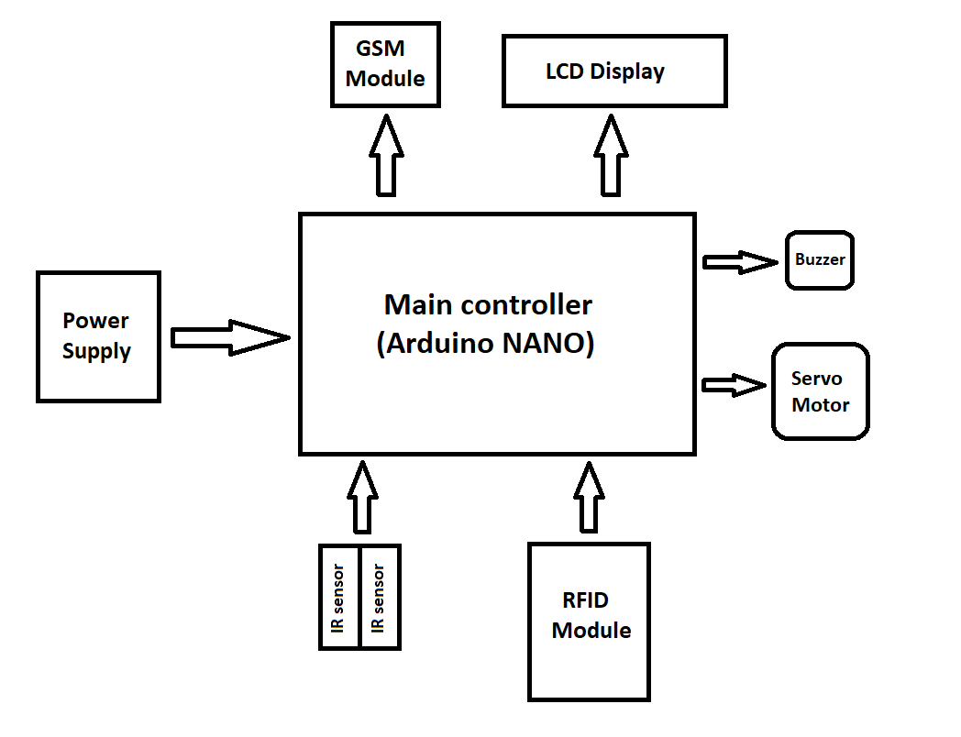
Figure 2.1: Block Diagram

Circuit diagram

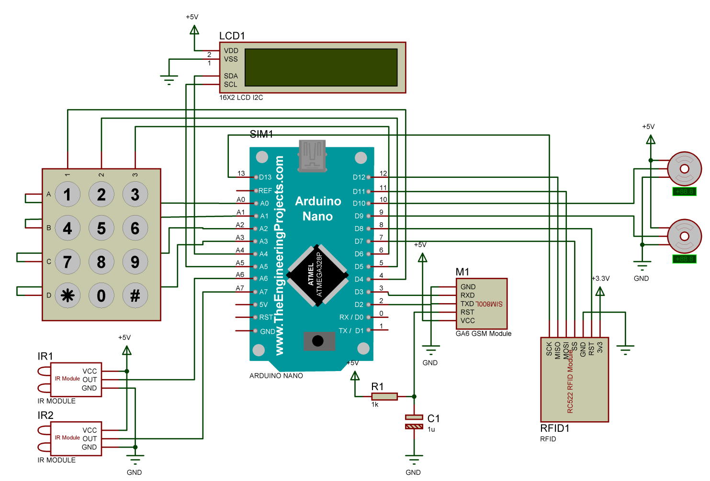
Figure 3.1: Circuit Diagram

Working principle of the system
In this article we will explain how the working principle of our system. In this circuit, we’ve used Arduino NANO as the controller that has both digital and analog IO pins. An RFID reader module to read the RFID supported cards. An LCD display to show the text messages. Two IR sensors to detect vehicles entry and exit. Two servo motor as the barrier gate. A GSM module to notify about toll collection and recharge via SMS. And lastly a keypad for recharge purpose.
When we power the system, firstly the controller initializes some functions to control the whole system. When all set, the controller rapidly reads the sensor if any vehicle comes inside the toll collection zone. When a vehicle enters into the zone, the 1st IR sensor detects the vehicle and the controller opens the 1st barrier gate for 3 seconds. The vehicle has to pass the gate within this 3 seconds. After 3 seconds, the gate closes down. Then the controller starts read the RFID module if any card is placed. If any card is placed, the module reads the data and sends it to the main controller. The controller then analyzes the data and crosschecks with the previously stored data. If the card is valid and has balance on it, the controller will allow the vehicle pass when the vehicle comes in front of the 2nd IR sensor. The controller pulls up the 2nd barrier gate for 3 seconds by providing signal to the servo motor. If the card is invalid, barrier won’t open until the customer pay Toll.
For insufficient balance situation, we’ve the recharge mode. Using a keypad, we can recharge any valid card. We’ve used a 3x4 matrix keypad. The procedure is to get into the recharge mode; we need to first place the card on the RFID reader module. In display, it will show insufficient balance. Now need to press the “*” button on the keypad to get into the recharge mode. In this mode the system will ask to put the recharge amount. Using the number key, we’ll put the amount and then press the “#” button again to complete the recharge function. Now the card is recharged and putting the card on the RFID module will now allow the vehicle to pass out.
For those, who don’t carry RFID card and also need to pass the toll gate, we have the cash system that will allow everyone to pass the toll system. For this system, who need to pass the toll by paying cash will pay cash to the toll booth, and an authorized person will collect the cash and press the “5” button to open the 2nd gate.
And who are accidentally unable to pay the toll and entered to the toll zone, can go back. For this the authorized person need to press the “6” button to open the 1st gate.
There is a GSM module for sending notification SMS for the toll collection and recharge function. When a valid card has been placed on the reader and has balance on it, the toll will be collected and an SMS will send to the vehicle owner’s mobile number. Same for the recharge function. If anyone recharges their card, then an SMS will be send to their phone as well.
There’s an option to count daily vehicle passed through the toll plaza and how much toll has been collected on that day. The system will send an SMS contains with total vehicle passed through the gate and how much toll has been collected to an authorized person’s number. To do so, user need to double press the “#” button on the keypad. By pressing the “#” button twice, user can see the total vehicle count and total collected toll amount on the LCD display.

Flow chart of our system
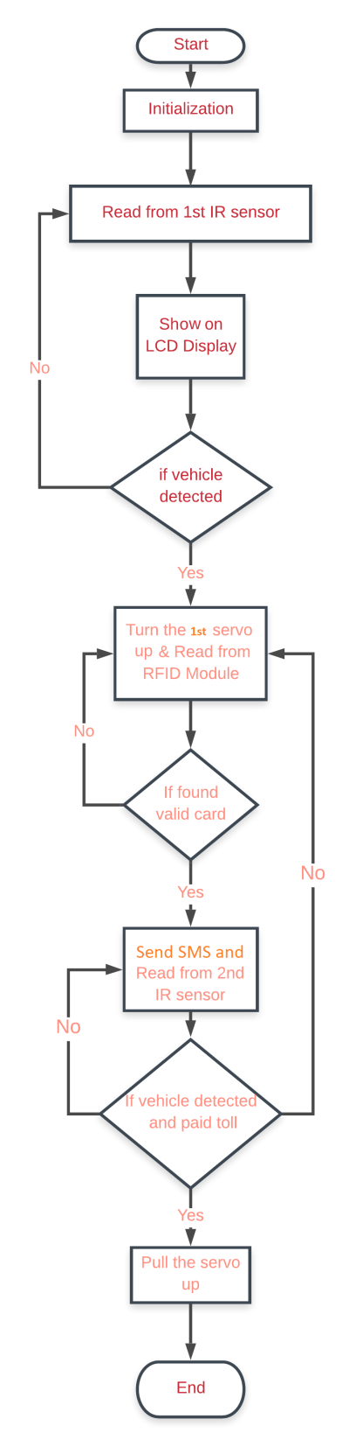
Figure 5.1: Flow chart

List of components

SI | Components name | Quantity | Used
01 | Arduino NANO | 01 | As a controller
02 | RFID Module | 01 | To read customer data
03 | GSM Module | 01
04 | IR sensor | 02 | Using for detecting vehicle
05 | Servo Motor | 01 | As the barrier gate
06 | Keypad | 01 | For recharge
07 | Display | 01 | Show output
08 | Power supply | 01 | To provide power to the system
Table 1: Component List

Summary
In this chapter of the system we are showing all of the system such as circuit design, block diagram, flowchart, and component list used all of the system. We learning how to development of our project.

ANALYSIS AND SIMULATION

Introduction
In the previous chapter we have clear many concepts such as our project design, working principle, component list, flowchart and many theoretical information of this project that connect a particular application. In our project we have discussed detail. It is the easy electrical and electronics connection that helps we understand quickly. In this chapter we are explain some choose of simulation of our project how we can correction of the component and how its make to easier our system.

Software analysis
In this section we discuss about software analysis and software language. We also explain program code; this section also documents the development of the program for the application.

Figure 2.1: Software Logo

Description of software
Arduino is world’s leading open-source platform software and hardware ecosystem. Arduino is a popular tools IoT product development and most successful for STEAM education. Student, engineer, designer and thousands other professional person use this software. Arduino is an open source software environment makes easy to write code and upload the input output board. It is capable of assembling program and uploads in to the board. The Arduino IDE comes with comes in to the C/C++ library. Setup ()- it is a function run once and start.
Loop ()- it is a function called replete until the power off the board. The screen shoot of Arduino is given below:
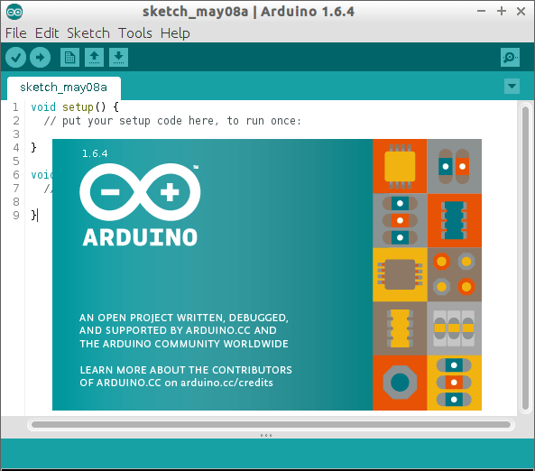
Figure 3.1: Arduino software

Important initialization &Setup
Sensor speaker pin is assigned to pin 46 using Veradale “sensor”
<SoftwareSerial.h>-header library is made us of!
Software serial communication is used with PWM pin of Arduino. “buzzer” – configured as output
“Sensor” - configured as input “Display” -configuration as output

Summary
In this chapter we explain about the software that, we use for project Electronic Toll Collection system, here is we used software for that is programming, executing, compiling and command for our project. We are drawing a circuit diagram for our system. Proper software is a simulation and its burn into Arduino for this reason the project is smooth end.

HARDWARE DEVELOPMENT

Introduction
Our project helps those people who are interest to build some project by using Arduino. To design our project includes two parts one is hardware part another is software parts. In this chapter, we will explain details about hardware design of “Electronic Toll Collection system” and we also describe component description, working procedure, features and cost analysis of all our equipment.

Basic Description of Arduino
Arduino is an open-source platform used for building electronics projects. Arduino build of some hardware part and software part. In the controller unit, we tend to explain Arduino hardware board. Arduino is an ASCII text file and easy to use hardware and compute code.
For some good reason, the Arduino platform has become quite popular with people just starting out with electronics, unlike most previous programmable circuit boards, the Arduino does not need a separate piece of hardware in as if load new code onto the board we can use a USB cable to connect. Additionally, the Arduino IDE uses an easy version of C++, easy to learn program. Finally, Arduino give a standard form factor that breaks out the functions of the micro-controller into a more get-at-able package. The Uno is one more popular board in the Arduino family and a great choice for beginners.

Architecture of Arduino
There are many types of Arduino board that can be used for varieties purpose. The Arduino are:
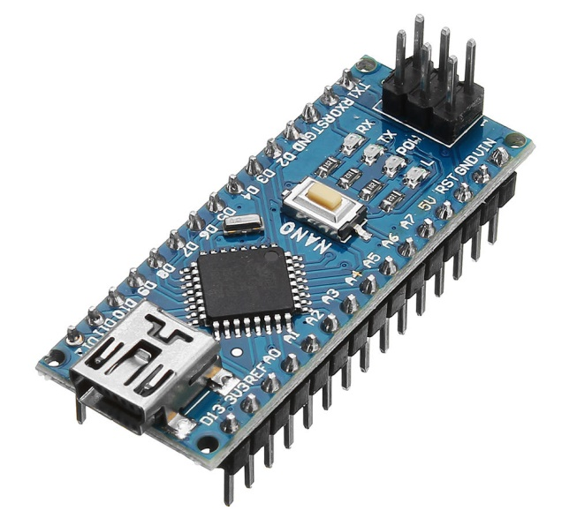
Figure 2.1: Arduino NANO R3 board

Block diagram of microcontroller
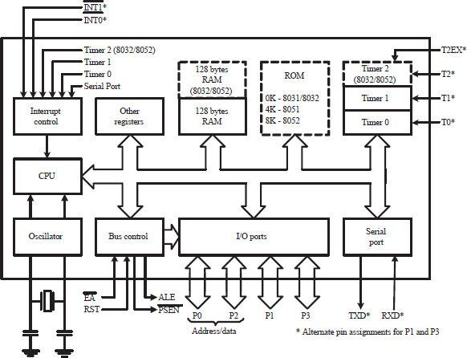
Figure 2.2: Block diagram of microcontroller

Specification of Arduino
Operating Voltage | 5 V
Input voltage | 7-10V
Input voltage limit | 6-20 V
Digital I/O pins | 14
Analog input pins | 6
Dc current per I/O pin | 40 Ma
DC current for 3.3V pin | 50mA
Flash memory | 32 KB of which 0.5KB
SRAM | 2 KB
EEPROM | 1 KB
Clock speed | 16 MHz
Length | 68.6mm
Weight | 25 g
Table 2: Specification of Arduino

Pin diagram of microcontroller
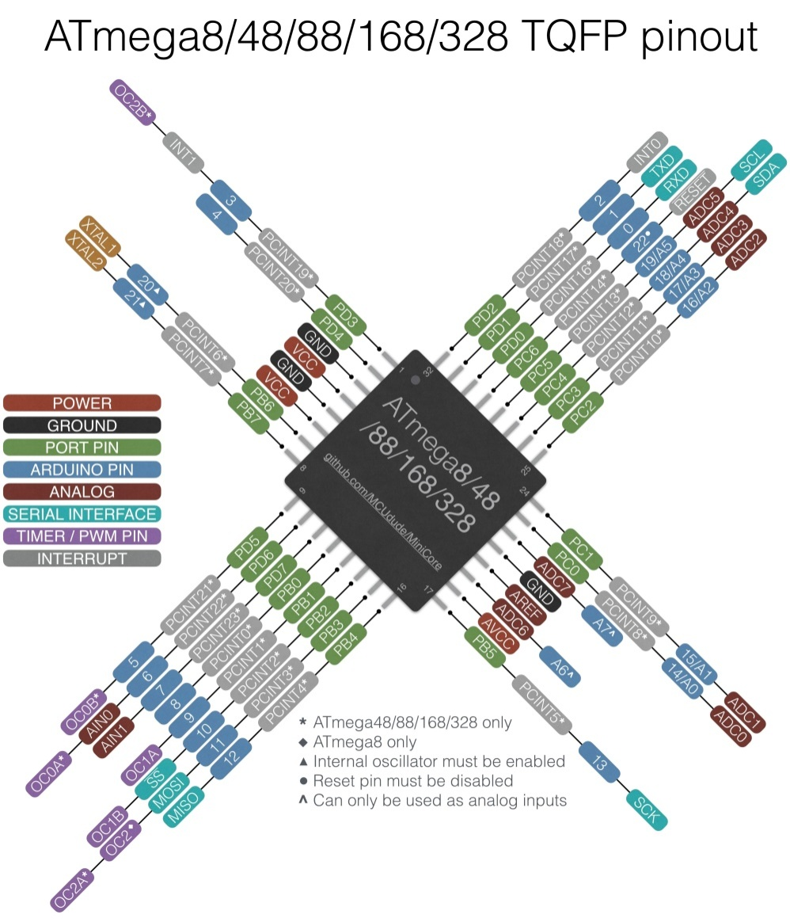
Figure 2.3: Pin diagram of microcontroller

Pin description of Arduino
We are describing each pin working procedure in the given below the power pins are as follows:
      - VIN. When we using an external power source the input voltage to the Arduino board is active. We can supply voltage through this pin, or if supplying voltage by the power jack, entry it through this pin.
      - 5V. the regulated power supply used to power the microcontroller and other components on the board. This is come either from VIN by an on-board Regulator, or be supplied by USB or another regulated 5V supply. As opposed to 5 volts from the USB connection.
      - 3V3. a 3.3-volt supply generated by the on-board regulator. Most current draw is 50mA.
      - GND. Ground pins.

Inputs Outputs
There are total 21 pins that can be used to input and output an electrical signal. Here 14 pins are digital and 6 pins is analog. And the inputs are the temperature sensor and the outputs are the control of the position of the arm on the servo
The inputs are the temperature sensor and the humidity sensor and the output is the control of the position of the arm on the servo. The processing that occurs in between the input and output of this example is discussed in the programming part.

Digital Inputs and Outputs
The 19 digital pins are situated in the head right. Digital inputs can only be used on or off. We could see this is the digital pins used only 5 volts or having zero volts
We can give an example that would be use a digital input pin sees if a switch on or off. If the switch has no power it would return a 0 for off. If the switch is on and has power then the Arduino would return a 1 for on.
The digital output pin works the same process. If we wanted to turn on an LED then we would have the digital output pin set to on and send 5 volts to the LED. 6 of the 14 digital pins are able of sending an analog signal for example a sine wave or a square wave.

Analog Inputs
At any time, an analog signal can vary in voltage. As like, would be the small blue temperature sensor in outside the evident plastic housing of the Arduino. For every degree of temperature, the temperature sensor will provide a various voltage. In the lower left the Arduino’s analog pins, will read correctly what voltage the sensor is providing and can freely convert this to a temperature in the programming. Dissimilar digital pins, analog pins can read only input data. To output an analog signal, we would need to use one of the 6 digital pins noted with the PWM icon (~).
In addition, some pin has specialized function:
- Serial: 0 (RX) and 1 (TX): Used for receive (RX) and used for transmit (TX) TTL serial data. These pins are connected to the similar pins of the ATmega8U2 USB-to-TTL Serial chip.
- External Interrupts: 2 and 3. Those pins can be configured to trigger an interrupt on a low value, a rising or falling edge, or a change in value. See the attach Interrupt function for elaborately. PWM: 3, 5, 6, 9, 10, and 11. Provide 8-bit PWM output with the Analog write function.
- TWI: A4 or SDA pin and A5 or SCL pin. Support TWI using for communication.
- LED: 13. LED is a built-in connected to digital pin 13. When the pin is HIGH value, the LED is on, when the pin is LOW, it's off.
- SPI: 10 (SS), 11 (MOSI), 12 (MISO), 13 (SCK). Those pins support SPI communication.
- There are a couple of other pins on the board:
- AREF. Reference voltage for the analog inputs. Used with analog reference.
- Reset. Bring this line LOW to reset the microcontroller. Generally used to add a reset button to shields which block the one on the board.

Description of Display
LCD means Liquid Crystal Display screen is an electronic display module and it is a wide range of applications. In this project we used a 16x2 LCD display
(16x2 means that 16 column and 2 rows) because it is a very basic module and very commonly used in different devices and circuits. These modules are preferred over seven segments and other multi segment LEDs. For this reason: LCDs are economical; easily programmable; it has no limitation of displaying specialized & even custom characters, animations and others.
In our project we used LCD each character is displayed in 5x7 pixel matrix. This Liquid Crystal Display (LCD) has two registers; the name is Command and Data.
The command register stores the command instructions that given to the LCD. The data is the ASCII value of the character to be displayed on the LCD.
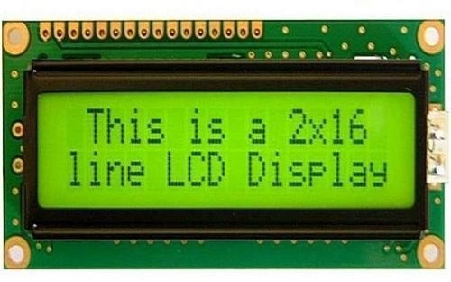
Figure 3.1: LCD (Liquid Crystal Display)

Pin diagram of LCD

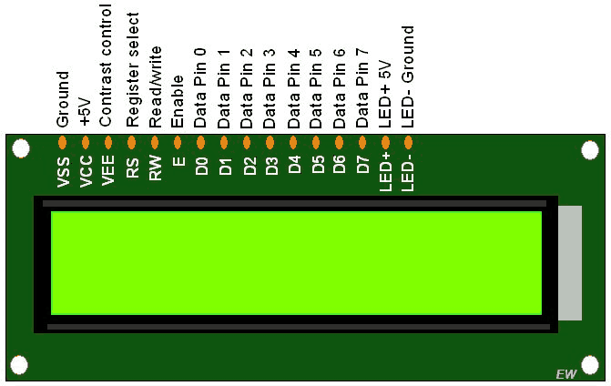
Figure 3.2: Pin diagram of LCD

Pin description
Function | Name
Ground (0V) | Ground
Supply voltage; 5V (4.7V – 5.3V) | VCC
Contrast adjustment; through a variable resistor | VEE
Selects command register when low; and data  register when high | Register  Select
Low to write to the register; High to read from the  Register | Read/write
Sends data to data pins when a high to low pulse is  Given | Enable
8-bit data pins | DB0
8-bit data pins | DB1
8-bit data pins | DB2
8-bit data pins | DB3
8-bit data pins | DB4
8-bit data pins | DB5
8-bit data pins | DB6
8-bit data pins | DB7
Backlight V_{CC} (5V) | Led+
Backlight Ground (0V) | Led-
Table 3: Pin description of LCD

RFID module
RFID - RC522

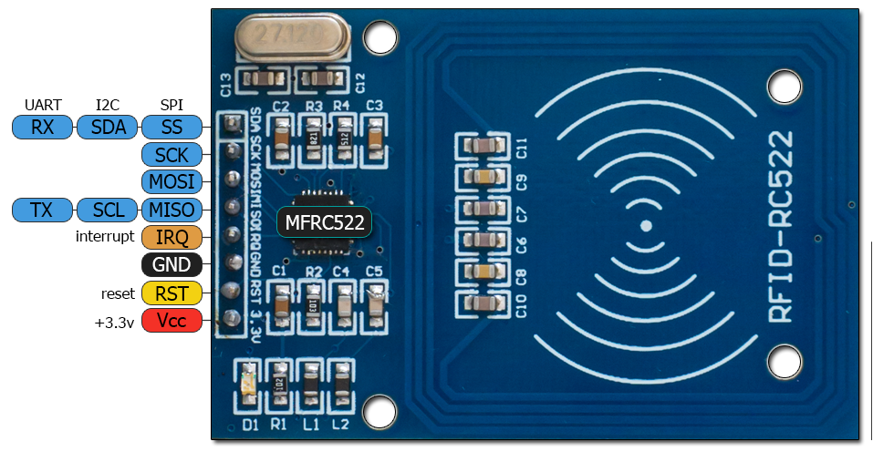
Figure 4.1: RFID Module

Mifare RC522 is the high integrated RFID card reader which works on non-contact 13.56mhz communication, is designed by NXP as a low power consumption, low cost and compact size read and write chip, is the best choice in the development of smart meters and portable hand-held devices.
MF RC522 use the advanced modulation system, fully integrated at 13.56MHz with all kinds of postive non-contact communication protocols. Support 14443A compatible answer signal. DSP deal with ISO14443A frames and error correction. Futhermore, it also supports rapid CRYPTO1 encryption to validate Mifare series products. MFRC522 support Mifare series higher speed non-contact communication, duplex communication speed up to 424 kb/s. As a new family member in 13.56MHz RFID family, MF RC522 has many similarities to MF RC5200 and MF RC530, and also has more new features.
This module can fit directly in hand held devices for mass production. Module use 3.3V power supply, and can communicate directly with any CPU board by connecting through SPI protocol, which ensure reliable work, good reading distance.

Features and benefits
- Highly integrated analog circuitry to demodulate and decode responses
- Buffered output drivers for connecting an antenna with the minimum number of xternal components
- Supports ISO/IEC 14443 A/MIFARE and NTAG
- Typical operating distance in Read/Write mode up to 50 mm depending on the antenna size and tuning
- Supports MF1xxS20, MF1xxS70 and MF1xxS50 encryption in Read/Write mode
- Supports ISO/IEC 14443 A higher transfer speed communication up to 848 kBd
- Supports MFIN/MFOUT
- Additional internal power supply to the smart card IC connected via MFIN/MFOUT
- Supported host interfaces
- SPI up to 10 Mbit/s I2C-bus interface up to 400 kBd in Fast mode, up to 3400 kBd in High-speed mode
- RS232 Serial UART up to 1228.8 kBd, with voltage levels dependant on pin voltage supply
- FIFO buffer handles 64 byte send and receive
- Flexible interrupt modes
- Hard reset with low power function
- Power-down by software mode
- Programmable timer
- Internal oscillator for connection to 27.12 MHz quartz crystal
- 2.5 V to 3.3 V power supply
- CRC coprocessor
- Programmable I/O pins
- Internal

RFID Card/ Tag
Radio-frequency identification (RFID) uses electromagnetic fields to automatically identify and track tags attached to objects. The tags contain electronically-stored information. Passive tags collect energy from a nearby RFID reader's interrogating radio waves. Active tags have a local power source (such as a battery) and may operate hundreds of meters from the RFID reader. Unlike a barcode, the tag need not be within the line of sight of the reader, so it may be embedded in the tracked object. RFID is one method for Automatic Identification and Data Capture (AIDC).
RFID tags are used in many industries, for example, an RFID tag attached to an automobile during production can be used to track its progress through the assembly line; RFID-tagged pharmaceuticals can be tracked through warehouses; and implanting RFID microchips in livestock and pets allows for positive identification of animals.
Since RFID tags can be attached to cash, clothing, and possessions, or implanted in animals and people, the possibility of reading personally-linked information without consent has raised serious privacy concerns. These concerns resulted in standard specifications development addressing privacy and security issues. ISO/IEC 18000 and ISO/IEC 29167 use on-chip cryptography methods for untraceability, tag and reader authentication, and over-the-air privacy. ISO/IEC 20248 specifies a digital signature data structure for RFID and barcodes providing data, source and read method authenticity. This work is done within ISO/IEC JTC 1/SC 31 Automatic identification and data capture techniques. Tags can also be used in shops to expedite checkout, and to prevent theft by customers and employees.
In 2014, the world RFID market was worth US$8.89 billion, up from US$7.77 billion in 2013 and US$6.96 billion in 2012. This figure includes tags, readers, and software/services for RFID cards, labels, fobs, and all other form factors. The market value is expected to rise to US$18.68 billion by 2026.
A radio-frequency identification system uses tags, or labels attached to the objects to be identified. Two-way radio transmitter-receivers called interrogators or readers send a signal to the tag and read its response.
RFID tags can be either passive, active or battery-assisted passive. An active tag has an on-board battery and periodically transmits its ID signal. A battery-assisted passive (BAP) has a small battery on board and is activated when in the presence of an RFID reader. A passive tag is cheaper and smaller because it has no battery; instead, the tag uses the radio energy transmitted by the reader. However, to operate a passive tag, it must be illuminated with a power level roughly a thousand times stronger than for signal transmission. That makes a difference in interference and in exposure to radiation.
Tags may either be read-only, having a factory-assigned serial number that is used as a key into a database, or may be read/write, where object-specific data can be written into the tag by the system user. Field programmable tags may be write-once, read-multiple; "blank" tags may be written with an electronic product code by the user.
RFID tags contain at least three parts: an integrated circuit that stores and processes information and that modulates and demodulates radio-frequency (RF) signals; a means of collecting DC power from the incident reader signal; and an antenna for receiving and transmitting the signal. The tag information is stored in a non-volatile memory. The RFID tag includes either fixed or programmable logic for processing the transmission and sensor data, respectively.
An RFID reader transmits an encoded radio signal to interrogate the tag. The RFID tag receives the message and then responds with its identification and other information. This may be only a unique tag serial number, or may be product-related information such as a stock number, lot or batch number, production date, or other specific information. Since tags have individual serial numbers, the RFID system design can discriminate among several tags that might be within the range of the RFID reader and read them simultaneously.

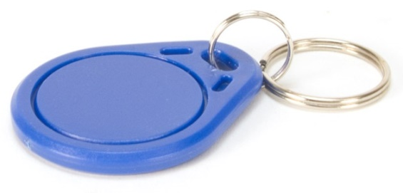 | 
Figure 5.1: RFID tag and card

Keypad
A keypad is a set of buttons arranged in a block or "pad" which bear digits, symbols or alphabetical letters. Pads mostly containing numbers are called a numeric keypad. Numeric keypads are found on alphanumeric keyboards and on other devices which require mainly numeric input such as calculators, push-button telephones, vending machines, ATMs, Point of Sale devices, combination locks, and digital door locks. Many devices follow the E.161 standard for their arrangement.
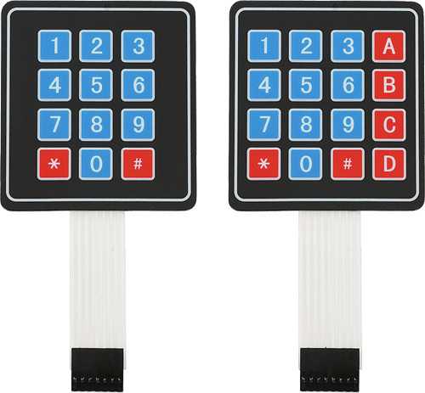
Figure 6.1: Keypad
Matrix keypads are the kind of keypads you see on cell phones, calculators, microwaves ovens, door locks, etc. They’re practically everywhere.
However, in DIY electronics, they are a great way to let users interact with your project and are often needed to navigate menus, punch in passwords and control robots.
Let’s take 4×4 keypad as an example. It has total 16 keys. Beneath each key is a special membrane switch.
All these membrane switches are connected to each other with conductive trace underneath the pad forming a matrix of 4×4 grid.
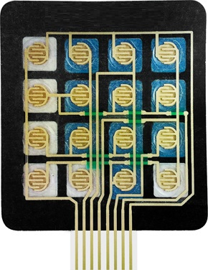
Figure 6.2: Internal Structure of a keypad
If you had used 16 individual push buttons, you would have required 17 input pins (one for each key and a ground pin) in order to make them work. However, with matrix arrangement, you only need 8 microcontroller pins (4-columns and 4-rows) to scan through the pad.
Pinout of 4×3 & 4×4 Membrane Keypad
The pinout of 4×3 & 4×4 membrane keypad is as follows.
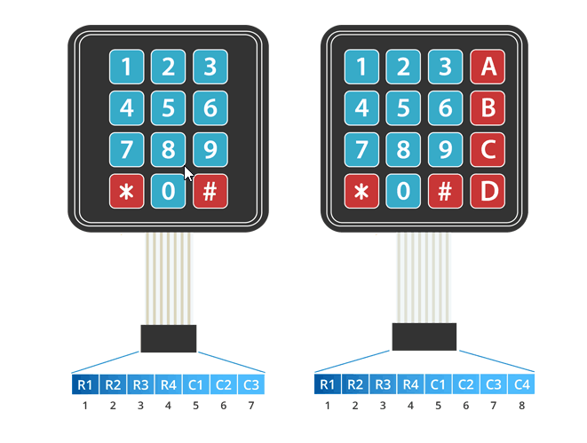
Figure 6.3: Keypad pinout
How keypad works & How to scan them?
The working principle is very simple. Pressing a button shorts one of the row lines to one of the column lines, allowing current to flow between them. For example, when key ‘4’ is pressed, column 1 and row 2 are shorted.
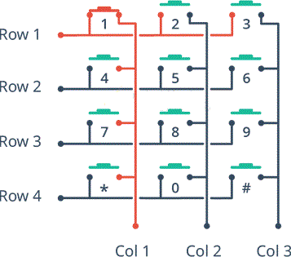
Figure 6.4: Keypad diagram
A microcontroller can scan these lines for a button-pressed state. To do this, it follows below procedure.
Microcontroller sets all the column and row lines to input.
Then, it picks a row and sets it HIGH.
After that, it checks the column lines one at a time.
If the column connection stays LOW, the button on the row has not been pressed.
If it goes HIGH, the microcontroller knows which row was set HIGH, and which column was detected HIGH when checked.
Finally, it knows which button was pressed that corresponds to detected row & column.

IR sensor
Infrared Obstacle Avoidance Proximity Sensors Module has built-in IR transmitter and IR receiver that sends out IR energy and looks for reflected IR energy to detect presence of any obstacle in front of the sensor module. The module has on board potentiometer that lets user adjust detection range. The sensor has very good and stable response even in ambient light or in complete darkness.
The sensor module can be interfaced with Arduino, Raspberry Pi or any microcontroller having IO voltage level of 3.3V to 5V.
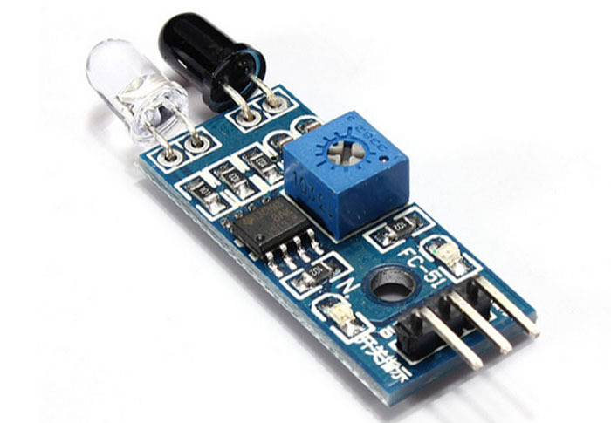
Figure 7.1: IR Sensor
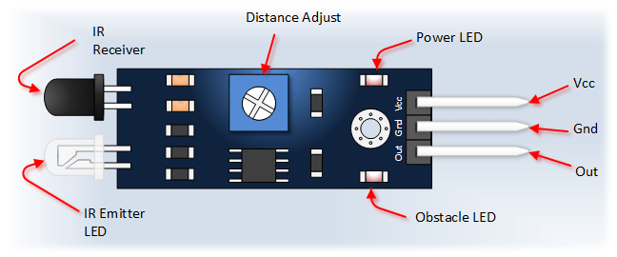
Figure 7.2: IR sensor module details
Features
- LM393 Comparator based detection circuit is very stable and accurate
- On board potentiometer sets obstacle detection range
- On board Power LED indicator
- On board Obstacle Detection LED indicator
- 3.0MM mounting hole for easy mounting the sensor.
- Male header for easy connection
- Good Accuracy: By use of Infra-red LED transmitter the module performs well in Ambient light
- Technical Specifications
- Model Number: FC-51
- Detection angle: 35 °
- Operating Voltage: 3.0V – 6.0V
- Detection range: 2cm – 30cm (Adjustable using potentiometer)
- pcb size : 3.1 cm (L) x 1.4 cm (W)
- Overall Dimension: 4.5cm (L) x 1.4 cm (W), 0.7cm (H)
- Ative output level: Outputs Low logic level when obstacle is detected
- In-active output level: Outputs High logic level when obstacle is not detected
- Current Consumption:
- at 3.3V : ~23 mA
- at 5.0V: ~43 mA

Applications
- Obstacle avoidance in robots
- Production counting on assembly lines
- Presence detection

Servo motor
Servo implies an error sensing feedback control which is utilized to correct the performance of a system. It also requires a generally sophisticated controller, often a dedicated module designed particularly for use with servomotors. Servo motors are DC motors that allows for precise control of angular position. They are actually DC motors whose speed is slowly lowered by the gears. The servo motors usually have a revolution cutoff from 90° to 180°. A few servo motors also have revolution cutoff of 360° or more. But servo motors do not rotate constantly. Their rotation is limited in between the fixed angles.
The servo motor is actually an assembly of four things: a normal DC motor, a gear reduction unit, a position-sensing device and a control circuit. The DC motor is connected with a gear mechanism which provides feedback to a position sensor which is mostly a potentiometer. From the gear box, the output of the motor is delivered via servo spline to the servo arm. For standard servo motors, the gear is normally made up of plastic whereas for high power servos, the gear is made up of metal.
A servo motor consists of three wires- a black wire connected to ground, a white/yellow wire connected to control unit and a red wire connected to power supply.
The function of the servo motor is to receive a control signal that represents a desired output position of the servo shaft and apply power to its DC motor until its shaft turns to that position.
It uses the position sensing device to figure out the rotational position of the shaft, so it knows which way the motor must turn to move the shaft to the instructed position. The shaft commonly does not rotate freely around similar to a DC motor, however rather can just turn 200 degrees.
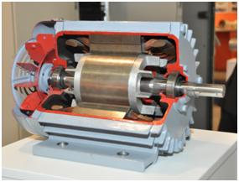
Figure 8.1: Servo motor cross-section
From the position of the rotor, a rotating magnetic field is created to efficiently generate toque. Current flows in the winding to create a rotating magnetic field. The shaft transmits the motor output power. The load is driven through the transfer mechanism. A high-function rare earth or other permanent magnet is positioned externally to the shaft. The optical encoder always watches the number of rotations and the position of the shaft.

Working of a Servo Motor
The Servo Motor basically consists of a DC Motor, a Gear system, a position sensor and a control circuit. The DC motors get powered from a battery and run at high speed and low torque. The Gear and shaft assembly connected to the DC motors lower this speed into sufficient speed and higher torque. The position sensor senses the position of the shaft from its definite position and feeds the information to the control circuit. The control circuit accordingly decodes the signals from the position sensor and compares the actual position of the motors with the desired position and accordingly controls the direction of rotation of the DC motor to get the required position. The Servo Motor generally requires DC supply of 4.8V to 6 V.

Controlling a Servo Motor
A servo motor is controlled by controlling its position using Pulse Width Modulation Technique. The width of the pulse applied to the motor is varied and send for a fixed amount of time. The pulse width determines the angular position of the servo motor. For example a pulse width of 1 ms causes a angular position of 0 degrees, whereas a pulse width of 2 ms causes a angular width of 180 degrees.

Advantages:
- If a heavy load is placed on the motor, the driver will increase the current to the motor coil as it attempts to rotate the motor. Basically, there is no out-of-step condition.
- High-speed operation is possible.

Disadvantages:
- Since the servomotor tries to rotate according to the command pulses, but lags behind, it is not suitable for precision control of rotation.
- Higher cost.
- When stopped, the motor’s rotor continues to move back and forth one pulse, so that it is not suitable if you need to prevent vibration

Applications of Servo Motors
- Servomotors are used in applications requiring rapid variations in speed without the motor getting overheated.
- In Industries they are used in machine tools, packaging, factory automation, material handling, printing converting, assembly lines, and many other demanding applications robotics, CNC machinery or automated manufacturing.
- They are also used in radio controlled airplanes to control the positioning and movement of elevators.
- They are used in robots because of their smooth switching on and off and accurate positioning.
- They are also used by aerospace industry to maintain hydraulic fluid in their hydraulic systems.
- They are used in many radio controlled toys.
- They are used in electronic devices such as DVDs or Blue ray Disc players to extend or replay the disc trays.
- They are also being used in automobiles to maintain the speed of vehicles.

Specification:
Model | : SG90
Weight(gm) | : 9
Operating Voltage | : 3.0 – 7.2 V
Operating Speed @4.8V | : 0.10sec/60°
Stall Torque @4.8V | : 1.2 kg-cm
Stall Torque @6.6V | : 1.6 kg-cm
Operating Temperature (°C) | : -30 to 60
Dead Band Width | : 7 μs
Gear Type | : Glass Fiber
Rotational Degree | : 180
Servo Plug | : JR
Cable Length | : 25 mm
Length (mm) | : 22.8
Width (mm) | : 12.6
Height (mm) | : 34.5
Shipment Weight | : 0.125 kg
Shipment Dimensions | : 8 x 6 x 4 cm
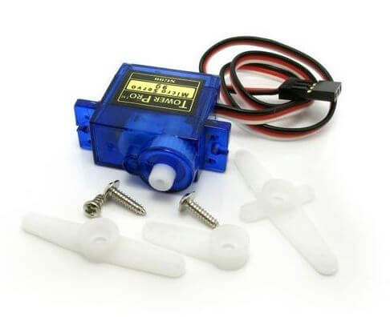 | 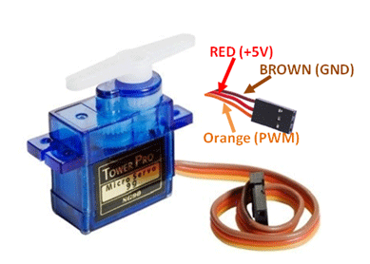
Figure 8.2: SG9 Servo motor

Power supply
First of all we have to rectify the system then signal will come from moderator and need to do filter.
After doing filtering, we will get DC output by the help of SMPS.
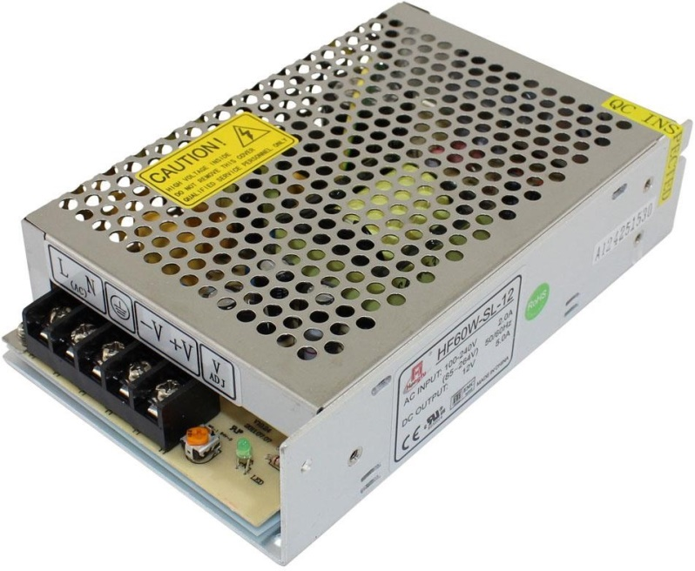
Figure 9.1: Power supply

Specifications:
Dimensions : 7.96" x 3.92" x 1.96" Minimum capacity :5000mA
Constantdischarge : 10c
Chargeplug : JST-XH
Dischargeplug :XT60
Configuration : 3SIP/12V Peak discharge (10s) : 20C Input Frequency : 47-63Hz.
Input Leakage Current : <0.7mA/230V.

Characteristics curve
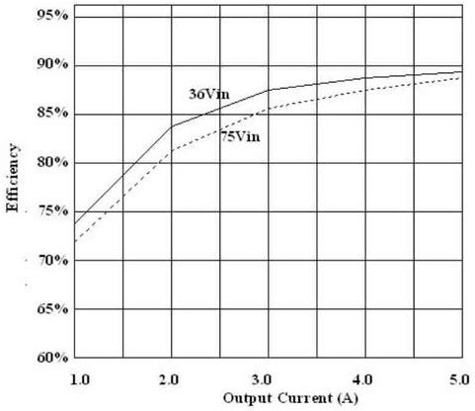
Figure 9.2: Characteristics curve

PCB
Description of PCB board:
PCB means printed circuit board a PCB mechanically supports and electrically adjust electronic components or electrical components using conductive symbol. It is anarrow board formed from an insulating material.
PCBs help save a lot of space and it is decreasing the overall board weight are also helps in reducing the board size.
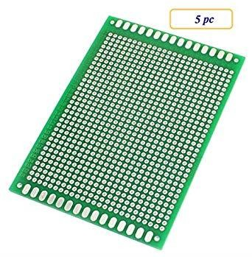
Figure 10.1: PCB board

Application of PCB board:
Monitoring Equipment Testing Equipment
The Telecommunications Industry The Automotive Industry
The Computer Technology Industry The Medical Industry

WIRES
In our project we used couples of males to male and female to male jumper wire.
We are connecting it Arduino to display, Arduino to relay and relay to fan and others.
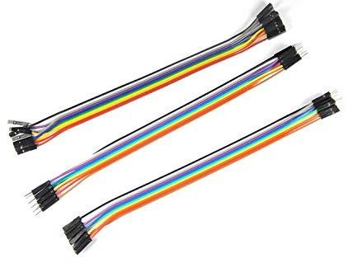
Figure 11.1: Wires

Cost Analysis
In this part we will show cost of our project that means cost sheet representation of our project.

Cost Sheet:
SI | Components name | Quantity | Purchase price (Tk.)
01 | Arduino NANO | 01 | 500
02 | RFID Module | 01 | 300
03 | IR Sensor | 02 | 300
04 | LCD Display | 01 | 150
05 | Servo motor | 01 | 370
06 | Keypad | 01 | 120
07 | 5v power supply | 01 | 300
08 | PCB board | 02 | 150
Table 4: Cost List

GSM Module
GA6 is one of the most commonly used GSM module among hobbyists and Arduino community. GA6 is a miniature cellular module which allows for GPRS transmission, sending and receiving SMS and making and receiving voice calls. Low cost and small footprint and quad band frequency support make this module perfect solution for any project that require long range connectivity. After connecting power module boots up, searches for cellular network and login automatically. On board LED displays connection state (no network coverage - fast blinking, logged in - slow blinking).
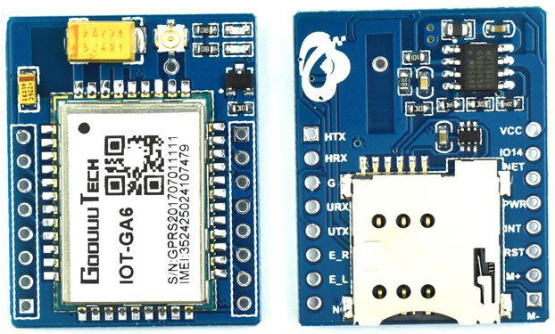
Figure 13.1: GA6 GSM module

Specification
- Supply voltage: 3.8V - 5V
- Recommended supply voltage: 5V
- Power consumption:
  - sleep mode < 2.0mA
  - idle mode < 7.0mA
  - GSM transmission (avg): 350 mA
  - GSM transmission (peek): 2000mA
- Module size: 25 x 23cm
- Interface: UART (max. 2.8V) and AT commands
- SIM card socket: microSIM (bottom side)
- Supported frequencies: Quad Band (850 / 950 / 1800 /1900 MHz)
- Antenna connector: IPX
- Status signaling: LED
Working temperature range: -40 do + 85 ° C

Conclusion
In this system we used some components to prepares it. Our system can be used in various countries, it is a secure system and low-cost system. Our component is very easy to buy our country market. So, we can use our project in daily life.

RESULTS AND DISCUSSIONS

Introduction
This project focuses more on the study case and the project development based on the RFID technology. The microcontroller will continually be working to receive the data from the RFID module via SPI communication protocol. It will process the data and cross check with the previously stored data. The data will be converted into displayed by the LCD. If the data matches and has balance on the card, it will allow the vehicle to pass otherwise not. The card numbers as being set on the source code. The methodology of the project divided in many steps taken so that entire the project. The methodology includes some step like planning, development of the design and the management of the project.

Experimental setup
In our project we will experiment all equipment part individually. The entire component we were connected according to the circuit diagram. At first the percentage of gas doesn’t show in the display when we change the program code then finally the show the percentage of gas on to the display.
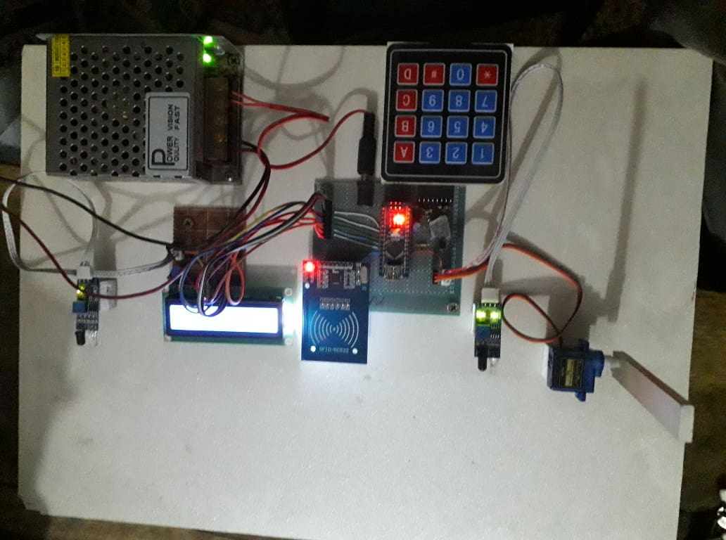
Figure 2.1: Display output of our system

Advantage
- Time saving – Electronic toll system users do not stop for paying toll, this helps a lot for saving the travel time
- Emission control — Due to the elimination of the acceleration and idling, harmful vehicular emissions are reduced. Though this benefit only affect the surrounding areas, even then it is highly beneficial for toll plaza areas. Hence, helps in air pollutant reduction.
- Increased Capacity — It is observed that the capacity of the lane also increases by approximately by three folds. The toll plaza would be able to accommodate the increasing traffic without additional lanes.
- Accident reduction —It is observed that there is reduction in the number of accident caused near the toll plazas due to considerable decrement in congestion around toll plazas.
- Fuel saving – In electronic toll collection system deceleration, acceleration and idling is completely eliminated. This helps in saving fuel for future purposes. Not only this, it also plays a vital role in reduction of operating cost of the vehicles.
- Enhanced cash handing – In electronic toll collection system there is no cash transaction involved so cash handling is reduced so difficulties with cash handling is eliminated. This aids in enhanced audit control by centralizing user accounts.
- Payment flexibility – In electronic toll collection system, the commuters do not have to worry about searching for cash for the toll payment. Since they set up an account for ETC usage, which gives customers the flexibility of paying their toll bill with cards.
- Congestion reduction — The toll transaction rate is highly increased due to the use of Toll Collection systems. Since the vehicles do not stop at the toll facility. This has reduced the congestion of the toll plaza in a considerable manner. The number of vehicles waiting in the queue reduces and hence the average waiting time is also reduced.
- Enhanced data collection — Information such as vehicle count of the day, date, time etc can be obtained due to the deployment of this electronic toll collection system.

Disadvantage
- Construction and design of this project is hard
- Program code is very long
- Take huge time to build the project

Result
In our project we get good output, it is the system that makes toll collection easy and effective. It helps to reduce traffic while collecting the toll. Electronic toll system users do not stop for paying toll, this helps a lot for saving the travel time. In electronic toll collection system deceleration, acceleration and idling is completely eliminated. This helps in saving fuel for future purposes. Not only this, it also plays a vital role in reduction of operating cost of the vehicles. Due to the elimination of the acceleration and idling, harmful vehicular emissions are reduced. Though this benefit only affect the surrounding areas, even then it is highly beneficial for toll plaza areas. Hence, helps in air pollutant reduction. It is observed that the capacity of the lane also increases by approximately by three folds. The toll plaza would be able to accommodate the increasing traffic without additional lanes. In electronic toll collection system, the commuters do not have to worry about searching for cash for the toll payment. Since they set up an account for ETC usage, which gives customers the flexibility of paying their toll bill with cards.

Summary
We test our project and it worked properly, firstly we use unit testing of the code section. we made each part and it test by unit testing. Afterwards we have complied development process of our whole project. Integration testing system that we tested. Each section when we test, we found some problems and we solve those problem as early. After than complete all procedure including testing, we are ensuring that now Electronic Toll collection system is like as our project which we can introduce in the market place and ready for commercial use.

CONCLUSIONS

Conclusions
In this research, a model that integrates all the quantifiable benefits for the ETC system based on the established assumptions has been developed. In addition, the effect of the number of ETC lanes on the total benefits has been analyzed. This offers some perspective into number of ETC lanes that need to be deployed in order to maximize the benefit. In addition, the benefit is estimated for the project life of the ETC. A model is developed to estimate the total benefits of the ETC system over the manual and automatic. The model helps in analyzing the time for the ETC deployment depending the benefits. The values for the benefits of the users are overestimated to an extent, as the model does not take into account the cost component for the user such as the cost of acquiring the transponder and the opportunity cost.

Limitations of the Work
During experiment our project we have faced some problem which is the IR sensor not working while it’s in the sun light. We need to use better sensor that works in most situation and environment. We have to update the servo system to run the big gate
In GSM communication module if the sim has no balance or SMS when the message doesn’t send in the responsible person. When we worked sometime display not working because it’s loose connection. Our program is not working until hardware and software pin doesn’t match.

Future Scopes of the Work
Some extensions that can be made to this research are as follows:
- Incorporate accidental benefits
- The model developed in the research models the user and the social benefits. Though
- these are the major benefits, incorporation of other benefits like the reduction in incidents
- at the toll plaza due to the ETC implementation would give a more comprehensive
- benefit model.
- Incorporate the value of the increased reliability due to the ETC system. The reliability of the travel time is increased due to the ETC deployment and it has an impact on the value of travel time. The estimation of this factor would give better estimate of the travel time savings.
- Study the effects of other delay models on the travel time and delay estimation Delay model used for this research was from the Highway Capacity Manual 2000. A model more specific to toll plaza would give better estimate for the waiting times at the manual and automatic lanes.
- Develop a dynamic system for ETC conversion In the current research, the number of ETC lanes and their time of implementation are decided based on the delays at the ETC lane and the value of the benefits. Thus an algorithm can be developed to decide upon the optimum number of ETC lanes as compared to the manual and automatic lanes and also take into account the lane type that needs to be converted in order to maximize the benefits and reduce the delays at the toll plaza.

REFERENCES
- Copeland, Larry, Toll roads take cashless route, USA Today, July 28, 2008.
- Kelly, Frank (2006). "Road Pricing: Addressing congestion, pollution and the financing of Britain's road". Ingenia. The Royal Academy of Engineering. 39: 36–42.
- Roth, Gabriel (2008). "Roads in a Market Economy". In Jordi, Philipp (ed.). Institutional Aspects of Directive 2004/52/EC on the Interoperability of Electronic Road Toll Systems in the Community. Europainstitut der Universität Basel.
- Change in ETC utilization rate -Ministry of Land, Infrastructure, Transport and Tourism(May 4, 2019)
- Jump up to:a b Poole Jr., Robert W. (November 6, 2007). "Life in the Slow Lane". The Wall Street Journal.
- European Parliament; European Council (April 29, 2004). "Directive 2004/52/EC of the European Parliament and of the Council of 29 April 2004 on the interoperability of electronic road toll systems in the Community". EUR-Lex. European Union. Retrieved March 8,2012.
  - European Parliament (April 30, 2004). "COD/2003/0081: Trans-European transport network: electronic road toll systems, widespread introduction and interoperability". European Union. Retrieved March 8, 2012.
- "Toll tags are made mandatory from 1 January 2015". Retrieved October 21, 2014.
- "Nåmåalletungekjøretøy ha bombrikke" (in Norwegian). Retrieved October 21, 2014.
- Vickrey, William (June 1992). "Principles of Efficient Congestion Pricing". Columbia University. Retrieved March 8, 2012.
- "Welcome to Salik". Roads and Transport Authority. Archived from the original on April 25, 2007. Retrieved March 8, 2012.
- Wærsted, Kristian (April 11–13, 2005). Urban Tolling in Norway—Practical Experiences, Social and Environmental Impacts and Plans for Future Systems. PIARC Seminar on Road Pricing with emphasis on Financing, Regulation and Equity. Cancun. Archived from the original on December 17, 2007. Retrieved March 8, 2012.
- Chin KianKeong (October 23–24, 2002). Road Pricing Singapore's Experience (PDF). Imprint-Europe Thematic Network: Implementing Reform on Transport Pricing: Constraints and solutions: learning from best practice. Brussels. Archived from the original (PDF) on April 10, 2008. Retrieved March 8, 2012.
- "Road Charging Scheme: Europe – Italy, Rome". Road User Charging Worldwide. UK Commission for Integrated Transport. June 21, 2006. Archived from the original on October 5, 2006.
- Staff. "Rome (Italy)". PRoGRESS Project. European Commission. Archived from the original on March 9, 2008. Retrieved March 8, 2012.

Appendix A
#include <deprecated.h>
#include <MFRC522.h>
#include <MFRC522Extended.h>
#include <require_cpp11.h>

#include <LiquidCrystal_I2C.h>
LiquidCrystal_I2C lcd(0x27, 16, 2); // set the LCD address to 0x27 for a 16 chars and 2 line display

#include <SoftwareSerial.h>
SoftwareSerial gsm (2, 3); //RX, TX

#include <Servo.h>

Servo entryGate;
Servo exitGate;

byte entryGatePos = 80;
byte exitGatePos = 130;

#define entrySen A6
#define exitSen A7

byte entrySenVal = 0;
byte exitSenVal = 0;

#define SS_PIN 8
#define RST_PIN 7

int card1Balance = 5000;
int card2Balance = 5000;
int card3Balance = 400;
int currentBal;

int bikeToll = 250;
int carToll = 400;
int truckToll = 500;

//int num;
//String number[3] = {"AT+CMGS=\"01723757028\"\r\n", "AT+CMGS=\"01911738055\"\r\n", "AT+CMGS=\"01738191041\"\r\n"};

String Alim = "AT+CMGS=\"01723757028\"\r\n";
String Rubel = "AT+CMGS=\"01911738055\"\r\n";
String Ole = "AT+CMGS=\"01799184043\"\r\n";
String number;

#include <Keypad.h>
const byte ROWS = 4; //four rows
const byte COLS = 3; //four columns

//define the cymbols on the buttons of the keypads
char hexaKeys[ROWS][COLS] = {
{'1', '2', '3'},
{'4', '5', '6'},
{'7', '8', '9'},
{'*', '0', '#'}
};

byte rowPins[ROWS] = {4, 5, 6, 17}; //connect to the row pinouts of the keypad
byte colPins[COLS] = {16, 15, 14}; //connect to the column pinouts of the keypad

//initialize an instance of class NewKeypad
Keypad customKeypad = Keypad( makeKeymap(hexaKeys), rowPins, colPins, ROWS, COLS);
char customKey, keypressed;

#define num 7
char Data[num];
byte data_count = 0;

String num1, num2, num3, card;

bool recharge = true;

byte totalCount = 0;
int totalToll = 0;
int rechBal = 0;
MFRC522 mfrc522(SS_PIN, RST_PIN);
bool state = false;
bool state2 = true;

Appendix B
void setup() {
Serial.begin(9600);
Serial.println(F("Getting Ready"));
entryGate.attach(10);
exitGate.attach(9);

entryGate.write(entryGatePos);
exitGate.write(exitGatePos);

gsm.begin(115200);
gsm.print("AT+CMGF=1\r\n");
delay(300);
gsm.print("AT+CNMI=2,2,0,0,0\r\n");
delay(200);
gsm.print("AT+CMGD=1\r\n"); // delete all SMS
delay(500);

SPI.begin();
mfrc522.PCD_Init();

lcd.init();
lcd.backlight();
lcd.setCursor(0, 0);
lcd.print(F("RFID Based Toll"));
lcd.setCursor(0, 1);
lcd.print(F("CollectionSystem"));
delay(3000);
lcd.clear();
lcd.setCursor(0, 0);
lcd.print(F(" Welcome!!!"));
delay(2000);
lcd.noBacklight();
lcd.clear();
Serial.println(F("System Ready"));
}

Appendix C
void loop() {
if (recharge == 0)
{
reCharge();
}

else
{
lcd.clear();
lcd.setCursor(0, 0);
lcd.print(F(" Welcome!!!"));
sensorRead();
KeyPad();
rfid();
if (entrySenVal <= 100)
{
entryGate.write(0);
lcd.backlight();
lcd.clear();
lcd.setCursor(0, 0);
lcd.print(F("Vehicle detected"));
delay(3000);
entryGate.write(80);
lcd.clear();
lcd.setCursor(0, 0);
lcd.print(F("Put your card to"));
lcd.setCursor(0, 1);
lcd.print(F("the reader......"));
delay(2000);
lcd.clear();
}
else if (exitSenVal <= 80)
{
if (state)
{
exitGate.write(0);
lcd.clear();
lcd.setCursor(0, 0);
lcd.print(F("Have a safe"));
lcd.setCursor(0, 1);
lcd.print(F("journey"));
delay(3000);
exitGate.write(130);
lcd.noBacklight();
lcd.clear();
state = false;
}
}

customKey = customKeypad.getKey();
if (customKey == '5')
{
exitGate.write(0);
delay(3000);
exitGate.write(130);
lcd.noBacklight();
}

if (customKey == '6')
{
entryGate.write(0);
delay(3000);
entryGate.write(80);
lcd.noBacklight();
}
}
}

void sensorRead()
{
entrySenVal = analogRead(entrySen);
exitSenVal = analogRead(exitSen);
}

void rfid()
{
if ( ! mfrc522.PICC_IsNewCardPresent())
{
return;
}
if ( ! mfrc522.PICC_ReadCardSerial())
{
return;
}

String content = "";
for (byte i = 0; i < mfrc522.uid.size; i++)
{
content.concat(String(mfrc522.uid.uidByte[i] < 0x10 ? " 0" : " "));
content.concat(String(mfrc522.uid.uidByte[i], HEX));
}
content.toUpperCase();
entrySenVal = analogRead(entrySen);
card = content.substring(1);
if (content.substring(1) == "71 56 4F 2E")
{
if (card1Balance >= 250)
{
totalCount++;
totalToll = totalToll + bikeToll;
card1Balance = card1Balance - bikeToll;
currentBal = card1Balance;
lcd.clear();
lcd.setCursor(0, 0);
lcd.print("Toll paid = ");
lcd.print(bikeToll);
lcd.setCursor(0, 1);
lcd.print("Balance = ");
lcd.print(card1Balance);
lcd.print("Tk");
delay(2000);
state = 1;
state2 = false;
number = Ole;
delay(100);
lcd.clear();
tollSMS();
return loop();
}
else
{
card = content.substring(1);
lcd.clear();
lcd.setCursor(0, 0);
lcd.print("Low Balance!");
lcd.setCursor(0, 1);
lcd.print(card1Balance);
lcd.print(" Tk");
delay(2000);
lcd.setCursor(0, 1);
lcd.print(F("Please Recharge"));
delay(2000);
lcd.clear();
state = 0;
state2 = false;
return loop();
}
}

else if (content.substring(1) == "E6 C9 4D 46")
{
if (card2Balance >= 400)
{
totalCount++;
totalToll = totalToll + carToll;
card2Balance = card2Balance - carToll;
currentBal = card2Balance;
lcd.clear();
lcd.setCursor(0, 0);
lcd.print("Toll paid = ");
lcd.print(carToll);
lcd.setCursor(0, 1);
lcd.print("Balance = ");
lcd.print(card2Balance);
lcd.print("Tk");
delay(2000);
state = 1;
state2 = false;
number = Rubel;
delay(100);
tollSMS();
lcd.clear();
return loop();
}
else
{
card = content.substring(1);
lcd.clear();
lcd.setCursor(0, 0);
lcd.print("Low Balance!");
lcd.setCursor(0, 1);
lcd.print(card2Balance);
lcd.print(" Tk");
delay(2000);
lcd.setCursor(0, 1);
lcd.print(F("Please Recharge"));
delay(2000);
lcd.clear();
state = 0;
state2 = false;
return loop();
}
}

else if (content.substring(1) == "BB 88 0F 2B")
{
if (card3Balance >= 500)
{
totalCount++;
totalToll = totalToll + truckToll;
card3Balance = card3Balance - truckToll;
currentBal = card3Balance;
lcd.clear();
lcd.setCursor(0, 0);
lcd.print("Toll paid = ");
lcd.print(truckToll);
lcd.setCursor(0, 1);
lcd.print("Balance = ");
lcd.print(card3Balance);
lcd.print("Tk");
delay(2000);
state = 1;
state2 = false;
number = Alim;
delay(100);
tollSMS();
lcd.clear();
return loop();
}
else
{
card = content.substring(1);
lcd.setCursor(9, 1);
lcd.print(card3Balance);
lcd.clear();
lcd.setCursor(0, 0);
lcd.print("Low Balance!");
lcd.setCursor(0, 1);
lcd.print(card3Balance);
lcd.print(" Tk");
delay(2000);
lcd.setCursor(0, 1);
lcd.print(F("Please Recharge"));
delay(2000);
lcd.clear();
state = 0;
state2 = false;
return loop();
}
}

else {
lcd.setCursor(0, 0);
lcd.print(F("Unknown Vehicle"));
lcd.setCursor(0, 1);
lcd.print(F("Access denied"));
delay(1500);
lcd.clear();
}
}

void KeyPad()
{
customKey = customKeypad.getKey();
Serial.print(customKey);
if (customKey == '*')
{
lcd.backlight();
lcd.clear();
lcd.setCursor(0, 0);
lcd.print(F("Recharging Mode."));
lcd.setCursor(0, 1);
lcd.print("................");
delay(1500);
lcd.clear();
recharge = 0;
return loop();
}

if (customKey == '#')
{
while (1)
{
lcd.backlight();
lcd.clear();
lcd.setCursor(0, 0);
lcd.print("Press # again");
delay(200);
customKey = customKeypad.getKey();
if (customKey == '#')
{
lcd.clear();
lcd.setCursor(0, 0);
lcd.print("Count: ");
lcd.print(totalCount);
lcd.setCursor(0, 1);
lcd.print("Toll: ");
lcd.print(totalToll);
tollInfo();
delay(3000);
lcd.noBacklight();
return loop();
}
}
}
}

void clearData()
{
while (data_count != 0)
{
Data[data_count--] = 0;
}
return;
}

void reCharge()
{
while (1)
{
lcd.setCursor(0, 0);
lcd.print (F("Enter the amount"));

customKey = customKeypad.getKey();
Serial.print(customKey);
if (customKey)
{
if (customKey == '#')
{
if (card == "71 56 4F 2E")
{
num1 = Data;
rechBal = num1.toInt();
card1Balance = num1.toInt() + card1Balance;
currentBal = card1Balance;
lcd.clear();
lcd.setCursor(0, 0);
lcd.print(F("Your current"));
lcd.setCursor(0, 1);
lcd.print(F("balance: "));
lcd.setCursor(9, 1);
lcd.print (card1Balance);
lcd.print(" Tk");
delay(3000);
clearData();
lcd.clear();
recharge = 1;
state2 = false;
number = Ole;
delay(100);
rechargeSMS();
return loop();
}

else if (card == "E6 C9 4D 46")
{
num2 = Data;
rechBal = num2.toInt();
card2Balance = num2.toInt() + card2Balance;
currentBal = card2Balance;
lcd.clear();
lcd.setCursor(0, 0);
lcd.print(F("Your current"));
lcd.setCursor(0, 1);
lcd.print(F("balance: "));
lcd.setCursor(9, 1);
lcd.print (card2Balance);
lcd.print(" Tk");
delay(3000);
clearData();
lcd.clear();
recharge = 1;
state2 = false;
number = Rubel;
delay(100);
rechargeSMS();
return loop();
}

else if (card == "BB 88 0F 2B")
{
num3 = Data;
rechBal = num3.toInt();
card3Balance = num3.toInt() + card3Balance;
currentBal = card3Balance;
lcd.clear();
lcd.setCursor(0, 0);
lcd.print(F("Your current"));
lcd.setCursor(0, 1);
lcd.print(F("balance: "));
lcd.setCursor(9, 1);
lcd.print (card3Balance);
lcd.print(" Tk");
delay(3000);
clearData();
lcd.clear();
recharge = 1;
state2 = false;
number = Alim;
delay(100);
rechargeSMS();
return loop();
}
}

if (customKey == '*')
{
clearData();
lcd.clear();
lcd.setCursor(0, 0);
lcd.print (F("Enter the amount"));
}

else
{
Data[data_count] = customKey;
lcd.setCursor(data_count, 1);
lcd.print(Data[data_count]);
data_count++;
}
}
}
}

void tollSMS()
{
Serial.println(F("Sending SMS..."));

//Set SMS format to ASCII
gsm.write("AT+CMGF=1\r\n");
delay(500);

//Send new SMS command and message number
// gsm.write("AT+CMGS=\"01732655924\"\r\n");
// delay(300);

gsm.print(number);
Serial.println(number);
delay(500);

//Send SMS content
gsm.write("Toll has been collected for your vehicle.\n");
delay(300);
gsm.write("Your current balance is: ");
delay(300);
gsm.print(currentBal);
delay(300);
gsm.print(" Taka\n");
delay(500);
gsm.write("Thank you! Safe journey.");

//Send Ctrl+Z / ESC to denote SMS message is complete
gsm.write((char)26);
delay(500);

Serial.println(F("SMS Sent!"));
}

void rechargeSMS()
{
Serial.println(F("Sending SMS..."));

//Set SMS format to ASCII
gsm.write("AT+CMGF=1\r\n");
delay(300);

//Send new SMS command and message number
// gsm.write("AT+CMGS=\"01XXXXXXXXX\"\r\n");
// delay(300);

gsm.print(number);
delay(300);

//Send SMS content
gsm.write("Your toll account has been successfully recharged by ");
delay(300);
gsm.write(rechBal);
delay(300);
gsm.print(" Taka\n");
delay(300);
gsm.write("Your current balance is: ");
delay(300);
gsm.print(currentBal);
delay(300);
gsm.print(" Taka\n");
delay(300);
gsm.write("Thank you! Safe journey.");

//Send Ctrl+Z / ESC to denote SMS message is complete
gsm.write((char)26);
delay(300);

Serial.println(F("SMS Sent!"));
}

void tollInfo()
{
Serial.println(F("Sending SMS..."));

//Set SMS format to ASCII
gsm.write("AT+CMGF=1\r\n");
delay(300);

//Send new SMS command and message number
gsm.write("AT+CMGS=\"01955529777\"\r\n");
delay(300);

//Send SMS content
gsm.write("Total vehicle count = ");
delay(300);
gsm.print(totalCount);
gsm.print("\n");
delay(300);
gsm.write("Total collected toll amount = ");
delay(300);
gsm.print(totalToll);
delay(300);
gsm.print(" Taka\n");
delay(300);

//Send Ctrl+Z / ESC to denote SMS message is complete
gsm.write((char)26);
delay(300);

Serial.println(F("SMS Sent!"));
}

