
An
Thesis Report
on
An Analysis of Credit Risk Management of
South Bangla Agriculture & Commercial Bank Limited.

Submitted by:
Name: Israfil Bhuiyan
ID: MBA2203027017
Program: MBA (Major in Accounting)
Semester: Spring-23

Submitted to:
Department of Business Administration
Sonargaon University (SU)

Submitted for the partial fulfillment of the degree of
Masters of Business Administration

Date of Submission: May 11, 2023

An
Thesis Report
on
An Analysis of Credit Risk Management of
South Bangla Agriculture & Commercial Bank Limited.
Supervised By:

Md. Shahbub Alam
Lecturer
Department of Business Administration
Sonargoan University

Submitted By:

Name: Israfil Bhuiyan
ID: MBA2203027017
Program: MBA (Major in Accounting)

Submitted for the partial fulfillment of the degree of
Master of Business Administration

Date of Submission: May 11, 2023

Letter of Transmittal

May 11, 2023

Md. Shahbub Alam
Lecturer
Department of Business Administration
Sonargaon University (SU)

Subject: Submission of Thesis Report.

Dear sir,
With humble honor and respect, I am submitting my Thesis report on “An Analysis of Credit Risk Management”. As per partial accomplishment of the requirements for the MBA degree, I have completed Thesis from “South Bangla Agriculture & Commercial Bank Limited” under the supervision of you.

This report is an integral part of our academic courses in completion of the MBA program which has given me the opportunity to have an insight into the Analysis of Credit Risk Management. I hope this report reflects on the contemporary issues on the Narshingdi that are being practiced by organizations in our country.

In completing the report I tried my best to blend all my knowledge and imparted every available detail and also attempted to avoid unnecessary amplification of the report.

I humbly request you to accept this report for your kind evaluation.

Sincerely,

___________________
Israfil Bhuiyan
ID: MBA2203027017
Department of Business Administration
Sonargaon University (SU)

Certificate of Supervisor
This is to certify that the thesis report “An Analysis of Credit Risk Management of South Bangla Agriculture & Commercial Bank Limited” has been prepared as a part of completion of the MBA program from Department of Business Administration, Sonargaon University (SU), carried out by Israfil Bhuiyan, bearing ID: MBA2203027017 under my supervision. The report or the information will not be used for any other purposes.
……………………………
Md. Shahbub Alam
Lecturer
Department of Business Administration
Sonargaon University (SU)

Student Declaration
I am Israfil Bhuiyan, a student of Master of Business Administration, ID: MBA2203027017 from Sonargaon University would like to solemnly declare here that this report on “An Analysis of Credit Risk Management of South Bangla Agriculture & Commercial Bank Limited” has been authentically prepared by me. While preparing this report, I didn’t breach any copyright act internationally. I am further declaring that, I did not submit this report anywhere for awarding any degree, diploma or certificate.
Sincerely Yours

-----------------------------
Israfil Bhuiyan
ID: MBA2203027017
Program: MBA
Major: Accounting
Semester: Spring-23

Letter of Authorization

Certified that this Thesis report titled “An Analysis of Credit Risk Management of South Bangla Agriculture & Commercial Bank Limited” is the bonafide work of Israfil Bhuiyan, who carried out the research under my supervision. Certified further that to the best of my knowledge the work reported herein does not form part of any other Thesis report or dissertation on the basis of which a degree or award was conferred on an earlier occasion on this or any other candidate.

…………………………
Md. Shahbub Alam
Lecturer
Department of Business Administration
Sonargaon University (SU)

ACKNOWLEDGEMENT

I wish to extend my gratitude to all the people who helped me accomplish my report title, “An Analysis of Credit Risk Management of South Bangla Agriculture & Commercial Bank Limited” at Narshingdi. At the very beginning, I want to thank my faculty advisor and Thesis supervisor in Sonargaon University (SU), Md. Md. Shahbub Alam Who has given me precious guidance from her busy schedule. I am very grateful for all her advice in order to make my report more effective.

Secondly, I am greatful to Mr. Shamim Ahammed, Branch Manager of South Bangla Agriculture & Commercial Bank Limited for being my Thesis supervisor. He has shown me how to get things done easily and helped me a lot. I am thankful to Mr. Mostafa Al Amin, Asst. Manager for granting my Thesis in his department. I want to express my sincere gratitude to Mr. Nirob Bhuiyan, Customer Relationship Officer for his cordial cooperation and encouragement.

EXECUTIVE SUMMARY
South Bangla Agriculture & Commercial Bank Limited is one of many private banks which are operating properly with abiding by all the rules being set by Bangladesh Bank. The whole bank is divided into many sub-committees who divides the whole work in different segments. At the top they have Directors and later they got different committees such as Credit Committee, Finance Committee etc. Along with the directors there is CEO/Managing Director who has centered all the works and kept a harmony in all departments for the betterment and efficiency of the bank.
The objective of this study is to gain information about the credit branch of South Bangla Agriculture & Commercial Bank Limited To set up this report both essential and optional wellsprings of information have been utilized.
The main segment of this report comprises of an initial part that has been created for the correct execution of the whole report. The subsequent segment portrays the organization profile including South Bangla Agriculture & Commercial Bank's set of experiences, their vision, mission and methodology, items and administrations, and operational organization organogram. Section three spotlight on the credit branch of SBAC. This is the primary piece of the task. It incorporates credit strategy, credit standards, and FICO score of SBAC. It additionally incorporates loaning models and loaning standards of SBAC. It additionally portrays in detail the methodology of endorsing credit, advance recuperation strategy, and execution, stepping observer, and other legitimate customs. It likewise depicts the credit hazard evaluating framework. The fourth part has clarified the working experience of my temporary position period at various divisions of SBAC. Discoveries and investigation of the data are in Part five of the report. It incorporates monetary information examination of SBAC. By utilizing 5 years of information here we assess the monetary exhibition of the SBAC credit division. The excess part comprised of suggestions and an end. At long last, I saw that South Bangla Agriculture & Commercial Bank Limited will guarantee better administrations to the individuals of Bangladesh and they will be more add to the improvement of the economy of Bangladesh.

Table of Contents
Letter of Transmittal i
Certificate of Supervisor……………………………………………………………………………………ii
Student’s Declaration...................................................................................................................................iii
Letter of Authorization iv
Acknowledgement v
Executive Summary vi
Chapter-1 9
1.1 Introduction 10
1.2 Origin of the Study 11
1.3 Objectives of the Study 11
1.4 Methodology of the Study 11
1.4.1 Primary Sources: 11
1.4.2 Secondary Sources: 11
1.5 Scop of the Study 12
1.6 Limitations of the Study 12
1.7 Literature Review 13
Chapter 2 14
2.1 Profile South Bangla Agriculture & Commercial Bank Limited 15
2.2 Vision of South Bangla Agriculture & Commercial Bank Limited 16
2.3 Mission of South Bangla Agriculture & Commercial Bank Limited 16
2.4 Objectives of South Bangla Agriculture & Commercial Bank Limited 16
2.5 Strategies of South Bangla Agriculture & Commercial Bank Limited 16
2.6 Products and services of South Bangla Agriculture & Commercial Bank Limited 17
2.7 Types of loan of what are offered by SBAC 18
2.8 Management Hierarchy of South Bangla Agriculture & Commercial Bank Limited 19
Chapter 3 20
3.1 Introduction 21
3.2 Credit Risk 21
3.3 Credit Risk Management System 21
3.4 Credit Principles of South Bangla Agriculture & Commercial Bank Limited 22
3.5 Credit Facilities of South Bangla Agriculture & Commercial Bank Limited 22
3.6 Lending Criteria of South Bangla Agriculture & Commercial Bank Limited 23
3.6.1Technical Viability 23
3.6.2 Commercial viability 23
3.6.3 Financial Viability 23
3.6.4 Economic Viability 23
3.7 Credit Evaluation Principles 23
3.8 Different Types of Credit Facilities by SBAC: 24
3.9 How South Bangla Agriculture & Commercial Bank Limited recover their Loan: 27
3.10 Problems in Loan Recovery 28
3.10.1 Problems created by economic environment 28
3.10.2 Problems created by government 28
3.10.3 Problems created by the bank 29
3.11 Overall Procedure for Sanctioning Loan 29
3.12 Computation of Credit Risk Grading 32
Chapter 4 36
4.1 Financial Data Analysis 37
4.1.1 Loan and Advance: 37
4.1.2 Loan to Deposit Ratio: 38
4.1.3 Standard Loan 39
4.1.4 Sub-standard Loan 40
4.1.5 Doubtful Loan 41
4.1.6 Bad/Loss Loan 42
4.1.7 Sector wise Distribution of Loan and advances: 43
4.2. Findings of the Study:.......................................................................................................................... 45
Chapter 5 46
5.1 Recommendations 47
5.2 Conclusion 48
References 49

Chapter-1
Introduction

Introduction
From an overall perspective, we signify "Bank" as a monetary organization that manages cash. There are various kinds of banks like Central bank, Commercial bank, Savings bank, Investment bank, Merchant bank, Co-employable bank, and so on. However, when we utilize the term bank it by and large methods a business bank that is one which is worried about tolerating store of cash from people in general, reimbursing on request or something else and withdraw able on request or something else, and utilizing the stores as credit and speculation to meet the monetary needs of business and different classes of society.
Recently, the banking area is modernizing and growing its hand on various monetary occasions each day. Simultaneously the financial cycle is getting quicker, simpler, and is getting more extensive. Thus, it has gotten basic for each individual to have some thoughts on the bank and banking technique.
These days, banks are giving the greatest chance to the business contemplates understudies to play out their temporary position in various branches I was likewise positioned in one of the famous banks named "South Bangla Agriculture & Commercial Bank Limited" The report essentially centers around the credit the executives exercise of South Bangla Agriculture & Commercial Bank Limited, particularly the Madhabdi Branch, Narshingdi in which I finished my temporary position. So as to keep the length of the detailing standard, I attempted to stay away from the normal and the well-established realities of the bank in a distinct manner.

1.2 Origin of The Study
This report has been produced to get the Master of Business Administration (MBA) degree from Sonargaon University and the essayist needs to experience as a temporary position at South Bangla Agriculture & Commercial Bank Limited working in Credit Risk Management.

1.3 Objectives of The Study
Broad Statement
The main objective of the study is to know the Credit Risk Management process of South Bangla Agriculture & Commercial Bank Limited
Specific Objectives
- To analyze various credit policies of South Bangla Agriculture & Commercial Bank Limited;
- To examine the credit appraisal procedures followed by South Bangla Agriculture & Commercial Bank Limited;
- To identify the problems related to credit management of South Bangla Agriculture & Commercial Bank Limited;
- To make some recommendations to solve those problems of South Bangla Agriculture & Commercial Bank Limited;

1.4 Methodology of the Study
Both Primary and Secondary information have been utilized in setting up this report. The subtleties of the wellsprings of information are as per the following:

1.4.1 Primary Sources:
- Practical work exposure with South Bangla Agriculture & Commercial Bank Limited
- Face to face conversation / Interview with the Bank Officials
- Observations

1.4.2 Secondary Sources:
- Annual Report of South Bangla Agriculture & Commercial Bank Limited
- Credit Operational Manual
- Training materials of the Bank
- Periodicals published by Bangladesh Bank
- Various books, journals, articles etc.
- Web Sites.

1.5 Scope of the Study
The study includes the financial management, hierarchical structure, credit offices, and credit hazard the board of South Bangla Agriculture & Commercial Bank Limited. This is the Thesis Paper using a loan hazard the executives of South Bangla Agriculture & Commercial Bank Limited.

1.6 Limitation of the Study
The genuine imperatives of this report are according to the accompanying:
- There was an absence of legitimate optional data for South Bangla Agriculture & Commercial Bank Limited and its items. Yearly reports, course of action rules, locales, and other related files don't cover full and sufficient information.
- Inside such a brief timeframe, it was unrealistic for me to examine everything about South Bangla Agriculture & Commercial Bank Limited.
- So as to monitor the mystery of the bank, the workers of South Bangla Agriculture & Commercial Bank Limited isn't intrigued to unveil some specific data required for this report.

1.7 Literature Review
Risk according to Athanasoglou et al (2005) is a situation occasioned by internal or external environmental factors that create hindrances in the way of achieving certain objectives of an entity. Modern banks operate in a highly dynamic environment that exposes them to varied risks ranging from liquidity, credit, foreign exchange to market vagaries; thus creating a source of threat towards survival and success. Al-Thamimi and Al Mazrooei (2007). Management of a bank therefore incorporates a trade-off between risks and returns especially its credit portfolio which constitutes a substantial income generating asset.
Traditionally, the five C‟s representing borrower‟s Characters, Capacity, Collateral and Conditions have been recommended in some literatures; Fatemi and Fooladi (2006), and Onyiriuba (2004). More than borrowers‟ attributes, the nature of bank credit delivery is often influenced by such operational antecedents as the state of the economy; market conditions or industrial dynamics that characterized borrowers‟ business and financial health. In the nineties when Nigerian banks operate in less dynamic environment, the use of „avoidance strategy‟ with preferences for self liquidating short term lending was common. Today, bank lending requires a more pragmatic approach involving identification, analysis and mitigation of damaging effects of credit risk exposures.
Apart from deposit – mobilization, lending is considered the most significant function of a commercial bank as loan asset created constitutes the highest income generating portfolio; Diamond (1984), Berger et al (2003) and Casu et al (2006). The role of lending to finance the deficit economic sector constitutes essential banks‟ efforts at ensuring shareholders‟ wealth maximization; but this is achieved at the expense of a risk – return trade – off. Almost every operational activities of a bank give rise to one form of risk ranging from interest, market, technology, concentration, reputational and other forms of risk with credit risk exposure occupying the center stage.
Above describe the centrality of the linkage between credit risk and other risks associated with banking operation.The ripple effects of a bank credit risk aggravates such operational risk like liquidity, concentration; market and reputational risks among others. Findings in some other studies have also identified systemic, international and national macroeconomic variables as well as un-systemic bank specific factors as determinants of credit risk, Demirguc-kunt (1989), Ariff and Marrisetti (2001), Cebenoyan and Strahan (2004) and Athanasoglou et al (2005).
More than systemic and macro-economic variables, bank specific factors such as the size of risky loan making up the credit portfolio; bank internal loan policy; pre-lending assessment of borrower and past audit analysis of financed project constitute significant factors that shape the quality of a bank credit portfolio; Ahmed (2003) and Ahmed and Ariff (2007). Other sources of credit risk highlighted in some studies include deficient loan appraisal process, inadequately defined lending policies, high credit concentration, poor credit analysis skill of bank officials, as well as a mismatch between credit monitoring system and external operating environment; (Bidani et al 2004, and Chen et al 2005).

Chapter 2
Organizational Overview

2.1 About South Bangla Agriculture & Commercial Bank Limited
South Bangla Agriculture & Commercial Bank Limited (SBAC) is a Banking Company enrolled under the Companies Act, 1994 of Bangladesh with its Head Office at present at BSC Tower, (5th - 16th Floor) 2-3 Rajuk Avenue, Motijheel, Dhaka-1000, Bangladesh. The Bank began its activity from 2013.
The Bank gives a wide range of help to exchange, trade, industry, and the general business of the nation. SBAC's accounts are likewise accessible for the business people to set up promising new pursuits. The bank was built up by a gathering of neighborhood business people who are all around rumored in the field of exchange, trade, industry, and business of the nation.
The Bank offers both regular and Islamic banking through assigned branches. The Bank is being overseen and worked by a gathering of profoundly taught and proficient group with enhanced involvement with money and banking. The Management of the bank continually centers around comprehension and envisioning clients' needs. Since the need of clients is changing step by step with the progressions of time, the bank tries its best to devise procedures and acquaint new items with adapt to the change. South Bangla Agriculture & Commercial Bank Limited has just accomplished enormous advancement since its start. The bank has just developed notoriety as one of value specialist organizations of the nation.
At present the Bank has continuous Online financial parts (of both Urban and Rural zones) network all through the nation having brilliant IT-spine. Other than customary conveyance focuses, the bank has ATMs of its own, imparting to other accomplice banks and consortium all through the nation.
The operation hour of the Bank is 10:00 A.M. To 6:00 P.M. from Sunday to Thursday with transaction hour from 10:00 A.M. to 4:00 P.M. The Bank remains closed on Friday, Saturday and government holidays.

2.2 Vision of South Bangla Agriculture & Commercial Bank Limited
To become a leading banking institution by playing a significant role in the development of the country.

2.3 Mission of South Bangla Agriculture & Commercial Bank Limited
The Bank is committed for satisfying diverse needs of its customers through an array of products at a competitive price by using appropriate technology and providing timely service so that a sustainable growth, reasonable return and contribution to the development of the country can be ensured with a motivated and professional work-force.

2.4 Objectives of South Bangla Agriculture & Commercial Bank Limited
- To acquire and keep up CAMEL Rating 'Solid'
- To set up relationship banking and improve administration quality through advancement of Strategic Marketing Plans.
- To stay probably the best bank in Bangladesh as far as productivity and resources quality.
- To present completely mechanized frameworks through incorporation of data innovation.
- To guarantee a satisfactory pace of degree of profitability.
- To keep hazard position at an adequate reach (counting any wobbly sheet hazard).
- To keep up satisfactory liquidity to meet developing commitments and responsibilities.
- To keep up a solid development of business with wanted picture.
- To keep up satisfactory control frameworks and straightforwardness in strategies.
- To create and hold a quality work-power through a compelling HR Management System.
- To guarantee ideal use of every accessible asset.
- To seek after a compelling arrangement of the executives by guaranteeing consistence to moral standards, straightforwardness and responsibility at all levels.

2.5 Strategies of South Bangla Agriculture & Commercial Bank Limited
- The strategies of SBAC are as follows:
- To manage and operate the Bank in the most efficient manner to enhance financial
- performance and to control cost of fund.
- To strive for customer satisfaction through quality control and delivery of timely services.
- To identify customers' credit and other banking needs and monitor their perception
- towards our performance in meeting those requirements.
- To review and update policies, procedures and practices to enhance the ability to extend
- better service to customers.
- To train and develop all employees and provide them adequate resources so that
- customers' needs can be reasonably addressed.
- To promote organizational effectiveness by openly communicating company plans,
- policies, practices and procedures to employees in a timely fashion.
- To cultivate a working environment that fosters positive motivation for improved
- performance.
- To diversify portfolio both in the retail and wholesale market.
- To increase direct contact with customers in order to cultivate a closer relationship
- between the bank and its customers

2.6 Products and services of South Bangla Agriculture & Commercial Bank Limited
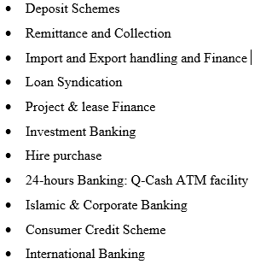
The Bank has an assortment of mode that readied budgetary items and administrations. Such items depend on Monthly Savings Schemes, Consumer Credit Schemes, Lease Finance and Personal Loan for Women and Shop Finance Scheme and so forth. South Bangla Agriculture & Commercial Bank Limited Ltd, additionally acquainted with Q-money ATM cards for its esteemed clients giving 24 hours banking administrations through Debit Cards. SBAC offers the accompanying administrations to esteemed client. The Bank is giving various sorts of administrations. Some of them are mentioned in below:

2.7 Types of loan of what are offered by SBAC

- Loan (General)
- House Building Loan (General
- House Building Loan (Staff)
- Other Loans to Staff
- Cash Credit (Hypo.)
- Cash Credit (Pledge)
- Corporate Social Responsibilities of the South Bangla Agriculture & Commercial Bank Limited
- Hire Purchase
- Lease Financing
- Time Loan
- Cons SOD (General)
- SOD (Others)
- SOD (Export)
- PAD
- LlM
- LTR
- IBP
- Export Cash Credit (ECC)
- Packing Credit (PC)
- FDBP
- IDBP
- FBP

2.8 Management Hierarchy of South Bangla Agriculture & Commercial Bank Limited












Chairman

Vice Chairman

Board of director
Managing director

Deputy Managing Director (DMD)

Executive Vice president (EVP)
Senior Vice president (SVP)
Vice President (VP)
Senior Assistant Vice President
Assistant Vice President (AVP)
Senior Executive officer (SEO)
Executive officer (EO)
Senior officer (SO)
Officer
Junior Officer

Figure 1 Organizational Hierarchy

Chapter 3
Credit Risk Management of
South Bangla Agriculture & Commercial Bank Limited

3.1 Introduction
Bank's fundamental work is to make a channel through storing cash from the excess unit and give financing to borrowers. In this manner, the need of the credit division in a bank happens. The credit office is a significant branch of a bank. The cash activated from extreme overflow units is distributed through this office to a definitive deficiency unit (borrower). The achievement of this division keeps an extraordinary impact on the benefit of a bank. Disappointment of this office may lead the bank to gigantic misfortunes or even insolvency. South Bangla Agriculture & Commercial Bank's credit division likewise attempts to carry out its responsibility impeccably.

3.2 Credit Risk
Credit hazard is the likelihood that a borrower will neglect to meet its commitment as per concurred terms. Credit hazard, accordingly, emerges from the Bank's dealings with or loaning to corporate, individual and different Banks or money related organizations. The technique that compose, control and rouse the borrowers will tail credit the executives.
Risk is characterized as the result of a peril, (for example, harm costs) and the likelihood that this risk happens. In other words, (probability) x (hazard) = risk. The first two values must be known or at least estimated in order to define risk.

3.3 Credit Risk Management System
South Bangla Agriculture & Commercial Bank Limited (SBAC) has set up a powerful credit hazard the board framework to proactively oversee advance portfolio so as to limit misfortunes. It has fundamentally improved danger the executive’s culture and set up standard for isolation of obligations and duties identifying with Credit Operation of the Bank. The significant advances taken by SBAC to actualize credit hazard the board rules are: The significant advances taken by SBAC to execute credit hazard the executives rules are:
- It has formulated its own Credit Policy Guidelines in line with the core risk guideline of Bangladesh Bank.
- The policy considers the sectorial concentration and specific industry exposure cap is set in the policy.
- Head Office Organizational structure has been segregated in line with CRM Guideline
- Borrower’s Risk Grade are assigned and mentioned in the credit proposal.
- Credit Approval Authority has been clearly defined in the policy.
- Strong monitoring of loan portfolio is ensured by separate Credit Monitoring Department.

3.4 Credit Principles of South Bangla Agriculture & Commercial Bank Limited
In the component, credit standards incorporate the overall rules of giving credit by the branch administrator or credit official. In South Bangla Agriculture & Commercial Bank Limited they follow the accompanying rule while giving advances and advance to the customer.
- Credit progression will zero in on the turn of events and improvement of client connections.
- All acknowledge expansion must go along for the prerequisites of Bank's Memorandum and Article of Association, Banking Company's Act, Bangladesh Bank's directions, different guidelines, and guidelines as revised every once in a while.
- Loans and advances will typically be financed from client's stores and not out of transitory assets or acquiring from different banks.
- The bank will give appropriate credit administrations to the business sectors in which it works. It ought to be given to those clients who can utilize them.
- Interest pace of different loaning classes will rely upon the degree of danger and kinds of security advertised.

3.5 Credit Facilities of South Bangla Agriculture & Commercial Bank Limited
The main focus of South Bangla Agriculture & Commercial Bank Limited is financing business, trade and industrial activities through an effective delivery system.
- South Bangla Agriculture & Commercial Bank Limited offers credit to practically all areas of business exercises having a profitable reason.
- The advance arrangement of the Bank incorporates a wide scope of credit programs.
- Credit offices are offered to people including housewives, finance managers, little and enormous business houses, dealers, makes, corporate bodies, and so forth.
- Prime clients appreciate prime rate in loaning and different administrations.
- Quick thankfulness, examination, choice, and payment are guaranteed.
- Credit offices are stretched out according to the rules of Bangladesh (Central Bank of Bangladesh) and operational methods of the Bank.

3.6 Lending Criteria of South Bangla Agriculture & Commercial Bank Limited
The business visionary must be trustworthy and equipped enough to run the proposed business. The undertaking ought to be reasonable from authoritative specialized, business, money related, and financial perspectives.

3.6.1Technical Viability
      - The project should be technically sound and environment-friendly.
      - Technology transfer in case of borrowed know-how ought to be ensured.
      - Building should be well planned and well-constructed.

3.6.2 Commercial viability
      - Market prospect and potential for the product has to be fully assured at competitive prices.
      - Marketing channel for the product should be accessible to the entrepreneur.

3.6.3 Financial Viability
      - There should be reasonable debt equity ratio as determined by the Bank on individual case basis.
      - Debt service coverage ratio should be at least 2.5 times at the optimum level of production.
      - IRR should preferably be not less than 20%

3.6.4 Economic Viability
The project should ensure benefit to the national economy and create sufficient employment opportunity and be environment friendly.

3.7 Credit Evaluation Principles
A few standards or guidelines of loaning are kept up in supporting advances so as to downplay acknowledge hazard level just as for fruitful financial business. The fundamental standards of loaning are given underneath
- Liquidity:
Liquidity implies the accessibility of bank assets without prior warning. The liquidity of a development implies it reimbursement on request on due date or after a short notification. In this manner, the banks must need to keep up adequate liquidity to reimburse its investors and tradeoff between the liquidity and benefit is must.
- Safety:
Wellbeing implies the affirmation of reimbursement of dispersed credits. Bank is ready to go to bring in cash, yet wellbeing ought to never be relinquished for gainfulness, to guarantee the security of advance. The borrower ought to be picked cautiously.
- Profitability:
Banking is a business targeting procuring a decent benefit. The distinction between the premium got on propels and the premium paid on store establishes a significant part of the bank salary, additionally, unfamiliar trade business is likewise exceptionally gainful. The bank won't go into an exchange except if a reasonable get back from it is guaranteed.
- Intent:
Banks endorse credits for profitable reason. No advances will be made by bank for useless purposes however the borrower might be liberated from all dangers.
- Security:
The security offered for a development is a protection to fall bank upon in instances of need. Security fills in as a wellbeing esteem for an unforeseen crisis. Since hazard factors are included, security inclusion must be taken before a loaning.
- National interest:
Banking industry has critical task to carry out in the monetary improvement of a nation. The bank would loan if the reason for the advances can offer more to the general financial improvement of the nation.

3.8 Different Types of Credit Facilities by SBAC:
Depending on the various nature of financing, all the lending activities have been brought under the following major heads:
Loan (General):
Short term, Medium term & Long-term loans allowed to individual/firm/industries for a specific purpose but for a definite period and generally repayable by installments fall under this head. This type of lending is mainly allowed to accommodate financing under the categories
  - Large & Medium Scale Industry and
  - Small & Cottage Industry.
  - Very often term financing for Agriculture & Others are also included here.
House Building Loan (General):
Credits permitted to singular/ventures for development of house (private or business) fall under this sort of advance. The sum is repayable by regularly scheduled payment inside a predefined period. Such advances are known as Loan (HBLGEN).
House Building Loan (Staff):
This loan is allowed only for Bank employees for purchase/construction of house shall be known as Staff Loan (HBL-STAFF).
Other Loans to Staff:
Loans allowed to employees other than for House Building shall be grouped under head - Staff Loan (Gen).
Cash Credit (Hypo.):
Advances permitted to singular/firm for exchanging just as discount reason or to businesses to get together the working capital prerequisites against hypothecation of products as essential security fall under this sort of loaning. It is a nonstop credit. It is permitted under the classes
- "Commercial Lending" when the customer is other than an industry and
- “Working Capital" when the customer is an industry.
Cash Credit (Pledge):
facilities to singular/firms for exchanging just as for entire deal or to enterprises as working capital against vow of products as essential security fall under this head of advance. It is likewise a ceaseless credit and like the above permitted under the classification
- "Commercial Lending" and
- "Working Capital".
Hire Purchase:
Recruit Purchase is a sort of portion credit under which the Hire-Purchaser consents to take the merchandise on enlist at an expressed rental, which is comprehensive of the reimbursement of Principal just as enthusiasm for modification of the advance inside a predefined period.
Lease Financing:
Lease Financing is one of the most helpful wellsprings of gaining capital apparatus and gear whereby a customer is allowed the chance to have an elite option to utilize a benefit ordinarily for a concurred timeframe against installment of lease. It is a term financing repayable by portion.
Time Loan:
This is one-time budgetary convenience for brief period most extreme a year to meet some particular reason. The credit is flexible inside the legitimacy and not sustainable and no exchange is permitted.
Consumers Credit Scheme:
It is an extraordinary credit plan of the Bank to fund acquisition of purchasers' strong to the fixed pay gathering to increase their expectation of living. The advances are permitted on delicate footing against individual assurance and store of determined level of value by the clients. The credit is repayable by regularly scheduled payment inside a fixed period.
SOD (General):
Advan1ces allowed to individual/firms against financial obligation (i.e. lien on FDR/PSP/ BSP/Insurance Policy/Share etc.). This may or may not be a continuous Credit.
SOD (Others):
Advances permitted against task of work request for execution of legally binding works falls under this head. This development is by and large taking into account a clear period and explicit reason for example it's anything but a ceaseless credit. It falls under the class "Others".

SOD (Export):
Advance considered buying unfamiliar money for installment against L/Cs (Back to Back) where the fares don't appear before the date of import installment. This is additionally a development for brief period which is known as fare money and falls under the classification "Business Lending".
PAD:
Installment made by the Bank against lodgment of transportation reports of products imported through L/C falls under this head. It is an interval advance associated with import and is by and large exchanged against installments normally made by the gathering for retirement of the reports for arrival of imported products from the tradition’s authority. It falls under the classification "Business Lending".
LlM:
Advances considered retirement of transportation archives and arrival of products imported through L/C assuming compelling responsibility for the merchandise by promise in god possesses under Bank's lock and key fall under this kind of advance. This is likewise a brief development associated with import which is known as post-import money and falls under the class "Business Lending".

3.9 How South Bangla Agricultural & Commercial Bank recovers their Loan:
When South Bangla Agriculture & Commercial Bank Limited sanctions credits and advances to its clients, they obviously express the reimbursement design in the advance understanding. Yet, some credit holders don't pay their credit in due period. The nationalized and private segment business banks need to confront such an issue. This circumstance is additionally found in South Bangla Agriculture & Commercial Bank Limited. To beat the issue of past due credit, the bank has taken specific advance recuperation programs. Recuperation Programs taken by South Bangla Agriculture & Commercial Bank Limited:
- Establishing credit management and checking cell in the bank
- Re-organizing the credit authorizing and disseminating strategy of the bank
- Sanctioning advances and advances against adequate protections as best as could reasonably be expected
- Giving more powers to the branch administrator in the credit the board dynamic cycle
- Offering a bundle of motivators to the sound borrowers
- Giving more accentuation on transient advances and advances
- Imposing limitations on credits and advances for wiped out businesses
- Taking legitimate activities rapidly against unsound borrowers as best as conceivable inside the period determined by the law of impediments

3.10 Problems in Loan Recovery
Though South Bangla Agriculture & Commercial Bank Limited is performing better in overseeing credit propels, still 12.39% of absolute advance and advances are arranged. There are a ton of purposes behind which the advance recuperation of the bank is still now deficient. Much of the time, issues might be raised from authorizing methods of advance, an examination of the venture, and examination of the credits, and so forth that is, the issue in advance recuperation demonstrates the results of the default cycle in advance dispensing. The primary reasons for helpless credit recuperation are arranged in four wide sorts as follow:

3.10.1 Problems created by economic environment
The following problems arise from the effect of economic environment:
  - Changing of management patterns may postpone the recuperation of mature credit
  - The banks sometimes sanction loan to the losing concern for further improvement of the respective sector, but in most cases, they fail to achieve progress.
  - There are numerous organizations which extend their business quickly, yet the development is for brief timeframe. Over the long haul, the measure of characterized credit increments.

3.10.2 Problems created by government
The following problems are arisen by the government:
- South Bangla Agriculture & Commercial Bank Limited has likewise confronted numerous issues in the advance recuperation measure as a piece of persistent weight from different intrigued gatherings
- Existing rules and guidelines are deficient to cover the lawful parts of advance recuperation. Accordingly, defaulters can get discharge effectively from all charges against them.
- Frequent changes in government strategies in regard to recovery of loan.

3.10.3 Problems created by the bank
The following problems are created by the banks:
- Before loaning, Sometime South Bangla Agriculture & Commercial Bank Limited neglects to appropriately dissect the business danger of the borrowers and the bank can't conjecture whether the business will succeed or fall flat. On the off chance that it neglects to run well, the advance gets ordered.
- In a few cases, bank neglects to decide the estimation of protection from the advance. Therefore, if the advance gets grouped, the bank can't recuperate its advance through the offer of home loan

3.11 Overall Procedure for Sanctioning Loan
The following procedure need to be followed for giving advances to the customer. These are:
- Party’s application
- Filling the form of profile of client
- Application to the Head Office of SBAC
- Collecting CIB report from Bangladesh Bank
- Processing loan proposal
- Project appraisal
- Head office approval
- Sanction letter
- Documentation
- Disbursement

Party’s application:
From the outset, the borrower needed to present an application to the individual branch for a credit, where he needs to obviously determine the explanation behind the advance. In the wake of accepting the application structure the borrower Bank official checks all the data cautiously. He additionally checks the record keeps up by the borrower with the Bank. On the off chance that the authority gets fulfilled, at that point he gives structure X (endorsed application type of Bank) to the forthcoming borrower.
Filling the form of profile of client:
After fulfilling with gathering's application, the candidate needs to top off the endorsed structure gives by the regarded branch that contains data of him. It contains-Name with its office area, Official location and phone number, subtleties of over a wide span of time business, its accomplishment and disappointments, sort of credit required and so forth.
Collecting CIB Report from Bangladesh Bank:
After receiving the application for advance, South Bangla Agriculture & Commercial Bank Limited sends a letter to Bangladesh Bank for acquiring a report from that point. This report is called CIB (Credit Information Bureau) report. South Bangla Agriculture & Commercial Bank Limited by and large looks for this report from the administrative center for a wide range of venture. The reason for this report is to be educated that whether the borrower has taken credit from some other Bank
Application to the Head Office of SBAC:
After being satisfied with the application given by the customer, then respected officer sends an application to the head office of the SBAC for the approval of the loan.
Processing loan Proposal:
After receiving CIB report from Bangladesh Bank, at that point individual branch readies an Investment proposition, which contains terms and states of Investment for endorsement of Head Office. Reports those are vital for sending Investment proposition are:
Necessary Documents:
- While propelling cash, banks make a great deal of archives, which are needed to be endorsed by the borrowers before the dispensing of the credit. Of them, some are in fact called charge reports. Fundamental advances and records:
- Loan application structure appropriately endorsed by the client.
- Acceptance of the term and states of authorization guidance.
- Trade permit.
- In Case of Partnership Firm, duplicate of enrolled association deed appropriately affirmed as a genuine duplicate or an organization deed on the non-legal stamp of taka-150 group properly Notarized.
- Demand promissory notes.
- Letter of hypothecation of stocks and products.
- Letter of hypothecation of books obligations and receivable.2
- Letter of hypothecation of plant and hardware.
- Personal letter of assurance.
Project Appraisal:
It is the pre-investment analysis. Project appraisal in the Banking sector is important for the following reasons:
- To achieve organizational goals
- To recommend if the project is not designed properly
- To justify the soundness of an investment
- To ensure repayment of Bank finance
Head Office Approval:
At the point when Head office get examination from the branch at that point, Head Office again evaluates the venture. In the event that it is by all accounts a feasible one, the HO sends it to the Board of Directors for the endorsement of the Investment. The Board of Directors (BOD) considers the proposition and takes choice whether to support the Investment or not. In the event that the BOD affirms the venture, the HO sends the endorsement to the concerned branch.
- Sanction Letter: After getting the approval of the HO the branch issues sanction letter to the borrower. A sanction letter contains:
- Name of borrower,
- Facility allowed,
- Purpose,
- Rate of interest,
- Period of the Investment and mode of adjustment,
- Security and Other terms and condition.
- Documentation: On the off chance that the borrower acknowledges the approval letter, the Documentation begins. Documentation is a composed explanation of actuality proving certain exchanges covering the lawful perspectives appropriately marked by the approved people having the lawful status. The most well-known reports utilized by the South Bangla Agriculture & Commercial Bank Limited for endorsing various types of Investment are:
- Joint Promissory Note,
- Letter of Arrangement,
- Letter of Disbursement,
- Letter of Installment,
- Letter of Continuity,
- Trust Receipt,
- Counter Guarantee,
- Stock Report,
- Letter of Lien,
- Status Report,
- Letter of Hypothecation,
- Letter of Guarantee
- Documents Relating to Mortgage.
- Disbursement: After sanction and completion of all customs the separate official dispenses the advance. The official composes check and gives it to the borrower. For this borrower needs to open a record through which he/she can pull back the cash.
Strategies for Recovery: Recovery of loan can be made in the following three methods:
  - Persuasive Recovery: The initial phase in recuperation technique is private correspondence that makes a psychological weight on borrower to reimburse the advance. In this circumstance bank can give some counsel to the borrower for reimbursing the advance.
  - Voluntarily: In this method, some steps are followed for recovering loan. These are:
    - Building Task Force
    - Arranging Seminar
    - Loan Rescheduling Policy
    - Waiver of Interest Rate
  - Legal Recovery: At the point when all means neglect to keep a record standard and the borrower doesn't pay the portions and premiums then the bank make essential legitimate strides against the borrower for acknowledgment of its levy. For this situation "Artha Rin Adalat Law 2003" assumes a significant part for gathering the credit.

3.12 Computation of Credit Risk Grading
To measure the actual risk related with the advance that will be paid by the bank to the specific customer, we need to follow a few stages and get a factual boundary of the danger. There are five stages follow the SBAC to figure credit hazard reviewing. Those are given and portrayed underneath:
Step 1: Identify all the Principal Risk Components
Credit risk for counterparty arises from an aggregation of the following:
- Financial Risk
- Business/Industry Risk
- Management Risk
- Security Risk
- Relationship Risk Each of the above-mentioned key risk areas require be evaluating and aggregating to arrive at an overall risk grading measure.
- Evaluation of Financial Risk:
Risk that counterparties will neglect to meet commitment because of monetary pain. This normally involves examination of financials for example examination of influence, liquidity, benefit and intrigue inclusion proportions. To finish up, this exploits the danger of high influence, helpless liquidity, low benefit and inadequate income.
- Evaluation of Business/Industry Risk:
Risk that unfriendly industry circumstance or ominous business condition will affect borrowers' ability to meet commitment. The assessment of this class of danger takes a gander at boundaries, for example, business viewpoint, size of business, industry development, market rivalry and hindrances to passage/exit. To close, this benefits from the danger of disappointment because of low piece of the pie and helpless industry development.
- Evaluation of Management Risk:
Risk that counterparties may default as a result of poor managerial ability including experience of the management, its succession plan and team work.
- Evaluation of Security Risk:
Risk that the bank might be exposed due to poor quality or strength of the security in case of default. This may entail strength of security & collateral, location of collateral and support.
- Evaluation of Relationship Risk:
These risk areas cover evaluation of limits utilization, account performance, conditions/covenants compliance by the borrower and deposit relationship.
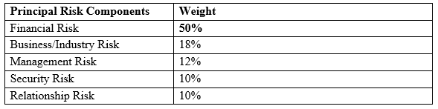
Step 2: Allocate weights to Principal Risk Components:

According to the importance of risk profile, the following weightings are proposed for corresponding principal risks.
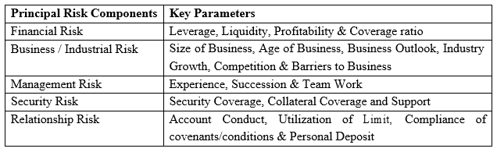
Step 3: Establish the Key Parameters:

Step 4: Assign weights to each of the key parameters:
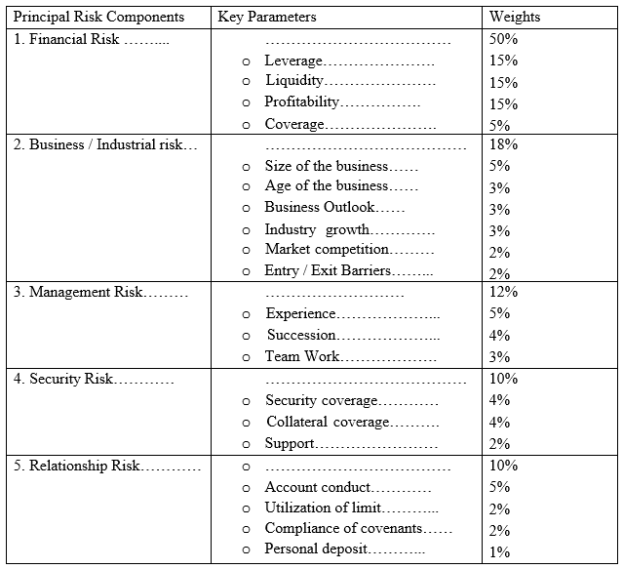

Step 5: Arrive at the Credit Risk Grading based on total score obtained:
The following is the proposed Credit Risk Grade matrix based on the total score obtained by an obligor
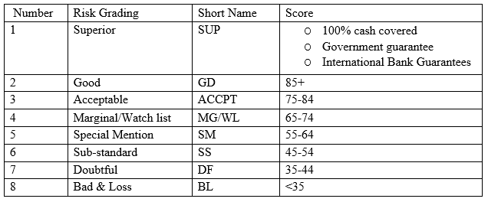

Chapter 4
Analysis & Findings

4.1 Financial Data Analysis
From past 5-year yearly report I have dissected some significant information related to credit activities of SBAC. The analyzed information is shown below by creating different chart graphs etc.:

4.1.1 Loan and Advance:
The genuine quality of an association is tried when it is capable react to the difficulties the earth hurls and transforms them into a preferred position. Regardless of the declining pattern of loan cost, interest for private part credit has remained generally low despite the fact that we have prevailing to proceed with the positive movement.
Year | Total Loan and Advance | Growth rate
2018 | 87,252,280,635
2019 | 117,099,608,428 | 25%
2020 | 142,252,940,000 | 18%
2021 | 165,402,850,000 | 14%
2022 | 177,278,780,000 | 7%

2018 2019 2020 2021 2022

Interpretation:
The total loan and advance of SBAC are increasing every year. In 2018 the total loan was TK. 87,252,280,635. It was increased to tk. 117,099,608,428 in 2019. In 2020 it was Tk. 142,252,940,000 and that is increased Tk. 177,278,780,000 in 2021 From the chart, it very well may be seen that complete credit and advances of SEBL are expanding a direct result of their alluring and adaptable advance bundles.

4.1.2 Loan to Deposit Ratio:
Loan to deposit ratio refers the liquidity of a bank by comparing a banks total loans to its total deposit at the same time periods. In the event that the proportion is excessively high, it implies that the bank might not have enough liquidity to cover any unexpected store prerequisites.
Year | Total Loan & Advances | Total Deposit | Loan to Deposit Ratio
2018 | 87,252,280,635 | 118,849,176,379 | 73.41%
2019 | 117,099,608,428 | 141,550,956,381 | 82.73%
2020 | 142,252,940,000 | 167,571,330,000 | 84.89%
2021 | 165,402,850,000 | 188,034,300,000 | 87.96%
2022 | 177,278,780,000 | 202,509,520,000 | 87.54%

2018 2019 2020 2021 2022

Interpretation:
Here we see that loan to deposit of SBAC are increasing every year. This is because of their attractive and flexible loan packages. In 2018 the total loan was TK. 87,252,280,635. It was increased to tk. 117,099,608,428 in 2019. In 2020 it was Tk. 142,252,940,000 and that is increased Tk. 177,278,780,000 in 2022. From the graph it can be seen that total loan to deposit of SEBL are increasing because of their attractive and flexible loan packages. SEBL’s deposit also increasing year by year.

4.1.3 Standard Loan
Standard loan is an unclassified loan. Such credit accounts are performing alluringly in the provisions of its segments and no past due is occurred.
Year | Total Loans and Advances (BDT) | Amount of Standard Loan (BDT) | Growth Rate | Ratio of Standard
2018 | 87,252,280,635 | 81,412,596,635 |  | 93.31%
2019 | 117,099,608,428 | 112,356,108,428 | 28% | 95.95%
2020 | 142,252,940,000 | 136,527,839,595 | 18% | 95.98%
2021 | 165,402,850,000 | 159,171,726,110 | 14% | 96.23%
2022 | 177,278,780,000 | 170,719,319,727 | 7% | 96.30%

2018 2019 2020 2021 2022

Interpretation:
Above the bar charts showing that standard loan of SBAC between 2018 to 2022. In 2018 their standard loan amount was 81,412,596,635 which ratios of standard is 93.31% and the next years it is growing than the last years which was ratio rate is 95.95%. And the couple of three years its slightly increasing of 2019 to 2022.

4.1.4 Sub-standard Loan
Sub Standard is a classified loan.
Year | Total Loans and Advances (BDT) | Amount of Sub-standard Loan (BDT) | Growth Rate | Ratio of Sub-standard
2018 | 87,252,280,635 | 1,637,902,000 |  | 1.88%
2019 | 117,099,608,428 | 135,100,000 | -1112% | 0.12%
2020 | 142,252,940,000 | 320,703,000 | 58% | 0.23%
2021 | 165,402,850,000 | 167,779,000 | -91% | 0.10%
2022 | 177,278,780,000 | 320,892,000 | 48% | 0.18%

2018 2019 2020 2021 2022
Interpretation:
From the above table it is identified that in 2020 their substandard loan growth rate is 58% which is higher than others year but unfortunately in 2021 their growth rate is gone to be decreases the rate is (-91%) which is very unlucky to the South Bangla Agriculture & Commercial Bank Limited so the last years of 2022 are respectably growth rate is increases where the rate is 48%.

4.1.5 Doubtful Loan
This plan contains where question exists on the full recovery of the credit and advance close by a disaster is anticipated anyway can't be quantifiable at this stage. The past due season of such a credit is 271-360 days. Such a development is an instance of described development.
Year | Total Loans and Advances (BDT) | Amount of Sub-Doubtful Loan (BDT) | Growth Rate | Percentage of Doubtful Loan in Total Loans
2018 | 87,252,280,635 | 580,184,000 |  | 0.66%
2019 | 117,099,608,428 | 185,600,000 | -213% | 0.16%
2020 | 142,252,940,000 | 294,990,000 | 37% | 0.21%
2021 | 165,402,850,000 | 498,639,000 | 41% | 0.30%
2022 | 177,278,780,000 | 418,265,000 | -19% | 0.24%

2018 2019 2020 2021 2022
Interpretation:
From the chart it shows the doubtful loan of SBAC in 2018 their doubtful loan growth rate was -213% which is much lower than the other years and the next years of 2019 their growth rate is 37% and 2020 it increased to 41% but last and final years of 2022 their growth gone to decreases which is -19%.

4.1.6 Bad/Loss Loan
Bad/Loss Loan is a specific credit and advance fall in this class when it appears to be that this advance and advance isn't collectible or useless even after all the security has been depleted. This sort of advance isn't recovered inside more than 360 days. Such credit is another instance of orchestrated development.
Year | Total Loans and Advances (BDT) | Amount of Bad/Loss Loan (BDT) | Growth Rate | Percentage of Bad/Loss Loan in Total Loans and Advances
2018 | 87,252,280,635 | 3,621,598,000 |  | 4.15%
2019 | 117,099,608,428 | 4,422,800,000 | 18% | 3.78%
2020 | 142,252,940,000 | 5,109,406,000 | 13% | 3.59%
2021 | 165,402,850,000 | 5,564,706,000 | 8% | 3.36%
2022 | 177,278,780,000 | 5,820,302,000 | 4% | 3.28%
2018 2019 2020 2021 2022
Interpretation:
From the above graph it represents that the overall Bad/loss Loan and its growth rate was fluctuating. In 2019 it was 18% and in 2018 it was 13%. So, the average growth rate of bad/loss loan is satisfactory. In 2022 the amount of Bad/loss loan is not much increased. So, it was good for the bank.

4.1.7 Sector wise Distribution of Loan and advances:
Figure in Crore Taka

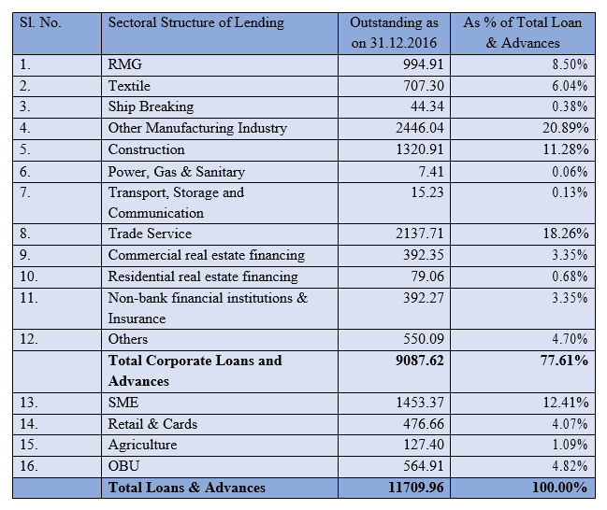


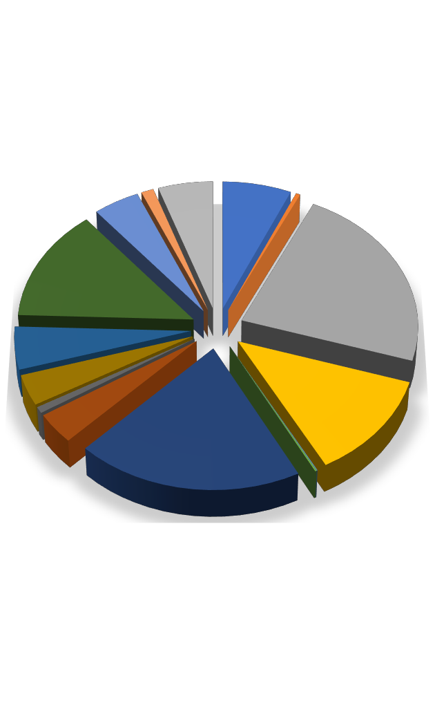













Textile

Ship Breaking
4%
1%
0%
Other Manufacturing Industry
5% 7%
Construction
14%
23%
Power, Gas & Sanitary
5%
Transport, Storage and
Communication
Trade Service
12%
4%
Commercial real estate financing
1%
4%
20%
Residential real estate financing
0%
0%
Non-bank financial institutions &
Insurance Others
SME
Retail & Cards Agriculture OBU

Interpretation:
The graphical presentation above reflects that SBAC maintained a balanced approach in lending to different industrial sectors and enjoyed a fair share of the business of RMG and Textile industry. SBAC’s exposure to RMG & Textile Industry stood at 14.54% of total loan portfolio. Loans in Manufacturing Industry dominated the total loan portfolio of SBAC, which stood at 20.89% and loans in Trade Service stood at 18.26% of total loan outstanding.

4.2 Findings of the Study
By analyzing the credit risk management practices of South Bangla Agriculture & Commercial Bank Limited and their performance in last five years the following:
- The SBAC bank's loan and advance were increasing gradually which was 177,278,780,000 in 2022 were much more than the previous four years.
- Though the SBAC bank loan to deposit was also increasing year by year and the ratio was 73.41% in 2018 is the lowest in five years.
- The standard loan was 96.30% in 2020. Where 2021 it was 96.23% standard loan. It should be 70% -75%.
- The sub-standard loan ratio also fluctuating. In 2018 to 2019 it was decreased 1.88% to 0.12%. But in 2020 it increased 0.12% to 0.23% after that it was again decreased.
- The proportion of doubt full loan is fluctuating. In 2018 it was highest than other years but in 2019 it was the lowest which was 0.16%.
- The bad loan of SBAC also increasing year by year. In 20221 was much more than other four years.

Chapter 5
Recommendations and Conclusions

5.1 Recommendations
To improve credit risk management further, South Bangla Agriculture & Commercial Bank Limited should improve in some areas. Those are:
- Need to expand the store of credit proportion. SBAC bank needs to make community who will unsurpassed screen the credit chance administration framework.
- Need to elevate their movement to make mindfulness in individuals of the bank. It tends to energize the general population for taking advance.
- Standard advance proportion SBAC bank ought to present and enhance data arrangement and should screen that the guidelines of credit the executives are entirely pursued
- For diminishing sub-standard advance SBAC bank can grow more redone parameters for credit endorsement process under the general rule of Bangladesh bank.
- For enhancing the dicey credit's execution and stable business condition securities must be esteemed appropriately.
- To decrease the terrible and misfortune credit, SBAC bank ought to make weight on to the customer for opportune reimbursement and make the essential legitimate move against the obstinate advance defaulter. It ought to be in the legitimate way.

5.2 Conclusion
South Bangla Agriculture & Commercial Bank Limited Ltd. is a business bank that dispatched its activity in 2013. It has just evolved altruism among its demographic by offering its phenomenal administrations by various divisions. This achievement has come about because of the devotion, responsibility, and dynamic initiative among its administration over the periods. The working climate of South Bangla Agriculture & Commercial Bank Limited is animating. During the limited capacity to focus season of its activity, the bank has been effective to situate itself as a reformist and dynamic monetary foundation in the nation.
Credit strategy is an advantageous financial apparatus for the business world. The estimation of this administration is tremendous. It has accumulated such a situation in the financial area that individuals at created and furthermore creating districts are a lot of subject to this administration. In Bangladesh, credit offices or advances began to turn out to be exceptionally appealing in ongoing periods. Yet, loads of enhancements in administrations and offices must be made in this office.
Credit Division of South Bangla Agriculture & Commercial Bank Limited has a certified and committed gathering of officials and staffs who are continually attempting to offer the best assistance to the customers. They generally screen credit in various areas and their position. Prior to giving the credit, they investigate whether the advance will be beneficial and whether the customer is sufficient to reimburse the advance inside the given timeframe.
The principle upper hand SBAC is appreciating that it has web based banking while other nearby business banks can't yet accomplish that advantage. However, all the business banks are currently attempting to accomplish this. In this bank, the representatives are exceptionally energetic by their compensations and different advantages. Here, all the workers are a lot of helpful with their clients, partners, and essentially guests.

References
- Chowdhury, L.R., A Textbook on Bankers Advances, 2nd Edition, Fair Corporation, Dhaka.
- Rose, P.S., Commercial Bank Management, 5th Edition, McGraw –Hill, New York, USA,2002.
- Bangladesh Bank, Managing Core Risk in Banking: Credit Risk Management, Dhaka, 2013.
- Bangladesh Bank, Credit Risk Grading Manual, Dhaka, 2012.
- South Bangla Agriculture & Commercial Bank Limited, Credit Operational Manual, Dhaka, 2012.
- South Bangla Agriculture & Commercial Bank Limited, Synopsis of Workshop on Documentation and Legal Aspects in
- Loan Sanction & Disbursements held at Bank’s Training Institute, 2012.
- Karim, Md. Enayetul, the Weekly Industry, Vol-146, Issue-44, July 2, Dhaka, 2013.
- Website: http:// www.jamunabankbd.com), accessed on December 9, 2014.
- Website: (http:// www.bangladeshbank.org), accessed on December 13, 2014.
- Basel II Accord, (from http://en.wikipedia.org/wiki/Basel_II), accessed November 23,2014.
- Published Document & Banking manual
- Credit Division Manual of SBAC
- Several Booklets from South Bangla Agriculture & Commercial Bank Limited
- Other Thesis reports of SBAC

