Chapter 1

INTRODUCTION

1.1 Introduction
Digital security is an all-encompassing term which includes the tools you can use to secure your indentify, assists and technology in the online and mobile world. These tools you can use to protect your identity include anti-virus software, web services, and biometrics and secure personal devices you carry with you every day.
The new law keeps provisions of up to 14 years in jail and Taka 10 million fine for offences like hacking, espionage in digital or electronic form as well as for ‘propaganda’ against the Liberation War and the Father of the Nation. In case of ‘hurting religious sensitivities’, offenders will face up to 10 years in jail and Taka 20 million in fine. Now a day’s very Controversial ICT Act’s Section 57 which is a threat to the freedom of expression that is the reason to choose this topic.
Rights activists and journalists have been critical of section 57 of ICT from the very beginning, and the debate over the provision and demand for its repeal intensified following the arrest of journalist Probir Sikdar in 2015. The senior journalist was arrested under the ICT Act for one of his face-book posts. Experts say the section goes against people's right to freedom of expression and free speech and it contains vague wordings, allowing its misuse against newsmen and social media users. Journalists took to the street last year after more than two dozen journalists were sued under the section. The Editors' Council in July demanded the government fully repeal section 57 and refrain from taking any initiative to re-introduce similar provisions in any new law. Amid widespread criticisms, Law Minister Anisul Huq on several occasions said section 57 would be removed and the Digital Security Act was in the pipeline. In 2016, the government took initiative to enact the law to ensure national digital security and prevent rising digital crimes.
1.2 Scope of the study:
Information Minister Hasanul Haq Inu has said the Digital Security Act was not formulated for the media, but for those who commit cyber crimes using digital instrument.“The act was formulated to control cyber crimes, not for the media. So there is nothing to fear,” he said while inaugurating the 3rd national conference of Bangladesh Nari Sangbadik Kendro at the Press Institute of Bangladesh in Dhaka on Sunday. Inu said children and women are the victims of cyber crime.
There will be no discrimination.” In the conference women leaders presented 13 demands including at least 30% of women journalists should be appointed in all media departments, arrangement of training for women journalists, equal opportunity to participate in the national and international training, promotion, forming a special committee in all media outlets to resolve any complaints and action if any discrimination occurs.

1.3 Objective of the study:
The objectives of this project paper are as follows:
- To analysis the Digital Security Act 2018.
- To give an overview of Digital Security Act 2018.
- To focus on the Digital Security Act 2018

1.4 Methodology of the study:
Throughout the report I presented historical background of the flow Digital Security Act 2018 and to get insight about the possible changes in the coming years. The United States shares the concerns of the international community that the recently passed Digital Security Act (DSA) could be used to suppress and criminalize free speech, all to the detriment of Bangladesh’s democracy, development and prosperity. We welcome Information Minister Inu’s offer to meet with media representatives to discuss their concerns about the DSA. We encourage the Government of Bangladesh to consider changes to the law that would bring it into conformity with the Bangladesh Constitution and with Bangladesh’s international commitments on human, civil and political rights. The analysis of the report is supported by some theoretical arguments that enhance the overall findings and guide towards a reasonable recommendation.
To complete my report I have gathered only secondary data.
Secondary Sources:
- Reports
- Articles
- Internet
- Bulletin
- BOI archive
- Books
- World Development Indicators

1.5 Limitations of the study:
Furthermore, Sections 25(a) and 31 contained vague descriptions of offences, and were lacking sufficient precision to make clear what speech would violate the law. This increases the likelihood of self-censorship, it added.
Meanwhile, HRW also said Sections 29 and 28, while more specific than the equivalent provisions of the ICT Act, were still not in line with international norms. Defamation as identified in Section 29 should be a civil offence, not criminal, and Section 28’s prohibition on speech that hurts someone’s religious feelings, reinforced by criminal penalties, cannot be justified as a necessary and proportionate restriction on speech, according to HRW.
“The passage of this law utterly undermines any claim that the government of Bangladesh respects freedom of speech,” Adams said. “Unless parliament moves swiftly to repeal the law it just passed, the rights of the country’s citizens to speak freely will remain under serious threat.”

1.6 Definition
The Digital Security Act, 2018 is a digital security law in Bangladesh. This act was passed with the aim of preventing the spread of racism; sectarianism; extremism; terrorist propaganda; and hatred against religious or ethnic minorities through social media, print media or any other electronic media. Any content over the internet or any other media that was deemed pornographic or otherwise inappropriate by the government could be punished by fines or prison terms of various lengths. As people of various sectors have different opinions about the act, hence it is deemed as controversial law.
The bill got through by voice vote amid opposition from a number of jatiya party lawmakers. The journalists and human rights activists have expressed worries over the law, saying it was passed without addressing their concern. They also said the act goes against the main spirit of constitution and will restrict free thinking, freedom of speech, freedom of expression as well as independent journalism.
Chapter 2

ICT ACT’S SECTION 57 MORPHING INTO DIGITAL SECURITY ACT 2018

The government has cleared the Digital Security Act, which incorporates issues addressed in the controversial Section 57 of the ICT Act in an elaborated way. The new law keeps provisions of up to 14 years in jail and Taka 10 million fine for offences like hacking, espionage in digital or electronic form as well as for ‘propaganda’ against the Liberation War and the Father of the Nation. In case of ‘hurting religious sensitivities’, offenders will face up to 10 years in jail and Taka 20 million in fine. The weekly cabinet meeting chaired by Prime Minister Sheikh Hasina has given the green light to the draft of the ‘Digital Security Act 2018’
This now awaits Parliament’s nod. It would render sections 54, 55, 56, 57 and 66 of the ICT Act defunct, Cabinet Secretary Md Shafiul Alam told the media at a briefing at the Secretariat afterwards. The proposed Act clarifies offences and their respective penalties. “Cyber crime is on the rise. Several government agencies, including the Bangladesh Bank, has been attacked and we do not have a law to combat it,” Shafiul said explaining the necessity for the law. The proposed law covers all forms of cyber crime, he said, and it has the provision of a Digital Security Council headed by the prime minister.

2.1 Detailed Section 57 in New Law
The ICT Act’s Section 57 criminalizes ‘publication of fake, obscene or defaming information in electronic form’. An offence under this provision of the Act is punishable by at least seven years to a maximum 14 years’ imprisonment. Fine can be as high as Taka 10 million. It has drawn criticism for effectively muzzling the freedom of speech and expression. Rights activists and journalists have termed it ‘draconian’ saying the law-enforcing agencies can misuse it.Law Minister Anisul Huq had said the ‘confusion’ around the issue would be cleared once Section 57 is removed from the ICT Act and the Digital Security Act is drafted. The new law will address the issues ‘in detail’, says Cabinet Secretary Shafiul. “Section 57 was concise. The new law stipulates penalties for different type of offences. It also details how investigations will be conducted.”Rights activists and journalists have termed Section 57 ‘draconian’ saying the law-enforcing agencies can misuse it. File photo The ICT Act was created in 2006 and revised twice in 2009 and 2013. The latest revision increased the maximum jail sentence from 10 years to 14 years and made offences under Section 57 non-bail able. The proposed Digital Security Act, however, keeps provisions of both bail able and non-bail able offences depending on the gravity of the charges, according to Shafiul. Asked whether espionage charges can be brought against journalists under the new law, he replied, “Not at all … journalists have not been targeted (in the law).”
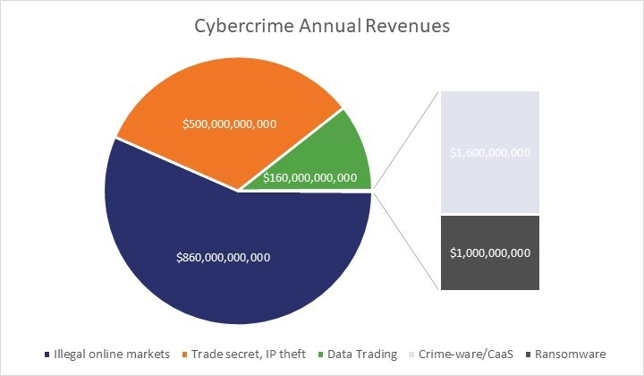

2.2 Offences and Punishments
- Unauthorized access or hacking into important data infrastructure up to 7 years in jail or Taka 2.5 million in fine or both.
- Destroying or manipulating important data infrastructure by hacking up to 14 years in jail or Taka 10 million in fine or both.
- Unauthorized access of computers or digital devices up to 1 year in jail or Taka 300,000 in fine or both.
- Aiding or abetting to illegally accessing computers or digital devices up to 3 years in jail or Taka 1 million in fine or both.
- Illegally obtaining, copying or transferring data from computers or computer system up to 7 years in jail or Taka 1 million in fine or both.
- Destroying or changing source code up to 3 years in jail or Taka 300,000 in fine or both.
- Propaganda against the 1971 Liberation War and Bangabandhu Sheikh Mujibur Rahman in digital or electronic form up to 14 years in jail or Taka 10 million in fine or both.
- Blocking access or illegally accessing into computer and internet network as well as aiding such efforts in to threaten the state’s sovereignty, security or to create a panic among the public will be counted as cyber terrorism and will cause up to 14 years in jail or Taka 10 million in fine or both.
- Posting contents on the internet or disseminate in digital form hurting religious sensitivities up to 10 years in jail or Taka 2 million in fine or both;
- Libelous offences in line with the penal code through website or in electronic form up to 3 years in jail or Taka 0.5 million in fine or both,
- Posting contents on the internet or circulate in digital form creating communal rift and hatred or disrupting communal harmony or fuelling unrest up to 10 years in jail or Taka 2 million in fine or both.

2.3 Related Section on Defamation under Digital Security Bill
On the Information and Communication technology Act 2006 defamation was attach with the computer or electric device hacking ,under section 57, now, in proposed digital security Act section 57 divides into 4 different sections. Section 32 is for illegal access on electronic device, section 29 if a parson publishes information with intent to defame someone, he will be charged with 3 years in jail or taka 5 lakh fine or both, reading with the penal code section 499 and 500.Repead of the offence will be charge with5 years imprisonment or 10 lack fine or both. Section 21 subject to against the liberation war statement or Bongobondhu, then charge with14 years imprisonment or 1 core fine or both, repeat of offence will be charge life time imprisonment or 3 core fine or both. Section 31, intentionally using digital media for fake news, the law stipulates 7 years imprisonment or taka 5 lakh fine or both. Extraterritorial effect is include in section 4 also. Defamation religious sentiment, public security, now a days become part of open concern to the mass people. It is sensitive also. So that in proposed digital security Act especially present in specific section. Internet opens the door of free speech, thought, conscience and expressions. Globally free speech practice increase day by day as well as hate speech also. Bangladesh is not different regarding this situation.
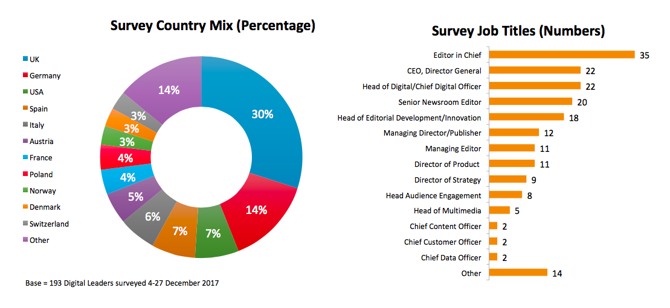

Chapter 3
LEGAL FRAMEWORK RELATING TO CYBER LAW OF BANGLADESH

3.1 Development of Cyber Law in Bangladesh
Law, acts, rules and regulations relating to the freedom of expression in Bangladesh can be categorized as follows the British colonial rule press laws and regulations (1799-1947) Pakistan rule (1947-71), and laws enacted after Pakistan laws and independence of Bangladesh (1971- ). Both the British and regulations were meant to suppress and control the press and freedom of expression. Newspaper is important media of freedom of expression. In Special Powers Act, 1974, there was provision for cancellation of newspaper. General Ershad abuses it.
In 1991, president Shahab Uddin repelled the Special Powers Act section 17,18, 19 .On that year, added section 99A in Criminal Procedure.BNP in 2006 place those repelled section from Special Powers Act to the Information and Communication Technology Act 2006, as a name of section 57.In 2013 present government, amend Information and communication Technology act 2006.They create the provision more strict. Information and Communication Technology Act is criticized for 5 sections, now present government adjusts that questionable section on the proposed Digital Security Act. Which are applying only for online publications.
1974.1991, 2006, 2013, moreover 2018,(bill of Digital Security Act),it is clear that, Press publication and online publication has much more differences to,
- Application their rights.
- Police or other security force search the offensive news, block them or remove them.
- Arrest without warrant.

3.2 Relating Provisions in Different Laws in Bangladesh
In Bangladesh, cyber laws are existing in different part of different laws. All of the laws indicate same perspective. They are written below

3.2.1 Constitutional Safeguard as a Fundamental Right
Under its Article 39, the constitution of Bangladesh guarantees the freedom of thought and conscience, and of speech. Recognizing it as a constitutional right, the Article’s Section 2 says the right is guaranteed subject to any reasonable restrictions imposed by law in the interests of the security of the State, friendly relations with foreign states, public order, decency or morality, or in relation to contempt of court, defamation or incitement to an offence. Although the constitution provides for freedom of expression subject to “reasonable restrictions,” the press can be constrained by national security legislation as well as sedition and criminal libel laws. The punishment for sedition ranges from three years to life in prison. The 15th amendment to the constitution includes language that equates criticism of the constitution with sedition.

3.2.2 Criminal Litigation
Against freedom of thought, opinion and expression is incorporated in section, 505(b) of Bangladesh Penal Code 1860, forbids any report or statement against the state ,the punishment for which is imprisonment for 7 years or a fine or both . Section 505A of the Bangladesh Penal Code 1860, According to section 99A of the Criminal Procedure. The government can forfeit any publication if constitutes defamation of the president, prime minister, or speaker of parliament. According to section 124A. A person can be punished with imprisonment for 3 years or fined, and as a highest punishment life time imprisonment. If they express dissatisfaction denotes disloyalty and the feeling of enmity, as explained in the provision. This is an undemocratic obstacle to people’s freedom of expression.

3.2.3 Other Laws
The most draconian of the laws against the free flow of information in Bangladesh is the Official secrets Act 1923.This bars public servants from providing secret government plans, documents, notes, sketches, models, signals, information etc. related to restricted places and which, if made public, could pose a threat to the security of the state.

3.3 Draft of the National Online Mass Media Policy 2017
The cabinet approved the draft of the National Online Mass Media Policy, 2017 incorporating a proposal for setting up a National Broadcast Commission to facilitate the operation of online mass media in a well-organized manner. The new draft policy contained detailed guidelines for smooth running of online mass media, including radio, TV and newspapers. Each mass media outlet would have to be registered with the National Broadcast Commission. However, online media outlets already registered under the Press and Publications Act, 1973 would not require re-registration. "The authorities concerned of the online media will have to inform the commission about their previous registration, The Commission will be empowered to frame the guidelines for issuing licenses to broadcasters.
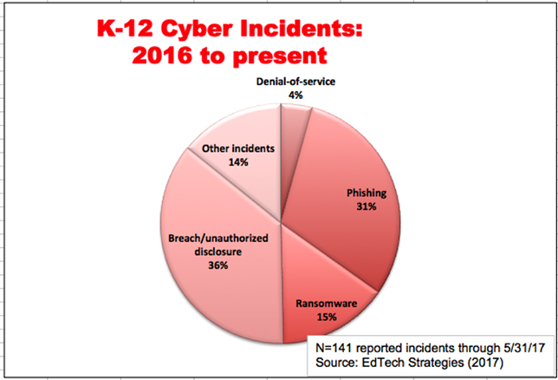
The commission will also make recommendations to the government for giving licenses to television, radio, internet TV or other digital broadcast stations and it will issue licenses upon the government's approval. Commission would issue show cause notice, initiate investigation, recommended the government for further proceedings against online media outlets if they broadcast something in violation of the National Broadcast Policy, 2014. The commission would be able to take action against online media outlets if they violated the code of conduct and breached discipline. The commission will also be given the authority to take measures against any online media outlet if any of its contents pose a threat to security, territorial integrity, peace, public order and unity of the country; if it is vulgar, false and malicious or if it is against the spirit of the Liberation War and distorts national history.

3.4 Necessity of the Law
Meaning of Cyber Law; the term Cyber Law derived from its generic term called Cybernetics, which means that this sector of law tend to resolves issues, and legal consequences that are raised in the Internet. And what makes Cyber Law in Bangladesh even a legal factor, honestly speaking, everything does. With time and generation the virtual world is becoming more familiar than reality, however, even than check and balances for the crimes committed in the virtual world can only be resolved through a practical commission of natural judicial process. This in turn needs assistance from Cyber Law.

Chapter 4
FEATURE OF PROPOSED DIGITAL SECURITY BILL 2018

4.1 Proposed Digital Security Bill 2018
The Digital Security Bill, 2018, aiming to deal with cybercrimes, including hurting the religious sentiment, negative propaganda against the liberation war and Bangabandhu, and illegal activities in e-transactions and spreading defamatory data, Posts, telecommunications and information technology minister Mustafa Jabbar placed the bill in the house. Many crimes mentioned in the proposed law have been made cognizable and no salable offences. In the proposed bill, digital, database and critical information infrastructure have been defined. The government of Bangladesh recently approved a Digital Security Bill which has now been sent to parliament for its review and ultimately adoption. An Analysis by CLD shows that the Bill fails in several important ways to respect international guarantees of freedom of expression. This is despite the fact that a lot of criticism has already been directed at provisions in Bangladeshi laws which restrict freedom of expression online.
Section 21 of the proposed law says anyone spreading negative propaganda against the Liberation War or the Father of the Nation, using digital devices or instigates to do so, will risk being sentenced up to 14 years in jail or a fine of up to Taka 1 crore or both. He or she will face up to life sentence or Taka 3 crore in fine or both for committing the offence for the second time, it said. Section 25 says a person may face up to three years in jail or Taka 3 lakh in fine or both if he or she is found to have deliberately published or broadcast in a website or electronic form -- something which is attacking or intimidating or which can make someone dishonest or disgruntled; knowingly publish or broadcast false and distorted (full or partial) information to annoy or humiliate someone; knowingly publish or broadcast false and distorted (full or partial) information to tarnish the image of the state or to spread rumor.
A person will face up to five years in jail or Tk 10 lakh or both for committing the offence for the second time, it said.Section 28 says a person may face up to seven years in jail or Tk 10 lakh in fine or both if he or she is found to have deliberately published or broadcast something in the website or in electronic form or get it done to hurt one's religious sentiment and values.A person will face up to 10 years in jail or Tk 20 lakh or both for committing the offence for the second time, it said.
Section 29 says a person may face maximum three years in jail or Tk 5 lakh in fine or both if he or she commits offence stipulated in section 499 of the Penal Code through website or in electronic form.He or she will face up to five years in jail or Tk 10 lakh in fine or both for committing the offence for the second time, it said.Section 31 says a person may face up to seven years in jail or Tk 5 lakh in fine or both if he or she is found to have deliberately published or broadcast something in the website or in electronic form which can spread hatred and create enmity among different groups and communities and can cause deterioration of law and order.
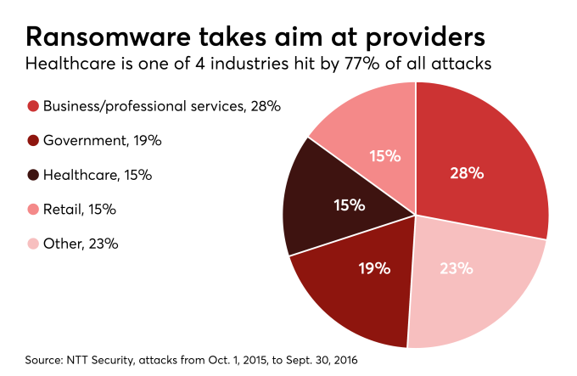

4.2 Some Other Provisions
According to the proposed law, the government will form a Digital Security Agency to ensure national digital security and combating cybercrimes. A director general will lead the body. To discuss the overall digital security of the country and to take “nationally important decision” over the issue, there will be a National Digital Security Council headed by the prime minister, the draft law reads. The government, through a gazette notification, will declare some specific. Computer systems, networks and information infrastructures, as “Essential Information Infrastructures” to serve the purpose of the proposed act.

4.3 No Need for Arrest Warrant
As per section 43 of the draft law, a police official can search or arrest anyone without any warrant issued by a court. If a police officer believes that an offence under the proposed law has been committed in a certain place or is being committed, or there is a possibility of crimes, or there is a possibility of destroying evidence, he or she can search the place or any person present there.

4.2 Questionable Sections and Requirements in Proposed Digital Security Bill 2018
The Digital Security Bill, 2018, was placed in parliament on April 9 amid growing concerns from journalists and rights activists. Highlighting the need for a law within growing concerns over the country's rapidly effective information technology sector, journalists, authors and rights activists said that if the proposed digital security bill was passed with its current content, it will severely curtail freedom of the press and expression.
The Editors' Council, an organization of editors of the country's national dailies, the Association of Television Channel Owners (ATCO) and the Bangladesh Federal Union of Journalists (BFUJ) faction voiced concern over the section 8, 21, 25, 28, 29, 31, 32, and 43 of the proposed law, saying these would greatly hamper the freedom of speech and independent journalism. The bill was placed in the House on April 9 and it was sent to the standing committee to place its report after scrutiny within four weeks. The Parliamentary Standing Committee on Post, Telecom and ICT, the representatives of the three organizations had the meeting with the committee and voiced their deep concern over the proposed law in 4 July 2018, The law minister told reporters that he would recommend that the standing committee bring necessary amendments to the proposed law. The minister also assured of clearing vagueness in different sections of the proposed law, especially in defining the spirit of the 1971 Liberation War, and the actions to be considered as offences of hurting religious sentiment, and causing deterioration in law and order.

4.4 Case Analysis
In Bangladesh, an aggrieved person can send a rejoinder or legal notice to a newspaper, lodge complaints with the Press Council or even file a defamation case under the Penal Code. But the recent trend is that cases are being filed against journalists under section 57, apparently to ensure immediate harassment of the accused, as one can be arrested under this law even before investigation.
At least 21 journalists were sued under section 57 of the Information and Communication Technology Act in the last four months amid growing demand for repeal of the provision which is wide open to misuse. Though the law minister on several occasions said the section would be scrapped, cases filed against journalists under the provision are on the rise with their leaders as well as rights activists terming it a tool to muzzle the press and freedom of expression.

4.5 Causes of Filling Cases
Most of the cases are filed for Defamation against Prime minister, Defamation Against lawful Government, defamation, hurting religious sentiment causing deterioration of law and order harming the established government reputation etc. but it is true that there is no specific definition of this matter on the previous Act or proposed Act. And more chances to abuse those terms.
In 2015, against journalist Probir Shikder at first file case and arrested under section 57.afterthat it is introduce as a tool of harassment from different classes of state people. Prabir Shikdar was the first journalist victim of this law. He went to police station to file a general diary (GD) alleging that an influential minister and two of his associates were threatening him.As the police did not receive the GD, he posted the copy of the GD on face book. The police, later, picked him up from his house and sued him.In the face of widespread criticism, he was granted bail after spending a day in police custody for quizzing. In 2016, 35 cases was filed, under section 57In 2017, June 13, A senior assistant judge filed a case against a journalist for produce false, fabricating and defamatory statement, in Manikgonj.

4.5.1 Who are Filling Cases?
In Favor of Prime Minister
In favor of Prime Minister Most of the cases was filed by the Party member of Bangladesh Awamilegue.
In Favor of Parliament Member
In favor of Parliament member filed case, there follower, In November 2016, a case was filed against a journalist , by Shoieb Choudhury, in Hobigonj. With Section 57, he was arrested in 4 cases. Editor and publisher of the local daily ‘Habiganj Samachar’ Golam Mostafa returned home on 26 after spending 18 days in jail. He was sued for publishing a news item titled ‘MP Abdul Majid Khan won’t be nominated for next national polls’.
Personal enmity
In personal enmity there are various cases was filed, Unauthorized using the electronic media defamation statement, hurting religious sentiment is increase day by day. Which are highly punishable offence.

Religious Sentiment
There are huge cases where religious sentiment is connected. Aggrieved person filed case against it.
Some Leading Case on Section 57
“Cota Sonskar Andolon” taking new way of suffering under secton 57, Which is started from 19 march, 2018, A Dhaka court placed Bangladesh Sadharon Chhatra Odhikar Songrokhon Parishad joint convener Muhammad Rashed Khan on a five-day remand in custody in a case filed under section 57 of the ICT act. In the case document, the BCL leader alleged that in a Facebook live at 8 08 pm on 27 June, Rashed Khan delivered a speech based on false information. He also accused him of defamation and creating sabotage. He alleged that some of the comments are clearly defamatory for the prime minister.
BCL leader Nahian said that after listening to the Facebook live, he felt that the speech was delivered to defame prime minister and so he filed the case.
“Nirapod sorok cai andolon” According to Dhaka Metropolitan Police’s media and public relations department, 42 people including the 22 private university students have so far been arrested on charges of vandalism, arson, attack on police and spreading rumors.
Nine people including internationally-renowned photographer Shahidul Alam and actress Quazi Nawshaba Ahmed were arrested under the Information and Communication Technology (ICT) Act. Law enforcers on Wednesday arrested Yousuf Chowdhury, 40, chief executive officer (CEO) of the online news portal Zoom Bangla and BUET student Daiyan Alam, 22, on charges of spreading rumours.
BUET’s mechanical engineering department student Daiyan has been arrested in a case filed under the Information Communication Technology (ICT) Act. Speaking to Prothom Alo, one of Daiyan’s intimate friends said nobody could realise what was really happening in Dhanmondi-Jhigatola areas on 4 and 5 August. And that sparked off the rumors. At that time his friend uploaded a post on his Face-book. He wrote no incident of deaths happened there, no girl student went missing. He mainly tried to stop rumors. Later a top leader of BUET unit of Chhatra League shared the post. Daiyan is innocent. However, he was in favor of the student protest demanding safe roads. He used the photograph of a poster as his profile picture on Face-book and so was arrested. During investigations, it was found that those who were arrested were the ones who took to the streets or uploaded statements demanding safe roads. They were accused after some of their statements were proved to be false. Now in 16 august 2018, total 51 cases was filed and 97 person arrested for false rumor in online electric media.
Hurt religious sentiment Brahman aria’s Rasraj Das is one of the victims of this section. He was arrested on charge of hurting religious sentiment on 29 October last year. A rumor in this regard triggered attack on the Hindu minority and vandalism of their houses. Later, the police Bureau of Investigation investigated the incident and conducted forensic test on handset, memory card, and SIM card over spreading the rumor on Facebook.
The probe team found no evidence that Rasraj committed any offence. However, Rasraj had to spend three months in jail.Upon getting bail, Rasraj returned to his occupation -- fishing -- but the incident still haunts him. Speaking to Prothom Alo on Tuesday Rasraj Das said, “I just can sign my name. I used to catch fishes with my brother at Balinga Bill (a water body). I have no knowledge of facebook.”

4.6 Freedom of Thought vs. Barrier
Although article 39 of the Constitution of the People’s Republic of Bangladesh ensures the freedom of thought, conscience and of speech in Bangladesh, the media activists and journalists of Bangladesh have been subject to continuous intimidation, harassment, attacks and arrests since her independence in 1971. In recent years the killing of journalists and free-thinkers has grown in an alarming rate. The religious terrorist groups are mostly responsible for these killings. On the other hand, Govt. agencies and Govt. made laws also creates harassment and sufferings for the journalists and media activists. The totalitarian and authoritarian role of the Governments has suppressed the Constitutional guarantee of freedom of thought, conscience and of speech. The Government has enacted various enactments in recent years hindering the fundamental rights of the citizens. Moreover, it is evident that these laws are being used to suppress the critics of the Govt. Observing the situation freedom of thought expression and conscience is converted as barrier to us.

4.7 Institution of Cyber Cases in the Tribunals
Speaking on the dynamic nature of cybercrime FBI Director Louis Freeh has said, ‘In short, even though we have markedly improve our capabilities to fight cyber intrusions the problem growing even faster and we are falling further behind’.The de-creativity of human mind cannot be checked by any law. Thus the only way out is the liberal constitution while applying the statutory provisions to cybercrime cases. In Bangladesh Cyber law is so strict. Digital Security Bill uphold it. The following shall be treated as crime, being unauthorized copying, extracting and downloading of any data, database, introduction of virus, Damage and disruption to computer system and computer network,
Denial of access to authorized person to computer, Providing assistance to make possible to commit to crime, Hacking with computer system, Tampering computer source documents, Electronic forgery for the purpose of cheating and harming reputation, Using a forged Electronic record, Publication of digital signature certificate for fraudulent purpose, Confiscation of computer, network etc., Publication of information which is obscene in electronic form Misrepresentation and suppressing material facts for obtaining digital signature certificate, Breach of confidentiality and privacy, Publishing false digital signature certificate. Such a judge appointed will be introduced as “judge” of Cyber Tribunal for the Whole Bangladesh. As we have only one Cyber Tribunal which is situated in Dhaka Judge Court and runs with the matter relating to ICT Act of the whole Bangladesh. From time to time it will be increased more. This court runs with the offences which are committed by the Act. This Special Tribunal may sit and continue its procedure on a place at a certain time and government will dictate all this by its order. According to Section 69 (1) of ICT Act, the special tribunal will not take any case for trial unless there is a written report by any Police Officer not under the rank of Sub – Inspector and Approval of the Controller or such person having the authority from the controller for the purpose. This Tribunal shall for the purpose of trial will follow Chapter 23 Trial by Court of Session under the Code of Criminal Procedure, trial in session court. If the Accused person is missing or hiding himself for which it is not possible to arrest him or there is less possibility to arrest him earlier, in that case the tribunal; by its order may ask that person to present in the court by publishing in two prominent Bangle Newspaper at a prescribed time and if that person fails to do so, the trial will held with his absent. When the Accused person having bail, after being present before the tribunal, if he is missing or if he fails to present in front of the tribunal; in that case sub-section 4 of 69 will not be applicable.

4.8 Different Types of Cases Increase Day By Day Complicacy in Dispose of Suit
Now in 16 august 2018 only nirapod sorrok andolon, total 51 cases was filed and 97 person arrested for false rumor in online electric media. The resent Act including cyber stalking, cyber harassment, cyber nuisance and cyber defamation only, in future new forms of cyber-crime will emerge which need to be taken care of. Therefore India should sign the cyber-crime convention.

4.9 Role of media and NGO
All NGO has a documentation team that keeps the organization updated with social rights abuses published in the major national dailies. The work of the documentation unit is to gather and document relevant information for investigation purposes from both the daily papers and personal and organizational sources contacts, including social rights defenders. These are included in annual human rights reports and monthly reports of human rights violations, which are distributed to the media for publication and to other NGOs. Most cyber-crimes are of general nature and they target men and women alike. But there are certain cyber-crimes that are more likely to target women than their male counterparts. Women especially the young girls who have been newly introduced to the internet are comparatively inexperienced in cyber world, and consequently they are most susceptible to falling into the bait of cyber criminals and bullies. Go can work for awareness of people.
In 2016,

The Centre for Law and Democracy is a non-profit human rights organization working internationally to provide legal expertise on foundational rights for democracy. Given some recommendation
Recommendations are
- Section 38 should be amended to provide simply that service providers are not responsible for content as long as they have not intervened in the content or been ordered by a court to remove it. At a minimum, the burden should rest on the party bringing a criminal prosecution against a service provider to show that they were aware of the offence.
- Sections 22-24 should be removed. The provisions on forgery, fraud and fraudulent impersonation in the Penal Code should be reviewed and, if they fail to cover the commission of these crimes online, they should be amended to address that lacunae.
- Sections 17(1) (a) and 18(1) (a) should either be removed (with the types of harm in section 18(1) (b) being expanded) or have intent and harm requirements added.
- Section 32 should be limited in scope to those who are under a primary obligation to respect government confidentiality (i.e. normally officials) and those who directly, illegally and intentionally access it, and it should also include a public interest override to protect whistleblowers.
- An intent requirement should be added to section 33 and it should include protection for whistleblowers.
- Section 34(a) should be removed and an intent requirement should be added to section 34(b).
- Section 19 should apply only where the person does not own the computer in question or have lawful access to it. Section 19(1) (a) should be removed, section 19(1)(e) should be limited in scope along the lines suggested above and consideration should be given to the purpose of section 19(1)(f) and whether or not it is needed.
- Section 20 should be limited in scope to cases where the person does not have lawful access to the computer and where the action causes harm or damage of some sort.
- Consideration should be given to whether section 26 belongs in the Bill at all and, if it is retained, a requirement of intent should be added.
- A clear intent requirement should be added to section 27. Consideration should be given to whether section 27(1) (c) should be included in the Bill. Section 27(1) (d) should either be removed or fundamentally revised so that it focuses on illegitimate activities which should in fact be prohibited. Section 30(1) (a) should be removed.
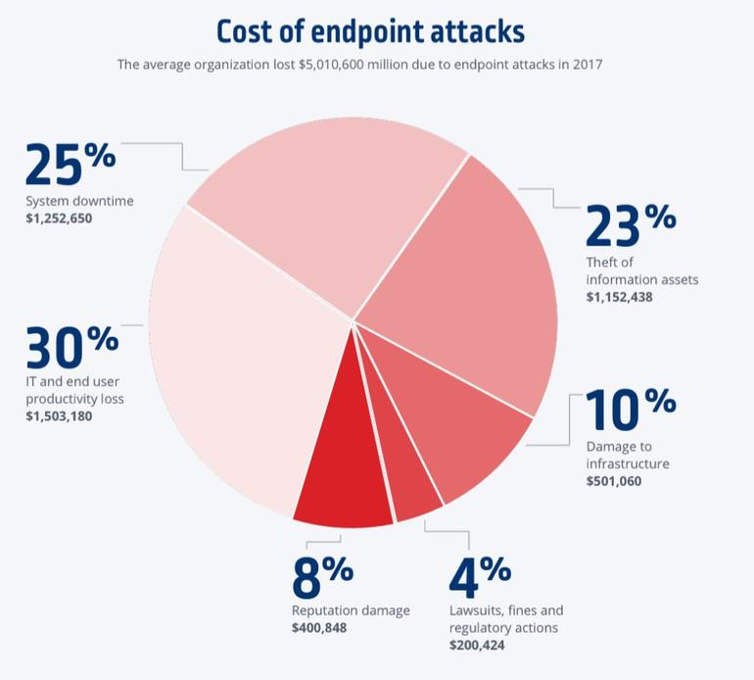
4.10 Lack of Coordination
Monitoring sale is necessary for preventing abuse of media or electric media although, Cyber Law Bangladesh Perspective There are some Cyber-crime prevention agencies like The Bangladesh Telecommunication Regulatory Commission (BTRC). Bangladesh Computer Security Incident Response Team (BDCERT) have been set up for the purpose of curbing cybercrimes Bangladesh has also set up various specialized cybercrime police stations. Cyber incident response unit and ‘a cyber-crime investigation cell’ & ‘IT Crime Forensic Lab’ are set up by the Bangladesh police to fight against cyber-crime or crime related with computer and other IT technology. Chapter Eight of the ICT Act creates a Cyber Tribunal & Cyber Appellate Tribunal to adjudicate of cybercrimes. Cyber Law Bangladesh Perspective There are some Cybercrime prevention agencies like The Bangladesh Telecommunication Regulatory Commission (BTRC), Bangladesh Computer Security Incident Response Team (BDCERT) have been set up for the purpose of curbing cybercrimes. Bangladesh has also set up various specialized cybercrime police stations. Cyber incident response unit and ‘a cyber-crime investigation cell’ & ‘IT Crime Forensic Lab’ are set up by the Bangladesh police to fight against cyber-crime or crime related with computer and other IT technology. But there is no monitoring and coordination agency .So it face challenges to implement accountable remedy to fulfilling the obligation of proposed Digital Security Act.

4.11 Inconsistency of Knowledge
The challenge is most of the cases are going unreported, because the is lace of awareness, If the person ere vigilant about their rights the law definitely protects there right, E.g. The Delhi high court, in October 2002 convicted a person for online cheating by buying Sony products using a stolen credit card.

4.12 Complicacy of Dispose of Case by Judges
Jurisdictional and extra jurisdictional matter is another challenges, it is so difficult to recognizing orders and warrants for information issued by complainant authorizes outside their jurisdiction and measure foe cooperation for exchange of material and evidence of computer crime between law enforcement agencies. So that new method of dispute resolution is necessary but the Act of 2006 as well as 2018 Digital Security Bill is silent about it.

Chapter 5
Recommendation and Conclusion

5.1 Findings of the Study
We are in 21 century, though there is a cybercrime prevention authority and a cyber-tribunal to prosecute the offender but there are no proper and exhaustive law neither the information and communication technology Act 2006 nor the new proposed law Digital security Act. Bangladesh also not the signatory state of Cybercrime Convention 2004.Expaets are of the opinion that one of the reason for the inadequacy of the legislation has been hurry in which it was passed by the parliament and it is also a fact that sufficient time was not given for public debate. The main intention of the legislation has been to provide for a law to regulate the e commerce and with that aim the ICT act 2006 was passed which also one of the reason for its inadequacy to deal with cases of cyber-crime. The Digital Security Act need to be derivative legislation Ambiguity of definition is another matter which are similar to the previous Act. Proposed Digital Security Act not deals with clear the ambiguity. There is every possibility to miss applied.

5.2 Recommendations
No doubt technological defense is better than legal remedy in prevention of high tech crimes .but there is always a chance of destruction of such defenses as there is not of perpetual nature. People who are more advance in technology than us can smash the security wall anytime. So legal and other related remedies are obligatory to fight the war against the said circumstances. In addition to present remedies the state can commences some new course of actions which are being tried by some developed high tech state of the world. There are some recommendations to insuring international standard in our domestic area,

- Constitutional Safeguard
Bangladesh is a country of constitutional supremacy .Constitution plays the mother role in preserving and insuring the rights and duties of both the state as well as the mass people .Constitutional provision against cyber-crime may escort the cyber warfare to a national temperament which may result in abettor form than any other organizational and legal remedy. Constitutional amendment may be the introducing procedure of such provisions.
- Special Wings of Police
For a digital Bangladesh we need to equip our law enforcement agencies with trending and technology to insure peaceful cyber cloud. Cyber Crime Agency must be independent to work If the cyber-crime agency is authorize to government then it could not independent to work.
- Cyber Crime Agency By Government
Government can commence such types of agencies the oath of such agencies that this will be able to perform malty dimensional actions lick advancing the internet infrastructure maintaining the ISPs, fixing the internet using charger preventing the cyber threats etc.
- Public Awareness
Most of the time common people become the victims of cyber threat and millions of computers are crashed away .So if it is possible to aware the public about the nature possible impairment and the anti-dote if the threat, it would be more convenient to defeat cyber criminals as well as save the virtual world and government can play crucial role here. Like other vital issues, the government should create awareness among the mass people all over the country through different media.

5.3 Conclusion
The policy maker may formulate a baseline security procedures police outlining the minimum requirements which must be meet by agencies regarding information security and may also develop a special analysis site which will be observed all the time. By training new officers to become experts in the field and providing adequate logistic support/equipment. Moreover, to keep the national security uninterrupted and avoid hacking, web servers running sites must be physically separate protected from internal corporate network and websites owner should watch traffic and cheap any inconsistency on the site by installing mass based intrusion detection devices on servers .Finally, we can say that the collective effort of state and nations is only a possible way to see the people’s dream of a digital Bangladesh in presence and could protect individuals and national security of the state from the aggression of cyber criminals.

REFERENCES

Book
- Professor Dr. M. Zahangir Kabir, Problems and Perspectives of the Relationship between the Media and Human Rights, 2nd ed. (Cambridges: Scholars Publication, 2017).

List of Statute
- The Code of Criminal Procedure 1898.
- The Digital Security Bill 2018.
- The Foreign Donations (Voluntary Activities) Regulation Bill, 5-10-2016.
- The Information and Communication Technology Act 2006.
- The Information Technology (Certificate Authority) rules in 2010.
- The National Broadcast Policy, 2014.
- The National ICT Policy, 2008.
- The National Online Mass Media Policy, 2017.
- The Official Secrets Act 1923.
- The Penal Code 1860.

News Article
- The Daily Prothom Alo, Retrieved 21 May 2018,
- The Daily Independent Retrieved 19 June,2017,
- The Daily Ittefaq. Retrieved 10 April -2018,
- The Daily Jugantor . Retrieved 5 July 2018,
- The Daily Kalaerkantho, Retrieved 17 June 2017,
- The Daily Bdpratidin, Retrieved 2 July 2018,
- The Daily Samakal, Retrieved 11 August,2018,
- The Daily Jonokantho,Retrieved 16 August,2018,
- The Daily Sun .march ,Retrieved 10,2015,

Websites
- [https//www.justaskgemalto.com/en/what-is-digital-security/ last visited 10 September 2018.]
- [https//bdnews24.com/bangladesh/2018/01/29/controversial-ict-acts-section-57 morphing-into-proposed digital-security-act, last visited 10 September 2018.]
- [http//www.thedailystar.net/backpage/section-57-be-there-some-changes-1526524 last visited 10 September 2018.]
- [https//bdnews24.com/bangladesh/2018/01/29/controversial-ict-acts-section-57-morphing-into-proposed-digital-security-act. last visited 11 September 2018.]
- [http//www.DailyProthom Alo,21.5.2018,last visited 10 September 2018.]
- [http//www.Dailyindependent19june,2017,last visited 13 September 2018.]
- [http//www.Ainosalishkendro,March 2018. last visited 13 September 2018.]
- [http//www.Dailyittefaq.10-04-2018. last visited 13 September 2018.]
- [http//www.DailyJugantor.5July2018 last visited 13 September 2018.]
- [http//www.Dailykalaerkantho,17June2017, last visited 13 September 2018.]
- [http//www.Dailybdpratidin,2July2018,last visited 14 September 2018.]
- [http//www.Dailysamakal,11August,2018, last visited 14 September 2018.]
- [http//www.DailyJonokantho16August,2018, last visited 14 September 2018.]
- [http//www. 5th director of The Federal Bureau of Investigation, USA, last visited 14 September 2018.]
- [http//www. cyber-crime convention Budapest, 23/11/2001, last visited 14 September 2018.]
- [http//www.TheDailySun.march 10,2015, last visited 14 September 2018.]
- [http//www.Bangladesh Digital Security Bill seriously flawed. Center for law and Democracy.2-5-2018. last visited 15 September 2018.]
- [http//www.sonysambandh.Com. Case,2002,Delhi High court , last visited 15 September 2018.]
- [http//www.Bdnews24.com/bangladesh/2018/01/29/controversial-ict-acts-section-57-morphing-into-proposeddigital-security-act last visited 15 September 2018.]
- [http//www.TheDailyStar.net/backpage/section-57-be-there-some-changes-1526524 last visited 15 September 2018.]
- [http//www.Banglanews24.com/bangladesh/2018/01/29/controversial-ict-acts-section-57-morphing-into-proposed-digital-security-act last visited 15 September 2018.]

"Freedom of Expression: Definition " History on the Net © 2000-2022, Salem Media. July 21 , 2022 https://www.historyonthenet.com/freedom-of-expression-definition-2 accessed on July , 2022
Wikipedia contributors. Digital Security Act, 2018. In Wikipedia, the Free Encyclopedia https://en.wikipedia.org/w/index.php?title=Digital_Security_Act,_2018&oldid=1098677321 (accessed on July 22, 2022)
Nasir Uz Zaman, Digital Security Act 2018: young generation speaks. Retrieved from New Age Youth: https://www.newagebd.net/article/53662/digital-security-act-ion-speaks
Digital Security Act, 2018.
Staff Correspondent, Digital Security Act: Cases filed for ‘merely expressing opinion’. from The Daily Star: https://www.thedailystar.net/backpage/news/digital-security-act-cases-filedmerely expressing-opinion-1924797, Last accessed on July 22, 2022.
Zyma Islam, Muntakim Saad (2020, May 7). Digital Security Act: 11 sued, two sent to jail. from The Daily Star: https://www.thedailystar.net/frontpage/news/digital-securit act-11-sued-two-sent-jail-1900228 Last accessed on July 22, 2022.
Chaitanya Chandra Halder, Emrul Hasan Bappy (2021, May 12). Kajol charged in another DSA case. The Daily Star: https://www.thedailystar.net/frontpage/news/kajol-charged-another-dsacase-2092173 Last accesed on July 22, 2022.
Article 39
The Penal Code 1860
Official secrets Act 1923
Diplomatic Correspondent, (2018, October 10). Revise Digital Security Act. The Daily Star: https://www.thedailystar.net/country/digital-security-act-2018-revise-un-1644727, accessed on July 22, 2022.
The National Broadcast Policy, 2014
The Digital Security Bill 2018.
[http//www.sonysambandh.Com. Case,2002,Delhi High court , last visited 15 September 2018.]
The Digital Security Bill 2018
The Daily Sun .march ,Retrieved 10,2015
The Daily Kalaerkantho, Retrieved 17 June 2017
The Digital Security Bill 2018
The National ICT Policy, 2008
ibid
[http//www.thedailystar.net/backpage/section-57-be-there-some-changes-1526524 last visited 10 September 2018.]
The Code of Criminal Procedure 1898
Ibid
The National ICT Policy, 2008.

