DESIGN & FABRICATION OF SHELL AND TUBE HEAT EXCHANGER

A Thesis
By

Md. Mokshed Alam
Student ID : ME2201026141
Palash Das
Student ID : ME2201026142
Md. Farok Mia  Student ID : ME2201026143 | Md. Midul Rahman Palash  Student ID : ME2201026034



Supervisor : Md. Toriqul Islam
Lecturer
Department of Mechanical Engineering
Sonargaon University (SU)

Submitted to the
DEPARTMENT OF MECHANICAL ENGINEERING
SONARGAON UNIVERSITY (SU)
In partial fulfillment of the requirements for the award of the degree
of
Bachelor of Science in Mechanical Engineering
January, 2026
APPROVAL

This is to certify that the project work entitled, “Design & Fabrication of Shell and Tube Heat Exchanger” has been carried out by Md. Mokshed Alom (ID: ME2201026141), Palash Das (ID: ME2201026142), Md. Farok Mia (ID: ME2201026143), and Md. Midul Rahman Palash (ID: ME2201026034) thereby declared that the work presented here is original work done by me and has not been published or submitted elsewhere for the requirement of a degree of Bachelor of Science (B.Sc.) in Mechanical Engineering in the year of 2026 Program in the Department of Mechanical Engineering, Sonargaon University of Bangladesh (SU) has been carried out under by supervisor.

Md. Toriqul Islam
Lecturer
Department of Mechanical Engineering
Sonargaon University (SU)

STUDENTS DECLARATION

This is to Certify that the thesis “Design & Fabrication of Shell and Tube Heat Exchanger” has been prepared as a part of completion of the Bachelor of Mechanical Engineering Program. I have discovered this paper very interesting, beneficial and insightful.

The entire paper is based on our practical experience. I expect this paper to be informative as well as comprehensive. This thesis paper will help me a lot in my future career life.

Thank you very much for your guidance and cooperation during the course without which this thesis paper cannot be completed.

Moreover, if you have any further inquiries concerning any additional information, I would be very pleased to clarify that.

[Authors]

Md. Mokshed Alom  ME2201026141 | Palash Das  ME2201026142
Md. Farok Mia  ME2201026143 | Md. Midul Rahman Palash  ME2201026034

ACKNOWLEDGEMENT

First of all, we give thanks to Allah. It give us immense pleasure to express our deep sense of gratitude to Md. Toriqul Islam, Lecture, Sonargaon University, Dhaka, Bangladesh, our guide and supervisor for his invaluable guidance, motivation and constant inspiration. He always bestowed parental care upon us and evinced keen interest in solving our problems. An erudite teacher, a magnificent person and a strict disciplinarian, we consider ourselves fortunate to have worked under his supervision. We are extremely thankful to Md. Mostofa Hossain, Head and Department Of Mechanical Engineering, Sonargaon University, Dhaka, Bangladesh, for their help and advice during the course of this work. We are greatly thankful to all the staff members of the department and all our well-wishers, classmates and friends for their inspiration and help. Finally, Authors also want to give cordial thanks to those teachers who have helped for this thesis work directly or indirectly to complete it.

ABSTARCT

The Shell and Tube Heat Exchanger project demonstrates an effective method of transferring heat between two fluids without direct contact, using a widely applied and industrially reliable design. In this system, one fluid flows inside a bundle of tubes, while the other moves around these tubes within an outer shell, allowing heat to transfer through the tube walls due to the temperature difference. The model provides practical insights into key heat transfer concepts, including conduction, convection, and overall thermal efficiency.

The experimental setup allows observation of parameters such as inlet and outlet temperatures, flow patterns, and heat transfer rates under controlled conditions. Construction materials like mild steel and metallic tubes are selected for their strong thermal conductivity and mechanical durability. This project illustrates how shell and tube heat exchangers are essential in industries like power generation, chemical processing, refrigeration, and other process industries.

By recovering and reusing thermal energy, the system highlights energy efficiency improvements. Its simple design, easy maintenance, and ability to operate under high pressures and temperatures make it highly reliable. Overall, this prototype offers hands-on learning while emphasizing the critical role of heat exchangers in energy conservation and thermal system optimization.

Table of CONTENTS

Approval……………………………………………………………………….. | ii
Declaration…………………………………………………………………….. | iii
Acknowledgement……………………………………………………………… | iv
Abstract………………………………………………………………………… | v
Table of Figure…………………………………………………………………. | viii

CHAPTER-1 INTRODUCTION
1.1 Introduction.…………………………………………………………………... | 01
1.2 Problem Statement………………………………………………………….…. | 02
1.3 Objectives…………………………………………………………………….. | 02
1.4 Scope Of Use Shell and Tube Heat Exchanger………………………………. | 03
1.5 Work Flow Diagram………………………………………………………….. | 03
CHAPTER 2 : LITERATURE REVIEW
2.1 Introduction…………………………………………………………………… | 04
2.2 Related Work……………………………………………………………….... | 04
2.3 Summary……………………………………………………………………… | 10
CHAPTER 3 : MATERIALS AND INSTRUMENT
3.1 Introduction……………………………………………………………………. | 11
3.2 Required Instrument…………………………………………………………… | 11
3.3 SMPS……………………………………………………………………………. | 11
3.4 Heat Exchanger……………………………………………………………….. . | 12
3.5 Digital Thermo-Meter…………………………………………………………. | 14
3.6 Pump Motor……………………………………………………………………… | 15
3.7 Copper Pipe……………………………………………………………………. | 15
3.8 Water Heater…………………………………………………………………….. | 16
CHAPTER 4 : METHODOLOGY
4.1 Our Methodologies for The Project……………………………………………… | 18
4.2 Heat Exchanger……………………………………………………………………. | 18
4.3 Classification of heat exchanger…………………………………………………… | 19
4.4 Tabular Exchanger………………………………………………………………… | 19
4.5 Block Diagram………………………………………………………………….. | 20
4.6 Heat Exchanger Flow Configuration……………………………………………. | 20
4.7 Working Principle……………………………………………………………… . | 21
4.8 Experimental Setup of our System……………………………………………… | 23
CHAPTER 5 : RESULT ANALYSIS
5.1 Formula……………………………………………………………………….. | 24
5.2 Calculation……………………………………………………………………….. | 24
CHAPTER 6 DISCUSSION AND FUTURE RECOMMENDATION
6.1 Discussion……………………………………………………………………. | 30
6.2 Future Scope…………………………………………………………………. | 31
CHAPTER 7 : CONCLUSION
7.1 Conclusion…………………………………………………………………. …. | 32
Reference………………………………………………………………………….. | 33

List of FIGURES

Figure 1.1 : Double Pipe Heat Exchanger…………………………………… | 02
Figure 1.2 : Work Flow Diagram……………………………………………. | 03
Figure 3.1 : SMPS…………………………………………………………… | 12
Figure 3.2 : Heat Exchanger Tube………………………………………….. . | 13
Figure 3.3 : Heat Exchanger Tube Inside View…………………………….. | 13
Figure 3.4 : Digital Temperature Sensor………………………………………. | 14
Figure 3.5 : Water Pump………………………………………………………. | 15
Figure 3.6 : Copper Pipe…………………………………………………………. | 16
Figure 3.7 : Water Heater……………………………………………………. | 16
Figure 4.1 : Classification of Heat Exchanger………………………………… | 19
Figure 4.2 : Block Diagram……………………………………………………… | 20
Figure 4.3 : Heat Exchanger Flow Configuration…………………………….. | 20
Figure 4.4 : Our System Structural Frame Setup………………………………. | 22
Figure 4.5 : Our ystem Heat Exchanger Set Up……………………………… | 22
Figure 4.6 : Project Progress Image……………………………………………… | 23
Figure 4.7 : Power Store Unit………………………………………………. | 23

CHAPTER 1
INTRODUCTION

  - Introduction
Heat exchangers are also used to transfer heat between two fluids that would be at various temperatures along a solid surface. The nonlinear dynamics of this process, notably the varying steady-state gain or time constant the with process fluid, make it complicated. The shell-and-tube heat exchanger is the most popular form of heat exchanger, with uses in refrigeration, power production, heating, air conditioning, chemical processes, manufacturing, and medicine. It is made up of a bundle of tubes contained in a cylindrical shell, including one fluid flowing thru the tube and another running between both the tubes as well as the shell.

A heat exchanger may be defined as a device that transmits thermal energy between two or more fluids of varying temperatures. Several industrial processes would indeed be impossible to complete without this equipment. Refrigeration, air conditioning, and chemical plants all use heat exchangers. It's utilised for a variety of things, including transferring heat from a hot to a cold fluid. They're commonly employed in a variety of industrial settings.

Researchers had worked on a variety of projects in attempt to increase performance. The velocity and temperature contour fields upon that shell side, on the other hand, are much more complicated, and their performance is influenced by baffle elements such as their arrangement the spacing scheme. Round tubes were put in cylindrical shells having their axes aligned with the shell axis to create this. Shell side refers to the region surrounding the tubes, whereas tube side refers to the inside tubes. The primary function of baffles would be to produce turbulence, which increases the convective heat transfer coefficient of the shell side fluid.

The first four approaches are commonly utilised, however they are poor at distinguishing the net effect of fouling of process disturbances. The total heat transfer coefficient technique, on the other hand, necessitates comprehensive computations and knowledge of the exchanger shape. Fouling causes the heat exchanger's performance to decrease over time. It tends to rise with time, with a particularly site-specific trajectory. As both a result, a predictive model of evaluating heat exchanger performance is required.
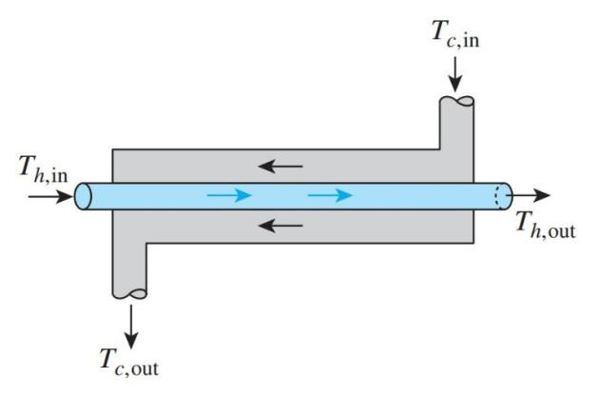
Figure 1.1: Double pipe heat exchanger

  - Problem Statement
- The project focuses on enhancing the effectiveness of the Shell and Tube Heat Exchanger to maximize heat transfer between fluids.
- Efforts are made to improve the efficiency of the system, ensuring better energy utilization and consistent performance.
- The project also aims to address the fouling factor, minimizing the negative impact of deposits on heat transfer surfaces.
- Developing a prototype allows controlled observation and analysis of these parameters, helping to study working principles, performance behavior, and limitations in a practical setup.

1.3 Objectives
We have some specific objectives for this project and they are pointed below:
- To understand and demonstrate the fundamental principle of heat transfer between two fluids without direct mixing.
- To monitor and analyze the inlet and outlet temperature variations of hot and cold fluids.
- To identify practical limitations, including heat loss and fouling effects.
1.4 Scope of Use Shell and Tube Heat Exchanger
- Industrial Applications: This project can be applied in power plants, chemical industries, refrigeration systems, and manufacturing processes for efficient heat transfer between fluids, helping improve energy efficiency, reduce operational costs, and ensure stable thermal control in industrial operations.
- Educational and Research Applications: The prototype is suitable for academic laboratories and research institutions to demonstrate heat transfer principles, performance evaluation methods like LMTD, and the impact of flow conditions, baffles, and fouling on heat exchanger efficiency.

1.5 Work Flow Diagram
The Diagram the step-by-step workflow of the Shell and Tube Heat Exchanger project. It starts with the study phase, where concepts of heat transfer, types of exchangers, and their industrial applications are explored. The next stage, design, involves determining the appropriate dimensions, materials, and flow configurations for the shell and tubes. During the components collection phase, all necessary materials—such as tubes, shell, piping, and fittings—are gathered. The assembly phase follows, where these parts are put together to create a working heat exchanger setup. Finally, the completed project undergoes operation, testing, and performance evaluation to ensure the system functions efficiently and meets design objectives.
CHAPTER 2
Literature review

2.1 Introduction
This chapter is arranged on Literature Review. Here's a look at some of last year's literature, like our project. By reading them, we can overcome the mistakes of the previous project and make a more effective project.

2.2 Related Research/ Works
Shrikant (2016)
the impacts of various baffle designs on the heat transfer coefficient and pressure drop in a shell and tube heat exchanger (STHX) were investigated. The use of baffles in shell and tube heat exchangers improves heat transmission while simultaneously increasing pressure drop. SOLIDWORKS Flow Simulation software is used to design shell and tube heat exchangers featuring single, double, triple segmental baffles, helical baffles, and flower baffles, as well as fluid dynamic simulations (ver.2015). Simulation studies revealed how single segmental baffles had the highest heat transfer coefficient, pressure drop, or heat transfer rate for much the same shell side mass flow rate [1].

Kamble Et Al (2014)
The use of artificial neural network (ANN) modelling in different heat transfer applications, such as constant and dynamic thermal issues, heat exchangers, gas-solid fluidized beds, and so forth, was examined. Several crucial issues in thermal engineering cannot always be solved using typical analysis methods such as basic equations, conventional correlations, or trial and error to build unique designs from experimental data. The use of the ANN tool using various methodologies and structures reveals that the findings provided using ANN and experimental data are in good agreement. The aim of this paper is to highlight current improvements in ANN and how it has been successfully used to a number of key heat transfer challenges. According to the literature, the feed-forward network with back propagation approach has been effectively utilised in various heat transfer investigations [2].

Kwang-Tzu Yang (2008)
The goal of this work is to showcase recent advances in ANN and how it has been effectively applied to a variety of major heat transfer problems. The feed-forward network incorporating back propagation technique has already been successfully used in many heat transfer experiments, per the literature [3].

Singh Et Al. (2011)
“The performance of three training functions (TRAINBR, TRAINCGB, and TRAINCGF) utilised for training NN to forecast the value of the specific heat capacity of both the working fluid, LiBr-H2O, employed in a vapour absorption refrigeration system were evaluated. The percentage relative error, coefficient of multiple determination, RMSE, and sum of a square owing to error were employed as comparison metrics. The input parameters include vapour quality and temperature, with specific heat capacity as being one of the output parameters. The training is maintained until the least mean square error (MSE) at a specific number of epochs was found. The TRAINBR function outperformed the other two training functions based on findings of performance parameters [4].”

Gerardo Diaz Et Al (2001)
Apply the artificial neural network (ANN) approach to the modelling of a heat exchanger's time-dependent behaviour and use it to manage the temperature of air travelling through it. Inside an open loop test facility, the tests are carried out. To begin, an approach for training and predicting the dynamic behaviour of thermal systems including heat exchangers was provided. Then, using two artificial neural networks, somebody to mimic the heat exchanger the other as a controller, an internal model strategy for controlling the overtube air temperature is devised. To avoid a steady-state offset, an integral control is performed in tandem with the neural network controller's filter. The findings correspond to PI and PID controllers that are commonly used. The neural network controller has less oscillating behaviour, allowing the system to attain steady-state operating conditions in areas where the PI and PID controllers are not quite as effective [5].

Ahilan C Et Al (2011)
“artificial neural networks are used to construct a prediction model for shell and tube heat exchangers (ANN). The trials are carried by using a full factorial design of experiments to construct a model utilising input parameters including such hot fluid intake temperature or cold and hot fluid flow rates. The total heat transfer coefficient of such a heat exchanger, which itself is utilised for performance evaluation, is the output parameter.” ANN model was educated and trained to use a feed forward back propagation neural network. Through comparing the ANN findings to the experimental data, the constructed model is validated and evaluated. It demonstrates that perhaps the model and the results are in good agreement [6].

Hisham Hassan Jasim (2013)
“Heat transfer study of shell-and-tube heat exchangers, which are frequently used in power plants and refineries, was performed using an Artificial Neural Network. To train & test networks, the Back Propagation (BP) technique was employed, which separated the data into three samples (training, validation, and testing data) to provide more approach data from genuine cases. Inlet water temperature, inlet air temperature, or air mass flow rate are all inputs to the neural network. In ANN, two outputs were collected (exit water temperature to cooling tower & exit air temperature to second phase of air compressor).” “To train the classifier, the reference heat exchanger model provided 150 sets of data on different days. Regression between the planned goal and the predicted outcome For training, validation, testing, as well as all samples, the ANN output shows that the values are fairly equal to one (R=1). A total of 50 sets of data were gathered to test the network and compare the intended and predicted exit temperatures (water and air temperatures) [7].”

GovindMaheshwari (2018)
“artificial neural networks were used to assess the performance of a parallel flow heat exchanger (ANNs). Experiments were carried out utilising a complete factorial design of experiments to construct a model employing characteristics such as temperatures, capacity ratio, and optimal NTU constant value. A feed forward back propagation neural network is used to construct and train an ANN model regarding efficiency, entropy generation number, and total heat transfer coefficient multiplied by the area of a theoretical/clean heat exchanger.” Through comparing the findings to the experimental results, the generated model is verified and evaluated. This model is used to evaluate the heat exchanger's performance in the real/foulled system. It helps the system enhance its performance through maximising asset usage, conserving energy, and lowering production costs [8].

Nader JamaliSoufiAmlashi (2013)
Applied an artificial neural network model to the nonlinear identification of a liquid saturated steam heat exchanger (LSSHE). Heat exchangers are nonlinear and non-minimum phase processes with changeable operating conditions. The rate of change of fluid flow into to the system is also employed as such an input variable, while experimental data collected from fluid outlet temperature measurement inside a laboratory environment has been used as an output variable. The outcomes of neural network & traditional nonlinear model identification are compared. Due to the obvious independence of the model assignment, the simulation results demonstrate that perhaps the neural network model is reliable and quicker than standard nonlinear models using time series data [9].

Mahdi JaliliKharaajoo (2004)
to control the dynamics of such a heat exchanger pilot plant, I created a neural network-based prediction model. Because a heat exchanger is just a nonlinear process, a nonlinear prediction approach may be a good fit for just a predictive control strategy. The benefits of neural networks in process modelling are investigated, and a neural network-based predictor was created, trained, and evaluated as part of the predictive controller. A Multi-Layer Perceptron (MLP) neural network is used to determine the plant's dynamics. After that, a predictive control method based here on plant's neural network model is used to accomplish set point tracking of the output. Using simulation tests, the suggested controller's performance by comparing with that of Generalized Predictive Control (GPC). The obtained results show that the proposed method is both effective and useful [10].

(Abeykoon, 2020) A counter flow heat exchanger was evaluated for design needs, and its length was theoretically estimated using the LMTD technique, as well as the pressure drop and energy consumption using the Kern method. After that, using ANSYS, a computational model of the same heat exchanger was created, and this model was then extended to six other models by changing its essential design parameter for the optimization purposes. These models were eventually utilised to investigate heat transfer behaviour, mass flow rates, pressure drops, flow velocities, and vortices of shell and tube flows within the heat exchanger. The cooling performance of the hot fluid was just 1.05 percent different between theoretical and CFD values. Both the total heat transfer coefficient and pump power requirement exhibited good correlations with axial pressure decreases. Overall, the findings of this study show that CFD modelling can be useful for the design and optimization of heat exchangers, since it allows for the testing of several design choices without the need for physical prototypes [11].

(SANDEEP, Chowdary and Babu, 2020) The report's central idea is to investigate the LMTD (logarithmic mean temperature difference), Heat transfer coefficient, & Effectiveness (ε) of a combination of heat exchanger employing an acetoacetate/water combination as a function of various mass flow rates. This work investigates the effects of acetoacetate/water mixture on heat transfer coefficient, LMTD, productivity, and total heat transfer coefficient in 3 distinct heat exchangers: tubes in tube, shell and tube, and combination heat exchangers. The exploratory examination of the forced convective heat transfer and flow properties of a 25% acetoacetate containing 75% water is summarised in these conducting tests. Assuming laminar flow conditions, the acetoacetate/water mixture flows in a parallel, counter-clockwise direction in the tube in tube, shell and tube heat exchanger, and combination of heat exchanger. The largest increase in the coefficient of convective heat transfer was 56.3 percent, with 49.6 percent effectiveness. Based on a multi-pass flow of Acetoacetate/water, integrated heat exchangers give greater heat transfer characteristics than parallel & counter flow tubular & shell and tube heat exchangers [12].

(KISHORKUMAR, MEHTA and SHAH, 2019) Shell and Tube Heat Exchanger in which It is Fixed Tubesheet and Counter Flow Type Heat Exchanger. In this research contain the analysis and comparison between plain tubes used Shell and tube heat exchanger and corrugated tubed used shell and tube heat exchanger system with different thickness. In this research, thermal analysis of the shell and tube heat exchanger. In this solid works 2014 is used for geometrical modelling. And also, TEMA standards are used for starting the experimental structure. Which are validate in ansys. Create a sample experiment model of a shell and tube heat exchanger inside which plain & corrugated tubes are used sequentially, as well as taking readings for thermal analysis calculations, and comparing the results of the experiment with the results of the Cfd simulation for affirmation [13].

(B, Lakshmi and Krishna, 2019) From the current situation, the Heat Exchangers uses extreme commonly are tube and Shell heat exchangers. The most usual uses of Shell and tube heat exchangers are electricity creation, cooling system of hydraulic fluid, oil in motors, transmissions, and hydraulic power packs. Shell and tube heat exchangers are made of the casing using a bunch of tubes with inside. The desirable outcome of the paper is to figure out the speed of heat transport using hot water as the hot liquid. The target of this paper is to mimic a tube and shell heat exchanger and also to assess blood flow and temperatures from the tubes and shell by employing applications tool Ansys. The simulation is composed of modelling and meshing cross section of tube and shell heat exchanger utilizing computational fluid dynamics (CFD). ANSYS Meshing is a general-purpose, intelligent, automated high-performance product. It produces the most appropriate mesh for accurate, efficient multi physics solutions [14].

(Pavani and Kumar, 2018) In the realm of energy conservation, conversion, as well as recovery, heat exchangers play a critical role. For the transfer of thermal energy, shell and tube heat exchangers are among the most extensively utilised in many technical applications. They're used in a variety of industries because of their capacity to transport vast volumes of heat in very low-cost, maintainable designs without combining hot and old fluids. They could provide a large number of functional tube surfaces while reducing floor space, liquid volume, and weight requirements. The heat transfer coefficient must be enhanced in order to compress the size of the heat exchangers. Nano fluids can be brought in use for increasing the heat exchanger performance. The heat transfer of a shell and tube heat exchanger operating with Nano fluids was evaluated analytically at various volume concentrations and evaluated to water as the base fluid in this research. The study takes into account turbulent flow conditions [15].

(Sankararao et al., 2017) A heat exchanger is a device used throughout the power generation, refrigeration, as well as chemical process sectors that permits heat from one fluid to flow to another without the fluids mixing or coming into direct contact. For several years, forced convection has been used in shell and tube heat exchangers to lower the hot fluid temperature while raising the cold fluid temperature. Work aimed for using the ANSYS software as well as experimental simulations to investigate temperature drops utilising camphor-water as a hot fluid and water as a cold fluid with varying inlet parameters such as temperature and velocity. The cross flow heat exchanger model was strengthened and studied for this purpose. The experimental results were compared to the CFD values [16].

2.3 Summary
The above has been discussed in detail in the past few literature's which has given us a lot of motivation to do this project.

CHAPTER 3
MATERIALS AND INSTRUMENT

3.1 Introduction
In this section, we will discuss elaborately about “ Shell and Tube heat Exchanger” and the component description, features, working procedure of our all equipment.The system hardware fabricates composed of micro-controller unit, power unit, source unit, power store unite and many more related components.

3.2 Required Instrument
- SMPS
- Heat Exchanger
- Temperature Meter
- Pump Motor
- Water Heater
- Copper Pipe

3.3 Switch Mode Power Supply (SMPS)
A switched-mode power supply (switching-mode power supply, switch-mode power supply, switched power supply, SMPS, or switcher) is an electronic power supply that incorporates a switching regulator to convert electrical power efficiently. Like other power supplies, an SMPS transfers power from a DC or AC source (often mains power) to DC loads, such as a personal computer, while converting voltage and current characteristics. Unlike a linear power supply, the pass transistor of a switching-mode supply continually switches between low-dissipation, full-on and full-off states, and spends very little time in the high dissipation transitions, which minimizes wasted energy. A hypothetical ideal switched-mode power supply dissipates no power. Voltage regulation is achieved by varying the ratio of on-to-off time (also known as duty cycles). In contrast, a linear power supply regulates the output voltage by continually dissipating power in the pass transistor. This higher power conversion efficiency is an important advantage of a switched-mode power supply. Switched-mode power supplies may also be substantially smaller and lighter than a linear supply due to the smaller transformer size and weight.
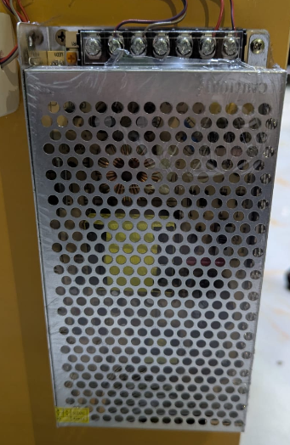
Figure 3.1: SMPS

Switching regulators are used as replacements for linear regulators when higher efficiency, smaller size or lighter weight are required. They are, however, more complicated; their switching currents can cause electrical noise problems if not carefully suppressed, and simple designs may have a poor power factor.12V 5A Industrial SMPS Power Supply – 60W – DC Metal Power Supply – Good Quality – Non Waterproof with Aluminum casing.

3.4 Heat Exchanger
A heat exchanger is a system used to transfer heat between a source and a working fluid. Heat exchangers are used in both cooling and heating processes. The fluids may be separated by a solid wall to prevent mixing or they may be in direct contact. They are widely used in space heating, refrigeration, air conditioning, power stations, chemical plants, petrochemical plants, petroleum refineries, natural-gas processing, and sewage treatment. The classic example of a heat exchanger is found in an internal combustion engine in which a circulating fluid known as engine coolant flows through radiator coils and air flows past the coils, which cools the coolant and heats the incoming air. Another example is the heat sink, which is a passive heat exchanger that transfers the heat generated by an electronic or a mechanical device to a fluid medium, often air or a liquid coolant.

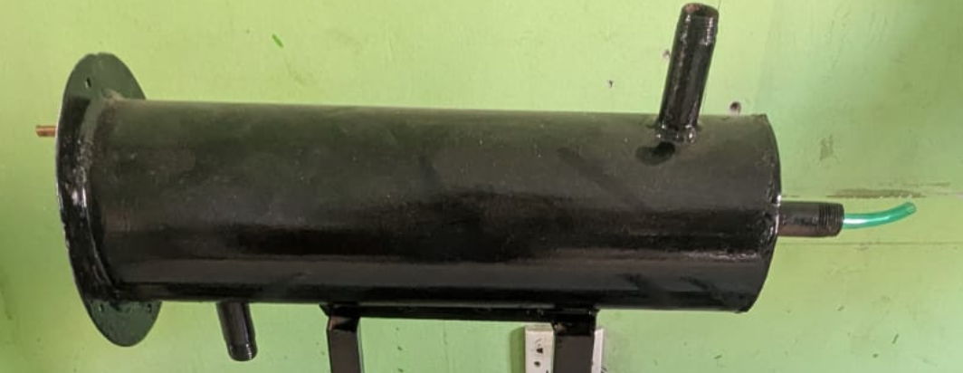
Figure 3.2: Heat Exchanger Tube

Double pipe heat exchangers are the simplest exchangers used in industries. On one hand, these heat exchangers are cheap for both design and maintenance, making them a good choice for small industries. On the other hand, their low efficiency coupled with the high space occupied in large scales, has led modern industries to use more efficient heat exchangers like shell and tube or plate. However, since double pipe heat exchangers are simple, they are used to teach heat exchanger design basics to students as the fundamental rules for all heat exchangers are the same.

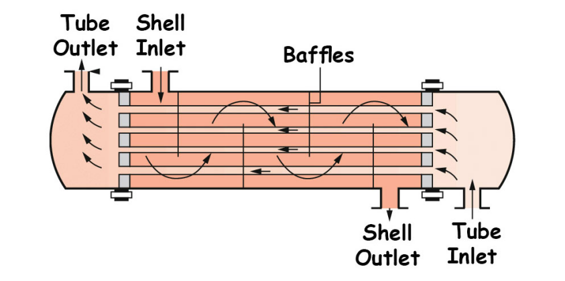
Figure 3.3: Heat Exchanger Tube inside view

In a shell-and-tube heat exchanger, two fluids at different temperatures flow through the heat exchanger. One of the fluids flows through the tube side and the other fluid flows outside the tubes, but inside the shell (shell side).
3.5 Digital Thermometer
A thermometer is a device that measures temperature or a temperature gradient (the degree of hotness or coldness of an object). A thermometer has two important elements: (1) a temperature sensor (e.g. the bulb of a mercury-in-glass thermometer or the pyrometric sensor in an infrared thermometer) in which some change occurs with a change in temperature; and (2) some means of converting this change into a numerical value (e.g. the visible scale that is marked on a mercury-in-glass thermometer or the digital readout on an infrared model). Thermometers are widely used in technology and industry to monitor processes, in meteorology, in medicine, and in scientific research.

Figure 3.4: Digital Temperature Sensor
Some of the principles of the thermometer were known to Greek philosophers of two thousand years ago. As Henry Carrington Bolton (1900) noted, the thermometer's "development from a crude toy to an instrument of precision occupied more than a century, and its early history is encumbered with erroneous statements that have been reiterated with such dogmatism that they have received the false stamp of authority." The Italian physician Santorio Santorio (Sanctorius, 1561-1636) is commonly credited with the invention of the first thermometer, but its standardization was completed through the 17th and 18th centuries. In the first decades of the 18th century in the Dutch Republic, Daniel Gabriel Fahrenheit made two revolutionary breakthroughs in the history of thermometry. He invented the mercury-in-glass thermometer (first widely used, accurate, practical thermometer) and Fahrenheit scale (first standardized temperature scale to be widely used).
3.6 Pump Motor
A pump is a device that moves fluids (liquids or gases), or sometimes slurries, by mechanical action, typically converted from electrical energy into hydraulic energy. Mechanical pumps serve in a wide range of applications such as pumping water from wells, aquarium filtering, pond filtering and aeration, in the car industry for water-cooling and fuel injection, in the energy industry for pumping oil and natural gas or for operating cooling towers and other components of heating, ventilation and air conditioning systems. In the medical industry, pumps are used for biochemical processes in developing and manufacturing medicine, and as artificial replacements for body parts, in particular the artificial heart and penile prosthesis.
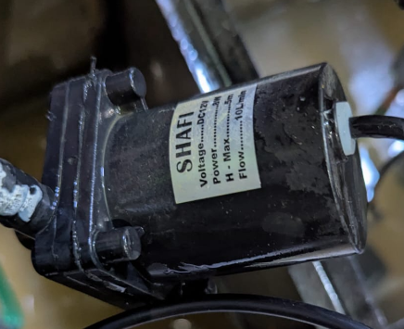
Figure. 3.5: water Pump.

3.7 Copper Pipe
Copper pipes are commonly used for exchange heat to the another medium in the construction industry for water supply lines and refrigerant lines in HVAC(heating, cooling and air-conditioning) systems. Copper pipes can be manufactured as soft or rigid copper and offer excellent corrosion-resistance and reliable connections.
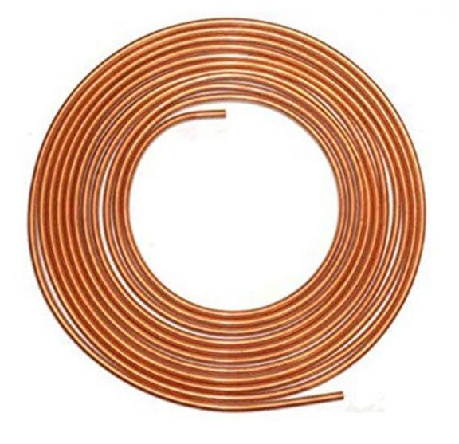
Figure 3.6: Copper Pipe

3.8 Water Heater
A water heater is a device that used to heat water or fluid. In this experiment water heater is used to heat up the water of hot cycle. Water heating is a heat transfer process that uses an energy source to heat water above its initial temperature. Typical domestic uses of hot water include cooking, cleaning, bathing, and space heating. In industry, hot water and water heated to steam have many uses.

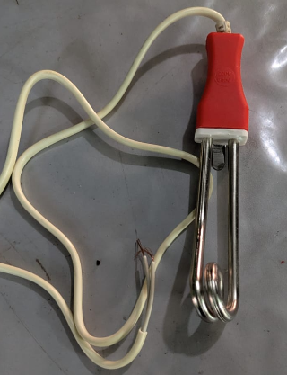
Figure. 3.7: Water heater
Domestically, water is traditionally heated in vessels known as water heaters, kettles, cauldrons, pots, or coppers. These metal vessels that heat a batch of water do not produce a continual supply of heated water at a preset temperature. Rarely, hot water occurs naturally, usually from natural hot springs. The temperature varies with the consumption rate, becoming cooler as flow increases.

CHAPTER 4
METHODOLOGY

4.1 Our methodologies for the project
Our methodologies for the project:
- Develop the design concept for a shell-and-tube heat exchanger. Prepare detailed block diagrams and construction layouts to determine the required dimensions and materials.
- Collect all necessary materials, including shell, tubes, insulation materials, and fittings.Ensure proper selection of tube type (plain or finned) and shell dimensions for the desired operating conditions.
- Assemble all parts to create the complete working model.Ensure proper alignment of tubes, sealing of joints, and leak-proof operation.

4.2 Heat exchanger
Heat exchanger may be defined as an equipment which transfers the energy from a hot fluid to a cold fluid, with maximum rate and minimum investment and running cost. The rate of transfer of heat depends on the conductivity of the dividing wall and convective heat transfer coefficient between the wall and fluids. The heat transfer rate also varies depending on the boundary conditions such as adiabatic or insulated wall conditions. Some examples of heat exchangers are:

I. Intercoolers and pre heaters;
ii. Condensers and boilers in refrigeration units;
iii. Condensers and boilers in steam plant;
iv. Regenerators;
v. Oil coolers and heat engines;
vi. Automobile radiators etc.

4.3 Classification of heat exchangers

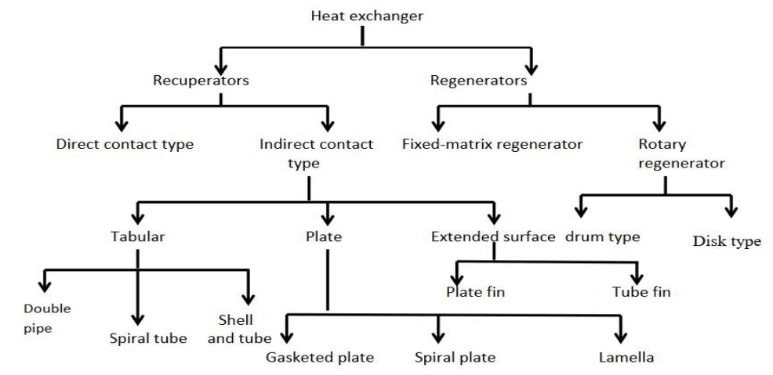

Figure 4.1: Classification of Heat Exchanger

4.4 Tabular heat exchanger
These kinds of heat exchangers are mainly made up of circular coils whereas many different shapes are also used for different applications. They provide flexibility because the geometric parameters such as length, diameter can be modified easily. These are used for phase change such as condensation, evaporation kind of operations. Again it is classified in to three different categories i.e. double pipe heat exchanger, spiral tube heat exchanger and shell and tube heat exchanger.

4.5 Block Diagram

In this diagram we will show by block the individual parts.
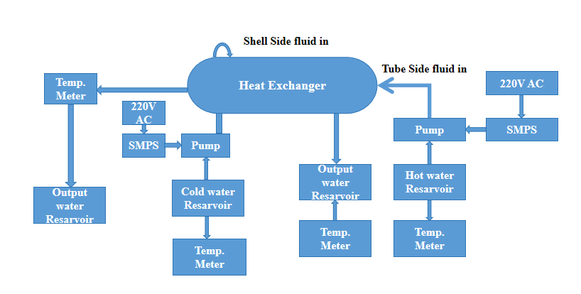
Figure 4.2: Block Diagram of Heat Exchanger

4.6 Heat Exchanger Flow Configurations:

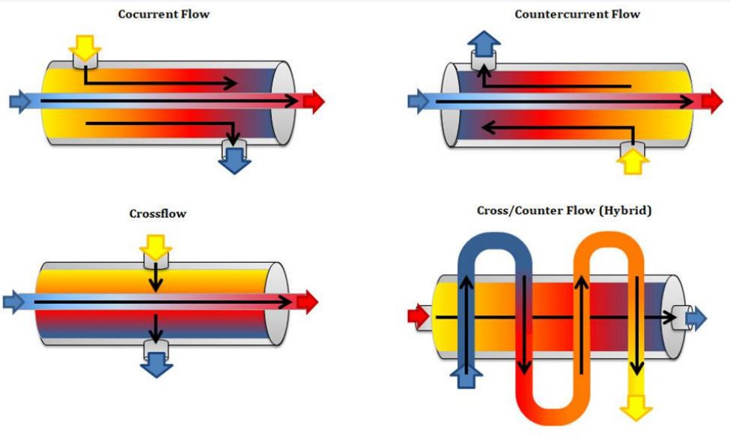
Figure 4.3: Heat Exchanger Flow Configuration
Counter Flow
Counter flow heat exchangers use flows in the opposite direction of each other. Shell and tube, and double pipes heat exchangers are examples of common exchangers using counter flow configurations. The best design for shell and tube and double-pipe exchanger is counter flow configuration, and the heat transfer between the fluid is the maximum. In counter flow, the efficiency is higher than the parallel, and temperature in the cooling fluid outlet can exceed the warmer fluid inlet temperature.

Parallel Flow
A parallel flow heat exchanger is a type of exchanger having a parallel fluid direction. In other words, the fluids having a high temperature and a cold temperature both move towards the same direction through separate tubes, which allows the heat to be transferred from a high-temperature liquid to a low-temperature liquid.
This process is less efficient compared to the counterflow method because this process cannot absorb a maximum amount of temperature from the warm liquid. This is because when the two liquids move in the same direction, the temperature difference between the two liquids becomes gradually low. However, this method is important when the flows at the outlet have a similar temperature together, and we also need these flows to have a closely similar temperature.
4.7 Working Principle
This project demonstrates how heat is transferred between hot and cold water using a mechanical shell and tube heat exchanger system with three water tanks. The Hot Water Reserve Tank stores incoming hot water, while the Cooling (Intermediate) Tank and Recycle Water Tank help track temperature changes and collect cooled water. Each tank is equipped with a temperature meter for monitoring.

Hot water from the reserve tank is pumped through copper and aluminum pipes, connected to a water-cooling heat sink, using a pump motor powered by an SMPS supply. As the water flows through the system, heat is gradually transferred to the surrounding medium, lowering the water temperature. The water first passes through the intermediate tank for partial cooling, then moves through the metal pipes for further heat exchange, and finally reaches the Recycle Water Tank, where the final temperature is recorded.
By comparing the temperatures across the three tanks, the heat transfer efficiency can be assessed. The setup also allows testing different flow arrangements, such as parallel and counterflow, to study their impact on performance.

4.8 Experimental Setup of Our System

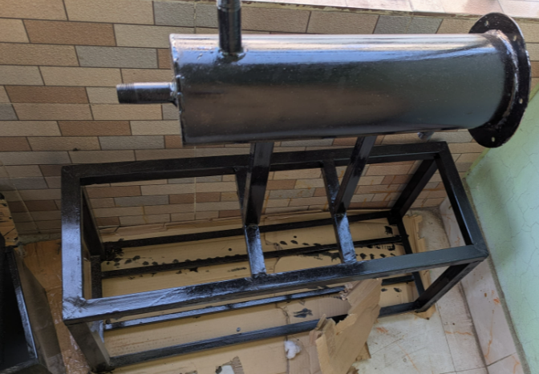
Figure 4.4: Our System Structural Frame Setup
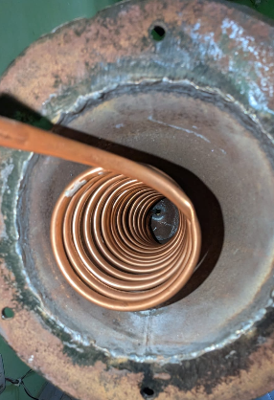
Figure 4.5: Our System Heat Exchanger set up.
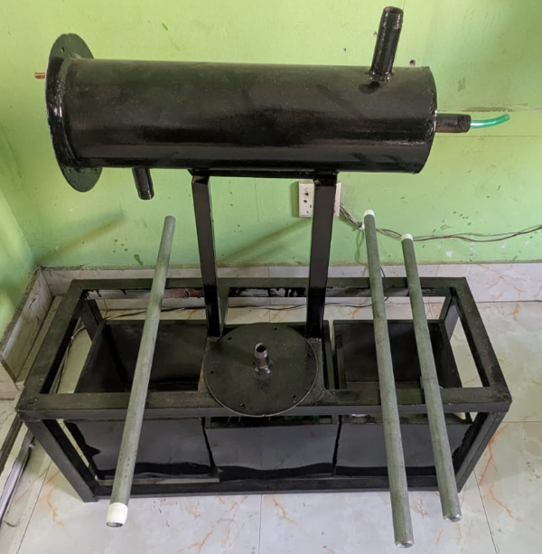
Figure 4.6: Project Progress Image
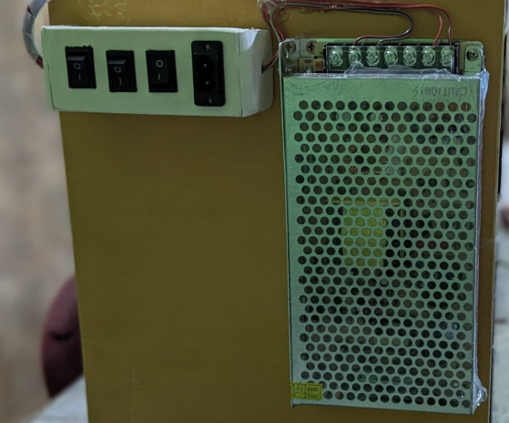
Figure 4.7: Power Store Unit

CHAPTER 5
RESULT ANALYSIS

5.1 Formula
Heat Transfer Rate
Q= u. A. ΔT_{lm}
Heat Transfer Rate
Q= m. C_{p.} ΔT_{lm}
Log Mean Temperature Difference
$∆T_{lm} = \frac{\text{∆}{\text{T}}_{\text{2}}\text{ - ∆}{\text{T}}_{\text{1}}}{{\text{L}}_{\text{n}} \frac{{\text{∆T}}_{\text{2}}}{{\text{∆T}}_{\text{1}}}}$

5.2 Calculation

Getting Value -

- Cold water value
$m_{c} = 0.2kg/s$
${cp}_{c} = 4.187 kj/kg.k$
$T_{c in} = 22℃$
$T_{c out} = 43℃$

- Hot water value
$m_{h} = 0.15kg/s$
${cp}_{h} = 3.976 kj/kg.k$
$T_{h in} = 60℃$
$T_{h out} =$?
A = ?
Let, U = 420 $W/m^{2}c$

- Applying Counter Flow:

We know that,

Q = $m_{c}{cp}_{c}( T_{c out } - T_{c in }) = m_{h} {cp}_{h} ( T_{h in} - T_{h out})$

$$∴ Q = m_{c} {cp}_{c} ( T_{c out } - T_{c in})$$
= 0.2 ×4.187 ( 43-220
= 0.839 × 21
= 17.6 kw
= 17.6 ×${10}^{3} watts$

$$∴ Again ,$$

$$Q = m_{h} {cp}_{h} ( T_{h in } - T_{h out })$$
= 0.15 × 3.976 ( 60 - $T_{h out }$)
= 1.99 ( 60 - $T_{h out }$)
17.6 = 1.99 × 60 - 1.99 $T_{h out }$
1.99 $T_{h out }$ = 1.99 × 60 - 17.6
${∴ T}_{h out } =\frac{1.99 × 60 ×17.6}{1,99}$
= 51.2$℃$

$$∴ ∆T_{1} = ( T_{h in} - T_{c out} )$$
= 60 - 43
= 17℃

$$∴ ∆T_{2} = ( T_{h out} - T_{c int} )$$
= 51.2 - 22
= 29.2℃

$∴ LMTD Method = \frac{∆T_{1} - ∆T_{2}}{L_{n} \frac{{∆T}_{1}}{{∆T}_{2}}}$

= $\frac{17 - 29.2}{L_{n} \frac{17}{29.2}}$
=22.55

$∴ Q = UALMTD$

$∴ A = \frac{Q}{ULMTD} =\frac{17.6 ×{10}^{3}}{420 × 22.56} =1.86 m^{2}$

$∴$ Area of Heat Exchanger A = $1.86 m^{2}$

$∴$ $∆ T_{1} = ( T_{h in } - T_{c in})$
= (60 - 22)
= 48℃

$∴$ $∆ T_{2} = ( T_{h out } - T_{c out})$
= (51.2 - 43)
= 8.2℃

$∴$ LMTD Method = $\frac{{∆T}_{1} - {∆T}_{2}}{L_{n} \frac{{∆T}_{1}}{{∆T}_{2}}}$
= $\frac{48 - 8.2}{L_{n} \frac{48}{8.2}}$
= 22.53

$$∴ Q = UALMTD$$

$$∴ A = \frac{Q}{ULMTD} = \frac{17.6 × {10}^{3}}{420 × 22.53} =1.86 m^{2}$$

$∴ A$rea of the Heat Exchanger A = 1.86 $m^{2}$

Efficiency Calculation of Heat Exchanger:
Given data
- Hot fluid inlet temperature, T_{h,in} = 120°C
- Hot fluid outlet temperature, T_{h,out} = 80°C
- Cold fluid inlet temperature,Tc_{,in} = 30°C
- Minimum heat capacity rate, C_{min} =2 KW/K

Step 1: Actual Heat Transfer
Q _{actual} = C_{h} (T_{h,in} - T_{h,out})
= 2 (120-80)
= 80KW

Step 2: Maximum Heat Transfer
Q_{max} = C_{min} ( T_{h.in} - Tc,in )
= 2 ( 120-30 )
= 180 Kw

Step 3: Efficiency
Effciency η = Actual heat Transfer / Maximum Possible Heat Transfer
= Q_{actual} / Q_{max}
= (80/180) 100%
T_{h,in} | T_{h,out} | T_{c,in} | Q_{actual} | Q_{max} | η
90 | 80 | 30 | 20 | 120 | 16.67%
80 | 70 | 20 | 20 | 120 | 16.67%
70 | 60 | 25 | 20 | 90 | 22.22%
60 | 50 | 15 | 20 | 90 | 22.22%
= 44.44%
Data Table

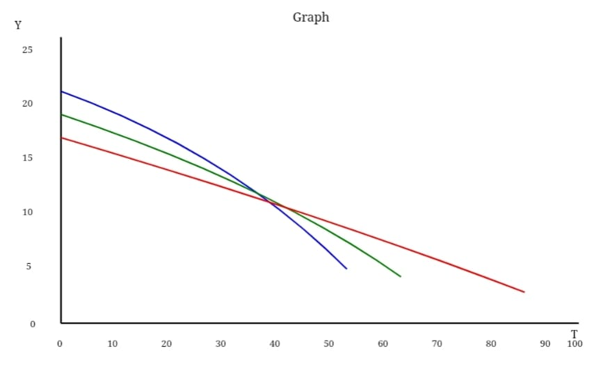

Fig: Efficiency vs Temperature graph

Typical Fouling factor Data Table
Fluid | Fouling Factor m²K/W
Distilled Water | 0.00002
Cooling Tower Water | 0.00018
River Water | 0.00035
Sea Water | 0.00035
Boiler Feed Water | 0.00009
Steam | 0.00002

Overall Heat Transfer Resistance Equation
For a Shell and Tube Heat Exchanger
1/U₀ = 1/h₀+R_{f,0}+{d₀ * l_{n} [(d₀/d_{i})/2k]}+d₀/d_{i*} Rf_{i}+ d₀/d_{i}h_{i}

Where,
- V₀ = Overall Heat Transfer Co-efficient
- h_{i,}h₀ = Inside and outside Heat Transfer Co-efficient
- R_{fI,} R_{fo} = Inside and Outside Fouling factors
- K = Tube Thermal Conductivity
- d_{i,} d_{o} = Tube Inner and Outer Diameter
Simplified Design Approch (Common In practice ) :

Engineers Often Calculate Clean U first

1/ U_{Clean} = 1/h_{i}+1/h_{o}
Then add Fouling
1/U_{dirty} = 1/ U_{clean} + R_{fi}+ R_{fo}

Example Calculation
Given
Clean Overall Co-efficient
U(Clean) = 1000W / m²_{k}
Fouling factor
Tube Side ( cooling Tower Water )
R_{fi} = 0.00018
Shell Side (Oil. R_{fo} = 0.00035)

Calculation
1/U_{dirty} = 1/1000+0.00018+0.00035
= 0.00153

U_{dirty} = 653 W/m²_{k}

Effectiveness Data Table of Heat Exchanger
- Effectivness ε
ε = Qa_{ctual} / Q_{max}
- NTU (Number of Transfer Unit)
NTU = UA / C_{min}
- Capacity Ratio
Cγ = C_{min} /C_{max}

Effectivness Data Table
Counter Flow Heat Exchanger
NTU | ε (C_{r} = 0) | ε (C_{r} = 0.25) | ε (C_{r} = 0.50) | ε (C_{r} = 1.0)
0.5 | 0.39 | 0.36 | 0.33 | 0.29
1 | 0.63 | 0.60 | 0.57 | 0.50
2 | 0.86 | 0.82 | 0.76 | 0.67
3 | 0.95 | 0.92 | 0.86 | 0.75

CHAPTER 6
DISCUSSION AND FUTURE RECOMMENDATION

6.1 Discussion
The Shell and Tube Heat Exchanger project provides a practical demonstration of heat transfer between two fluids at different temperatures without direct mixing. Through a simple mechanical setup, the project helps in understanding core heat transfer mechanisms such as conduction and convection. Observing temperature changes at different points allows clear visualization of how thermal energy is transferred and dissipated within the system.

A key focus of the project is improving the effectiveness and efficiency of the heat exchanger. By analyzing inlet and outlet temperature variations, the system’s heat transfer rate can be evaluated. Different flow arrangements, such as parallel and counterflow, help compare performance and show how proper design choices significantly influence overall heat transfer effectiveness.

The project also highlights real-world challenges such as heat loss and fouling. Fouling reduces the heat transfer surface efficiency over time and directly affects system performance. Studying these limitations in a controlled prototype makes it easier to understand why regular maintenance and proper material selection are important in industrial heat exchangers.

Overall, this project bridges theoretical concepts with practical application. It demonstrates the importance of shell and tube heat exchangers in energy conservation and industrial processes. The prototype serves as an effective educational model, offering hands-on experience while emphasizing performance optimization, reliability, and efficient thermal system design.
6.2 Future Scope
The model can be improved by making some changes in the program and components. Some suggestions are given below.
- By using the same set of tabulators, heat transfer augmentation for various fluids can be studied.
- Integration with IoT sensors for real-time monitoring and data logging.
- Use of advanced materials like aluminum alloys or stainless steel for higher thermal conductivity and durability.
- Can be combined with renewable energy systems, like solar water heaters, for energy conservation.

CHAPTER 7
CONCLUSION

7.1 Conclusion
The Shell and Tube Heat Exchanger project successfully demonstrates heat transfer between two fluids without direct mixing. By focusing on improving effectiveness, efficiency, and reducing fouling, the prototype provides insights into real-time performance and operational limitations. This project highlights practical applications in industries, emphasizes energy conservation, and serves as an effective tool for understanding heat exchanger principles..
REFERENCES

[1] A.A Shrikant (2016), CFD simulation study of shell and tube heat exchangers with different baffle segment configurations, Applied Thermal Engineering, 1-29.
[2] L.V. Kamble, D.R. Pangavhane, T.P. Singh (2014), Heat Transfer Studies using Artificial Neural Network - A Review, International Energy Journal. 14, 25-42.
[3] Kwang-Tzu Yang (2008), Artificial Neural Networks (ANNs): A New Paradigm for Thermal Science and Engineering, Journal of Heat Transfer, 130(9), 112-120.
[4] Singh D.V., Maheshwari G, Shrivastav R., Mishra D. K., (2011), Neural network – comparing the performances of the training functions for predicting the value of specific heat of refrigerant in vapour absorption refrigeration system, International Journal of Computer Applications, 18(4): 1-5.
[5] Gerardo Diaz, MihirSen, K.T. Yang, Rodney L. McClain (2001), Dynamic prediction and control of heat exchangers using artificial neural networks, International Journal of Heat and Mass Transfer, 44, 1671-1679.
[6] Ahilan C, Kumanan S, Sivakumaran N (2011), Prediction of Shell and Tube Heat Exchanger Performance using Artificial Neural Networks, Proceeding of the nternational Conference on Advanced Computing and Communication Technologies, 307-312.
[7] Hisham Hassan Jasim (2013), Estimated Outlet Temperatures in Shell-and-Tube Heat Exchanger Using Artificial Neural Network Approach Based on Practical Data, Al-Khwarizmi Engineering Journal, 9(2), 12- 20.
[8] GovindMaheshwari (2018), To Evaluate the Performance of Heat Exchanger hrough Artificial Neural Networks Approach, International Journal Of Core Engineering & Management, 5(3), 21-31.
[9] Nader JamaliSoufiAmlashi (2013), Nonlinear System Identification of Laboratory Heat Exchanger Using Artificial Neural Network Model, International Journal of Electrical and Computer Engineering, 3(1), 118-128.
[10] Mahdi JaliliKharaajoo (2004), Neural network based predictive control of a heat exchanger nonlinear process. Journal of Electrical and Electronics Engineering 4:1219‒1226.
[11] Abeykoon, C. (2020) ‘Compact heat exchangers – Design and optimization with CFD’, International Journal of Heat and Mass Transfer. Elsevier Ltd, 146, p. 118766. doi: 10.1016/j.ijheatmasstransfer.2019.118766.
[12] SANDEEP, M. S., Chowdary, D. V. L. and Babu, K. madh. (2020) ‘Comparison On Cfd Analysis Of Acetoacetate / Water & Investigational Analysis Of Heat Transfer Characteristics Of Acetoacetate / Water By Using Tube In Tube And Shell And Tube Heat Exchanger’, European Journal of Molecular & Clinical Medicine, 07(08).
[13] KISHORKUMAR, G. H., MEHTA, D. M. and SHAH, A. P. J. (2019) ‘EXPERIMENTAL AND NUMERICAL STUDY OF SHELL AND TUBE HEAT EXCHANGER BY VARYING THE INNER RADII OF CORRUGATED TUBE’, International Journal of Technical Innovation in Modern Engineering & Science (IJTIMES), 5(04), pp. 629–640.
[14] B, K. P., Lakshmi, B. U. and Krishna, A. H. (2019) ‘Numerical Simulation of Shell and Tube Heat Exchanger using Ansys Fluent’, International Journal of Innovative Technology and Exploring Engineering, 8(11S2), pp. 543–545. doi: 10.35940/ijitee.k1093.09811s219.
[15] Pavani, K. and Kumar, V. R. (2018) ‘NUMERICAL INVESTIGATIONS FOR PERFORMANCE IMPROVEMENT IN SHELL AND TUBE HEAT EXCHANGERS USING NANO FLUIDS’, International Journal of Engineering Sciences & Research Technology, 7(7), pp. 1–16.
[16] Sankararao, U. et al. (2017) ‘Enhancement of heat transfer in shell and tube heat exchanger by using nano fluid’, International Journal of Mechanical and Production Engineering Research and Development, 7(5), pp. 191–198. doi: 10.24247/ijmperdoct201720.

